Geography
Department Information

About the role
We are looking for an enthusiastic Teacher of Geography who passionately believes in putting students first. You will be joining a committed and hardworking department. It is expected that the successful candidate will be able to teach across the age and ability range within the school including A-level. We simply want the best teachers for our students, and that could be you!

About the department
The geography department is situated in recently refurbished rooms grouped close to a central humanities faculty workspace. The department consists of three teachers who are either full or part-time. In addition, some have whole school responsibilities on top of their teaching covering the development of NQTs, RQTs, the leading of whole-school assessment and senior leadership duties. This gives a creative mix of youth and experience within the team that actively aims to support any new staff joining the team.

The department has a collaborative approach to teaching and learning. We believe in sharing ideas and resources, and supporting each other in a continual drive to improve the geographical experience we provide for our students. We are a well-resourced department with a genuine pride in providing exciting and rewarding lessons for every student that walks into our classrooms.
About the courses
Following compulsory study in Years 7 and 8, there are around 100 students in each year group studying the subject at GCSE, followed by a group of around 20 students in both Years 12 and 13.
For all classes, geography students are taught in mixed ability groups: providing the very best learning experiences for all students of all abilities and backgrounds.
One of the greatest strengths of the department is our ability to foster exceptional working relationships with all; culminating in the significant recruitment of students for both the GCSE and A-level courses. Students always express their fondness for both the topics they learn and the ways the lessons are delivered.
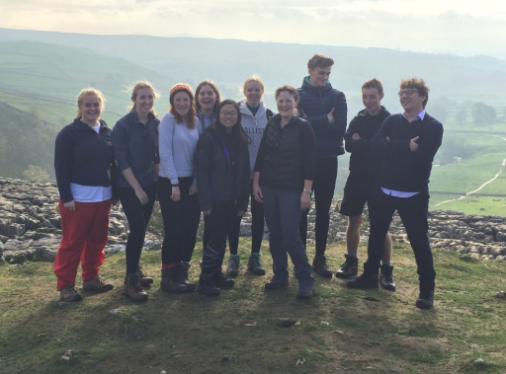
About the results
The geography exam results over the last few years have remained strong, with last year’s GCSE cohort attaining at an ALPs 3 and A-level at an ALPs 2.
We enjoy our time at Richmond School and find it a rewarding place to work.

