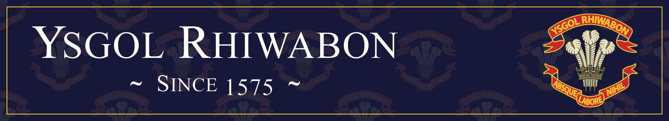

Vacancy Information Pack

Teacher of Welsh & French

Part Time (0.6fte), Permanent

Required from September 2025

“Ysgol Rhiwabon is a caring and inclusive school, which strives to support its pupils to ‘succeed with soul’ and to develop both academically and personally. Staff are ambitious for all pupils to achieve their full potential and leave school prepared for the next steps in their lives” (Estyn, May 2023).

Ruabon
Wrexham
LL14 6BT
Tel: 01978 822392
Email: mailbox@rhiwabon-high.wrexham.sch.uk
www.ysgolrhiwabon.co.uk

Headteacher: Mrs M Ferron-Evans B.A. (Joint Hons), MSc, N.P.Q.H

Part-Time Teacher of Welsh and French
(0.6 fte)

Required for September 2025

We are seeking to appoint an enthusiastic and creative teacher of French and Welsh to contribute to the excellent delivery of modern foreign languages in Ysgol Rhiwabon. The post is offered on a part time, permanent contract.

We are looking for an innovative professional who is passionate about leading teaching and learning and committed to making a difference.

The person appointed will be expected to;
- Teach across the age and ability range.
- Lead with energy and enthusiasm.
- Contribute to the development of the New Curriculum Framework for Wales.

In return we will provide;
- An induction support programme.
- Opportunities to play a role in shaping whole school development.
- A true learning community with a strong focus on teaching and learning.
- An environment where your skills and talents can be recognised and developed through our excellent professional training.

The school is committed to safeguarding and promoting the welfare of young people and expects staff and volunteers to share this commitment.

An Enhanced DBS & EWC registration are required for this position.

The Council welcomes applications from suitably qualified candidates regardless of race, gender, disability, sexuality, religious belief or age.

If you would like to be a part of our forward-looking, rapidly improving school and want the opportunity to develop your teaching career then please contact Mrs Emma Williams, PA to the Headteacher on Tel: 01978 822 392 or by E-mail: williamse45@hwbmail.net to request an application pack.

PLEASE RETURN COMPLETED APPLICATION FORMS DIRECTLY TO MRS EMMA WILLIAMS, PA TO THE HEADTEACHER VIA EMAIL OR POST

Closing date: Monday 10th March2025

Thank you for the interest you have shown in our school. Ysgol Rhiwabon, with its proud history, is a very special place to work. Our family ethos surrounds all who work and study here, creating a safe, supportive and nurturing environment. This is an exciting time in the development of our school and I hope you will agree that this role will present you with real opportunities to develop your career in the heart of a local community. I very much hope that, after reading the information below you will feel that you want to play your part in our process of rapid improvement and innovation, securing progress and achievement for all our students.

About us

Headteacher: Mrs M Ferron-Evans
Age Range: 11-16 years
Number of pupils: 512
Staff: 31 Teaching Staff and 13 Learning Support Assistants

It is with great pride and pleasure that I introduce Ysgol Rhiwabon. We are a caring, family school with excellent community links with Ruabon and its surrounding villages. Ysgol Rhiwabon has a proud heritage, which provides us with the firm foundations we need to develop the youngsters in our care. At the same time, we are a modern, innovative school with lots of exciting learning experiences available for our students. We continually review provision to ensure that we meet the needs of all our learners.

We have a very caring, hardworking staff in Ysgol Rhiwabon and visitors to our school comment regularly on the calm, happy, family atmosphere where standards of uniform and behaviour are high and where our young people are supported and challenged to be the very best they can be.

We continue to be one of few schools in Wales in the Prince’s Teaching Institute which involves our staff and students in outstanding training. As part of this, two of our students were invited to represent schools from across the UK in a Prince’s Teaching Institute Conference and they have both featured in national publications, commenting on inspirational teaching. Staff from our school are asked regularly to be consultants for the Princes’ Teaching Institute. This year we will lead in Science, History and at Senior Management Level. This keeps Ysgol Rhiwabon at the forefront of best practice across the UK.

In recent times our school has improved in so many ways, modernising and responding to the many changes which face our staff every year. Ysgol Rhiwabon is founded on strong traditional values, and it is this which will lead to our continued success in the future. We look forward to developing even stronger links in the village and beyond as our young people and staff see opportunities to learn and contribute both in school and the local and wider community. This is particularly important as we embrace the significant reforms which will develop education in Wales for future generations.

We are very proud of our school and the many achievements of our students and staff. We look forward to sharing this with you when you visit us.

Mrs M Ferron-Evans

Headteacher

