

RECRUITMENT PACK
Targeted Provision Tutor
Grade 9 actual salary £25,163 (pending pay award)
Start Date: ASAP
Term time only

Introduction from the Headteacher

Queen Emma's Primary School sits at the heart of our local community. We prioritise personal, social development and wellbeing alongside our irresistible knowledge curriculum. We are truly inclusive, no child held back, no child left behind. We ensure our children's needs are met whilst developing their independence and resilience.

Our school site is magical! We have an outdoor gym, the daily mile, netball courts, football pitches, a vast outdoor space for our children in Early Years, vegetables patches and our very own forest. Our staff are an amazing team who are relentlessly bothered about our children.

Our approach

This is a hugely exciting time for our family of schools as we are presented with a rare opportunity to make a real difference to the lives and life chances of so many children and young people. Our vision is to enable individual schools to flourish whilst remaining integral to the communities they serve.

Here we think deeply about how we can have the biggest impact on pupils. In a world where the algorithms of life give us more of the same, we believe education has the role to give children something different. We continually ask ourselves the following five questions:
- Are we securing equity?
- Is our leadership driving school improvement?
- Is our curriculum irresistible?
- Are we research informed?
- Are we deploying resources effectively?

All schools in our Trust have a culture of compassion underpinned by high expectations and understanding. We have three rules: ready, respectful and safe. We are a truly inclusive organization and passionately believe that every child has a right to mainstream education.

Our curriculum principles

We use Read, Write, Inc to teach children how to read. This approach ensures every child learns how to read accurately and fluently to enable them to comprehend. We teach writing using the 'Write Stuff' principles. These principles guarantee that all children develop their vocabulary and confidence with a range of sentence structures. We teach Maths using 'Inspire Maths'. Children a in small, flexible groups to ensure prerequisites are embedded and gaps are closed. Using this concrete, pictorial and abstract methods to teach mathematical concepts enables all children to make incredible progress.

Here at Queen Emma's Primary School we provide a broad and balanced curriculum based around the Cornerstones Curriculum, a nationally recognised approach for delivering outstanding learning opportunities for children. What is the Cornerstones Curriculum? The Cornerstones Curriculum is a creative and thematic approach to learning that is mapped to the 2014 primary national curriculum to ensure comprehensive coverage of national expectations. It is based on a child-centred pedagogy called The Four Cornerstones and is delivered through Imaginative Learning Projects (ILPs) and Knowledge Rich Projects (KRPs), which provide a rich menu of exciting and motivating learning activities that make creative links between all aspects of children’s learning. We believe children learn better when they are encouraged to use their imagination and apply their learning to engaging contexts. Our curriculum provides many learning challenges throughout the academic year that require children to solve problems, apply themselves creatively and express their knowledge and understanding effectively. Cornerstones also provide a rigorous skills and knowledge framework that outlines the end of year expectations in all subjects. These skills and knowledge are tied to activities and are age-related so that staff can track children’s progress and identify their individual learning needs.

Queen Emma’s Primary School is committed to promoting the welfare of children and young people and expects all staff and volunteers to share this commitment.

Victoria Musson
Headteacher

The opportunity
Position: Targeted Provision Tutor
Working Hours: 8.00am to 3.30pm Monday to Friday, Term Time only
Required: ASAP

We are seeking to appoint an energetic, enthusiastic and skilled Targeted Provisions to support children to flourish in our mainstream setting by planning, delivering, assessing, and reviewing targeted provision on a 1-1 or small group basis.

We are looking for candidates who are committed to the learning and development of our pupils, inspiring and motivating them in their learning, as well as successfully working as part of our friendly school team and the wider Trust team.



Key Tasks

- Coordinate resources to secure provisions identified in Section F on Educational, Health and Care Plans
- Take responsibility for the ‘plan, do, review’ cycle for targeted provision using EduKey
- Support the SENCo in developing and implementing interventions that reduce the attainment gap between children with special educational needs and other pupils.
- Communicate their knowledge and understanding of pupils to other school staff and education, health and social care professionals, so that informed decision making can take place on intervention and provision.
- Liaise with, and support parents to help support children’s development.
- Prepare, maintain, and use equipment/resources required to meet the lesson plans/relevant learning activity and assist pupils in their use.
- Demonstrate an informed and efficient approach to teaching and learning by adopting relevant strategies to ensure all children make progress.
- Use effective behaviour management strategies consistently in line with the school’s policy and procedures.
- Communicate effectively and sensitively with pupils to adapt to their needs and support their learning.
- Maintain a stimulating and safe learning environment by organising and managing physical teaching space and resources.

Additional Responsibilities:
- To use and assist others in the use of information technology systems to carry out duties in the most efficient and effective manner.
- To achieve school outcomes and outputs, and personal appraisal targets, as agreed with the Line Manager.
- To undertake training and constructively take part in meetings, supervision, seminars and other events designed to improve communication and assist with the effective development of the post and post holder.
- To be committed to the School and Academy’s core values and ethos and to demonstrate this commitment in the way duties are carried out.
- Maintain confidentiality and ensure that duties are undertaken with due regard to and compliance with the GDPR, Data Protection and Equality Act at all times.
- To carry out duties and responsibilities in accordance with the School’s Health and Safety procedures, the Academy’s Health and Safety Policy and relevant Health and Safety legislation.
- Demonstrate consistently high standards of personal and professional conduct; showing tolerance and respect of the rights of others whether other staff, students or parents, observing proper boundaries and having regard to the safeguarding and wellbeing of pupils.
- The post holder is responsible for ensuring all child protection policies are adhered to and that any concerns or incidents are raised in accordance with these policies.
- To undertake any other reasonable tasks commensurate with the grade as are required from time to time at the discretion of Headteacher.

For all staff - You have specific responsibilities under Health & Safety / Child Protection legislation to ensure that you:
- Take reasonable care for your own health and safety, and that of others affected by what you do, or do not do.
- Cooperate on all issues involving health and safety.
- Use work items provided for you correctly, in accordance with training and instructions.
- Do not interfere with or misuse anything provided for your health, safety or welfare.
- Report any health and safety concerns to your line manager as soon as practicable.
- Report any safeguarding children / child protection concerns to a senior member of staff.
- Attend safeguarding training as requested.

Person Specification
Qualifications and Training | Essential | Desirable
5+ GCSE (or equivalent) at grade A-C, Including Maths and English | ✓
Read Write Inc Phonics and Fresh Start training |  | ✓
First Aid Qualification or training, or willingness to become first aid trained | ✓
Qualified Teacher Status (QTS) |  | ✓
ELSA training |  | ✓
Lego Therapy training |  | ✓
Thrive Practitioner training |  | ✓
Forest School Level 1 |  | ✓
SCERTs model training |  | ✓
Social stories – writing and delivering training |  | ✓
Experience
Several years of working with children to improve outcomes | ✓
Experience of successfully working with children with complex needs | ✓
Experience of planning and delivering provision | ✓
Knowledge of the SEND Code of Practice and CAFA 2014 |  | ✓
Experience of attending multi-agency meetings and annual reviews |  | ✓
Good ICT skills and ability to use relevant technology e.g. MS Office, photocopier, printers, relevant software such as EduKey and Scholarpack (MIS) | ✓
Experience of using the 5 point scale and zones of regulation |  | ✓
Speech and language therapy – following SALT advisory reports |  | ✓
Occupational Therapy - developing fine and gross motor - following OT reports and OCC OT activities |  | ✓
Colourful semantics/Blanks Level of Questioning - to develop expressive language development. |  | ✓
Personal Skills
Proactive | ✓
Excellent communication skills both written and verbal | ✓
Excellent organisational skills | ✓
Resilient | ✓
Ability to prioritise workload work and under pressure while maintaining a positive, professional attitude | ✓
The ability to ensure that deadlines are met | ✓
Have high expectations of yourself and be able to model these behaviours in others | ✓
Work constructively as part of a team, understanding school roles and responsibilities and your own position within these | ✓
The ability to relate well to children and adults | ✓
Committed to professional development and training | ✓

This job description is current at the date shown, but, in consultation with you, may be changed by the Headteacher to reflect or anticipate changes in job commensurate with the grade or job title.

Working with Children and Safeguarding

The MILL Academy is committed to safeguarding children and promoting the welfare of children and young people and expects all staff and volunteers to share this commitment. All successful candidates are required to have enhanced DBS clearance and will need to undertake the DBS check with our organisation. Other relevant pre-employment checks will also be carried our including references from present and previous employers, a confidential health check and internet/social media checks.

What we can offer you:
- A hard working and committed team of colleagues
- Competitive salary with upper pay scales above the usual national levels
- Regular programmes of professional development to Teacher Development Trust Gold Standard
- Support for and commitment to your future training and development needs
- On-site free car parking
- Cycle to work salary sacrifice scheme
- Annual free flu vaccination
- 24/7 employee assistance wellbeing scheme

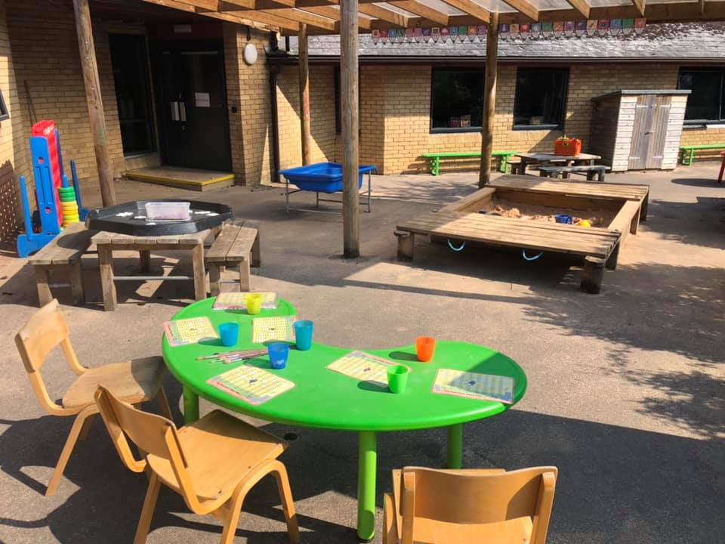
The Application Process

We are seeking to appoint the best possible candidate and our recruitment process will reflect our desire to undertake all possible measures to achieve this.

Applicants should download and complete the teaching staff application form from our website or complete the online application form on one of our partner recruitment sites. You should also submit an accompanying letter of application, addressed to the Headteacher, that is no more than two sides of A4. Applications should be returned to jobs@millacademy.co.uk please or via the online portal on the partner recruitment site.

Visits to the school prior to interview are also encouraged and warmly welcomed and can be arranged with the HR Team or the School Office. If you have any queries about this role, please do not hesitate to contact the HR Team on 01993 848166 or email jobs@millacademy.co.uk.

The closing date for applications is Monday 30th October 2023 at 9am. Shortlisting will take place during that week and candidates will only be notified if they are successful in being called for interview. Applications may be considered as soon as they are received, and the Trust reserves the right to withdraw the vacancy at an earlier date if a suitable applicant is found.

If you decide you want to be part of our amazing team, we look forward to hearing from you and to receiving your completed application form.



