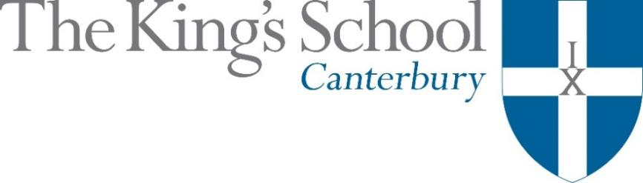

Appointment of a Teacher of English
September 2018

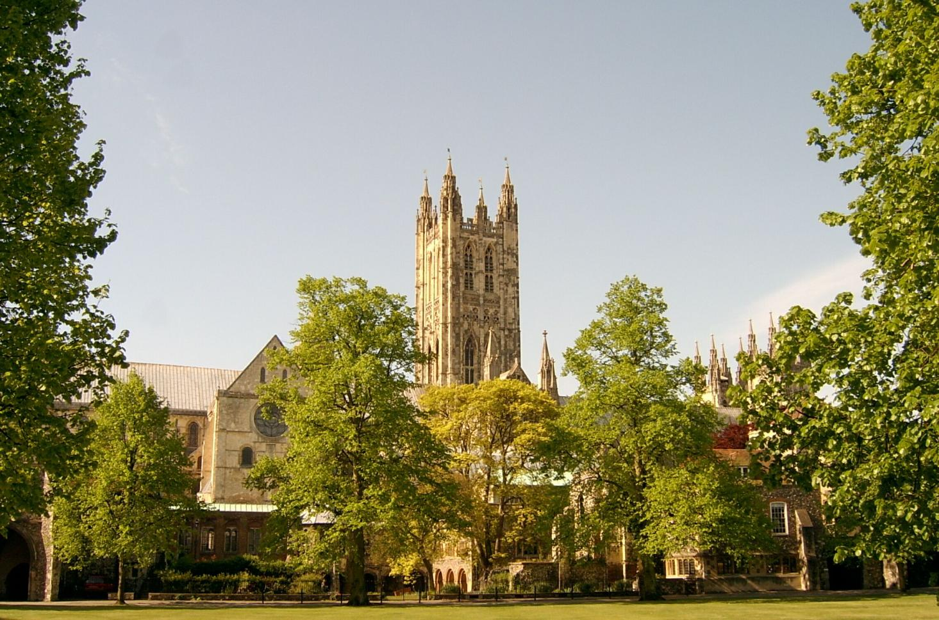

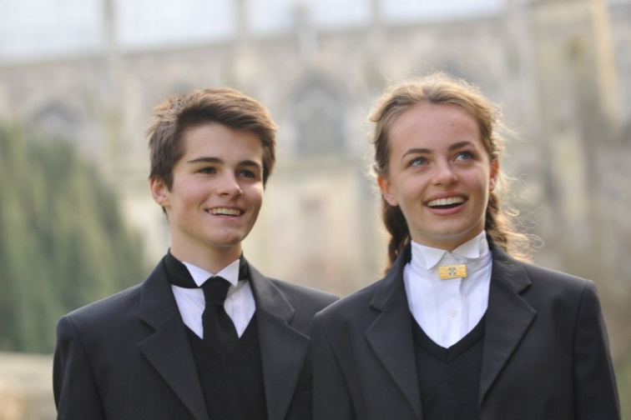
THE KING’S SCHOOL is a leading independent co-educational boarding school, situated in the heart of the historic cathedral city of Canterbury in Kent.

The precincts of Canterbury Cathedral are part of a world heritage site, a centre of pilgrimage and study, and host to over 1 million visitors each year from many different cultures. This international dimension deeply influences the life of the city and the school.

The origins of King’s date back to the arrival of St Augustine in 597 AD and the school’s Christian tradition remains at its heart although pupils and staff subscribe to many different faiths and beliefs and none. Embracing this diversity, there is a desire to foster fairness, tolerance, courage, perseverance, mutual respect and understanding. The Benedictine tradition of developing mind, body and spirit within a community given to hospitality still influences the life of the Cathedral and the school lives out its life in that context. Thus, academic excellence and scholarship take their place alongside the school’s commitment to physical and cultural endeavour. Sport is strong, with a number of boys’ and girls’ teams at national level. Music and drama are outstanding, both having the finest traditions and producing performances of the highest standards. King’s Week, the school’s own Festival of Creative and Performing Arts, attracts thousands of visitors each summer.

The curriculum at King’s is based upon strong academic roots. It emphasises and relies upon what is best in traditional school education: scholarly excellence supported by a caring pastoral and tutorial system, and a wide-ranging co-curricular programme. The curriculum is continually adapting and reacting to the changing demands of modern education: new subjects are added, new teaching techniques adopted, and there is an increasing awareness of the need to provide programmes of study that match individual needs and skills. The school does not gauge its success by exam results alone but by broader measures of educational attainment and personal development, helping pupils to achieve their potential and equipping them to play an active and responsible role in society as young adults.

Our family of schools comprises The King’s School, Canterbury (KSC), The Junior King’s School (JKS) and, from September 2018, the International College. At KSC there are currently 826 pupils at the school – 452 boys and 374 girls – of whom about 80% are boarders. There are six boys’ boarding houses, seven girls’ boarding houses and three mixed day houses. Junior King’s occupies a fine rural site on the banks of the River Stour, in Sturry, two miles from Canterbury. There are over 375 pupils at Junior King’s of whom around 20% are boarders.

The King’s School occupies various sites around the Cathedral and its precincts. Many teaching departments and the majority of houses are in the beautiful ancient buildings around Green Court on the north side of the Cathedral. To the east of the Cathedral the St Augustine’s site is home to five boarding houses, a medieval refectory, and the magnificent neo-Gothic school library (shown in the picture below). There are two major sites for sport: Birley’s, and the Recreation Centre, both within walking distance of the school, with rowing at Westbere Lakes in Sturry. The International College opens in September 2018 as the third school in the King’s family and a fourth school is planned in Shenzhen, China.

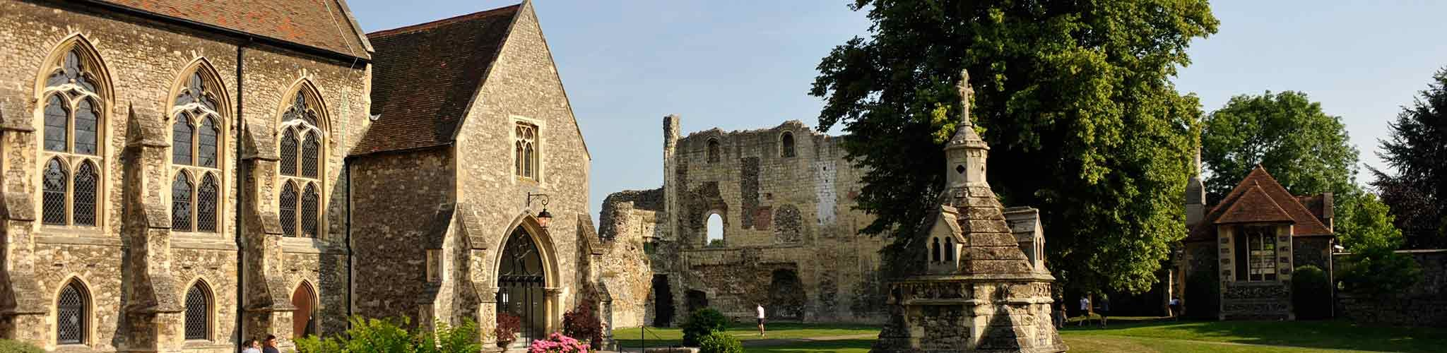

The school library, Undercroft, and ruins of St Augustine’s Abbey on the St Augustine’s campus at King’s

www.kings-school.co.uk

THE ROLE
We seek applications from well-qualified graduates to teach English. The applicants should be able to demonstrate a breadth of both teaching styles and academic interests. Successful applicants will be graduates of English or a closely related subject, and will have the opportunity of teaching across the year groups, perhaps including to Oxbridge preparation level.
A PGCE or equivalent is desirable but not essential. We welcome applications from experienced teachers as well as those graduating this summer, those moving to a second post, and those making a change of career into teaching.

English at King’s
The English Department at King’s comprises eight full-time and three part-time members of staff, most of whom teach at every level from the Shell (Year 9) to 6a (Year 12) and for university entrance. The Department is academic, energetic, and multi-talented. It currently has an enviable balance of youth and experience, and a wide range of expertise beyond literature, including sport, drama, writing, and public speaking. Apart from working hard to achieve outstanding examination results, the department contribute widely to school life – for example: editing magazines, teaching drama, coaching sport, running literary societies, and being involved in King’s Week, our annual summer Arts Festival, by directing plays and coaching pupils for a ‘poetry slam’ and Declamations, a speech recitation competition. All teachers of English look after tutees and fulfil weekly boarding or day house duties. Three of the department are currently housemistresses and two are deputy housemasters.
Remove (Year 10) and Fifth Form (Year 11) study for CIE IGCSE English Language and English Literature. They are set in groups of between fifteen and twenty in number. Each teacher usually keeps an IGCSE set for two years. Since 2015 Sixth Form students take CIE Pre-U English Literature and are taught in mixed-ability sets of between seven and thirteen. The subject is very popular in the Sixth Form, averaging between sixty and seventy candidates in each year group. Results at both levels are impressive – in 2017 53% of pupils achieved D1 or D2 grades (equivalent to A* at A level) – and half a dozen pupils apply for Oxbridge English every year, for which an extra, intensive programme of study is organised.
The department is well resourced in the old Priory building and in other classrooms around the school. Teaching spaces are equipped with white boards, interactive white boards and there is wifi throughout the school. The English section in the main school library at St Augustine's was recently re-stocked so that its collection of relevant criticism is especially rich, and it is updated all the time. The department is currently developing a collection of online resources, for pupils at all levels, which will help feed the school’s growing focus on independent learning.
A great deal happens outside the classroom, too. The Marlowe Society, which honours the memory of the playwright, who attended the school, invites pupils and staff to share literary enthusiasms. Mind's Eye, a yearly magazine in the mould of Prospect, is written and edited by pupils, and dozens of all ages contribute a wide range of pieces about the outside world, often dealing maturely with controversial topics. In 2014 a new publication – Poetry and Prose – was launched to celebrate pupils’ creative writing exclusively. From 2016, the department has developed an exciting collaboration with the English department at Folkestone Academy. There are several trips to the theatre every year, including to The Globe.
This post is suitable for a man or a woman who is a fine communicator and who combines academic excellence, energy, enthusiasm and experience with good humour and patience. S/he will have the opportunity to add creatively to the English Department and we would welcome a confident person with new ideas. A willingness to participate in the department’s co-curricular provision will be viewed favourably, as well as contributing to the wider life of the school through the pastoral and co-curricular programmes, by negotiation.

APPLICATIONS
Applications should be submitted online through the King’s School website (www.kings-school.co.uk – Staff Vacancies), and should include a personal statement for the Headmaster and a CV by 12pm on Tuesday 6th February. If you have any difficulties accessing the internet please contact the School Office: reception@kings-school.co.uk; 01227 595501.
Those considering applying but requiring more information, can contact the Head of English, Dr Alex Latter,
for an informal discussion: athl@kings-school.co.uk.

January 2018

