September 2021

Dear Applicant,

Thank you for expressing an interest in the post of part-time Teaching Assistant Level 2 at Ysgol Penglais School. You will be joining the school at a very exciting time as we live our vision for Penglais in the future.

‘Ysgol Penglais School is a happy, ambitious and high-achieving school where everyone is ‘respected and valued’. We are working hard with staff, students, parents and the governing body to ensure that Ysgol Penglais School becomes the school that our students and community deserve. We are continually working to achieve the highest standards of student achievement, behaviour and teaching and learning. Our recent GCSE results show significant improvements with 33% of all grades awarded at A*/A and 80% at A* - C.

We have an experienced body of staff who work hard and maintain a supportive and friendly ethos. Our students want to achieve more than they thought possible and want to be challenged and supported to do so. There are many different needs within the school and the ALN department work hard across the school to support students when needed. The 6th form is very strong with nearly 300 students, achieving excellent results again this year.

By joining Ysgol Penglais School, you will be supported professionally to achieve excellence in your role. I can promise you a demanding but ultimately rewarding experience as we move forward to becoming an excellent school.

The enclosed information gives you a snapshot of the school. If you would like further information, please contact Helena Clements by email at hcl@penglais.org.uk, or on 01970 624811. I look forward to receiving your application.

Yours sincerely

Mair Hughes
Pennaeth/Headteacher

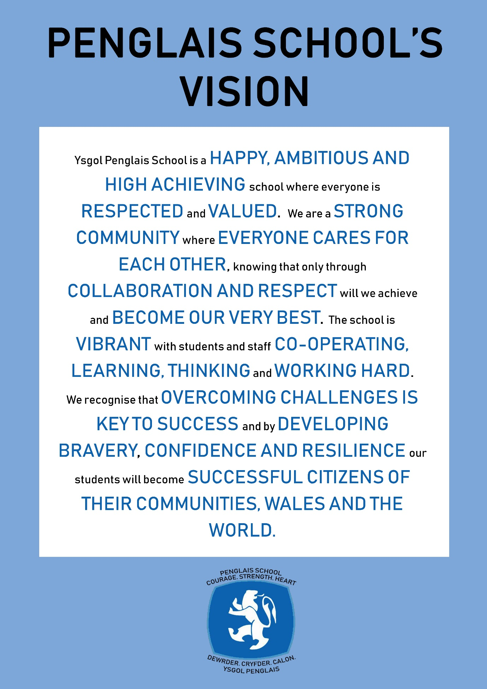
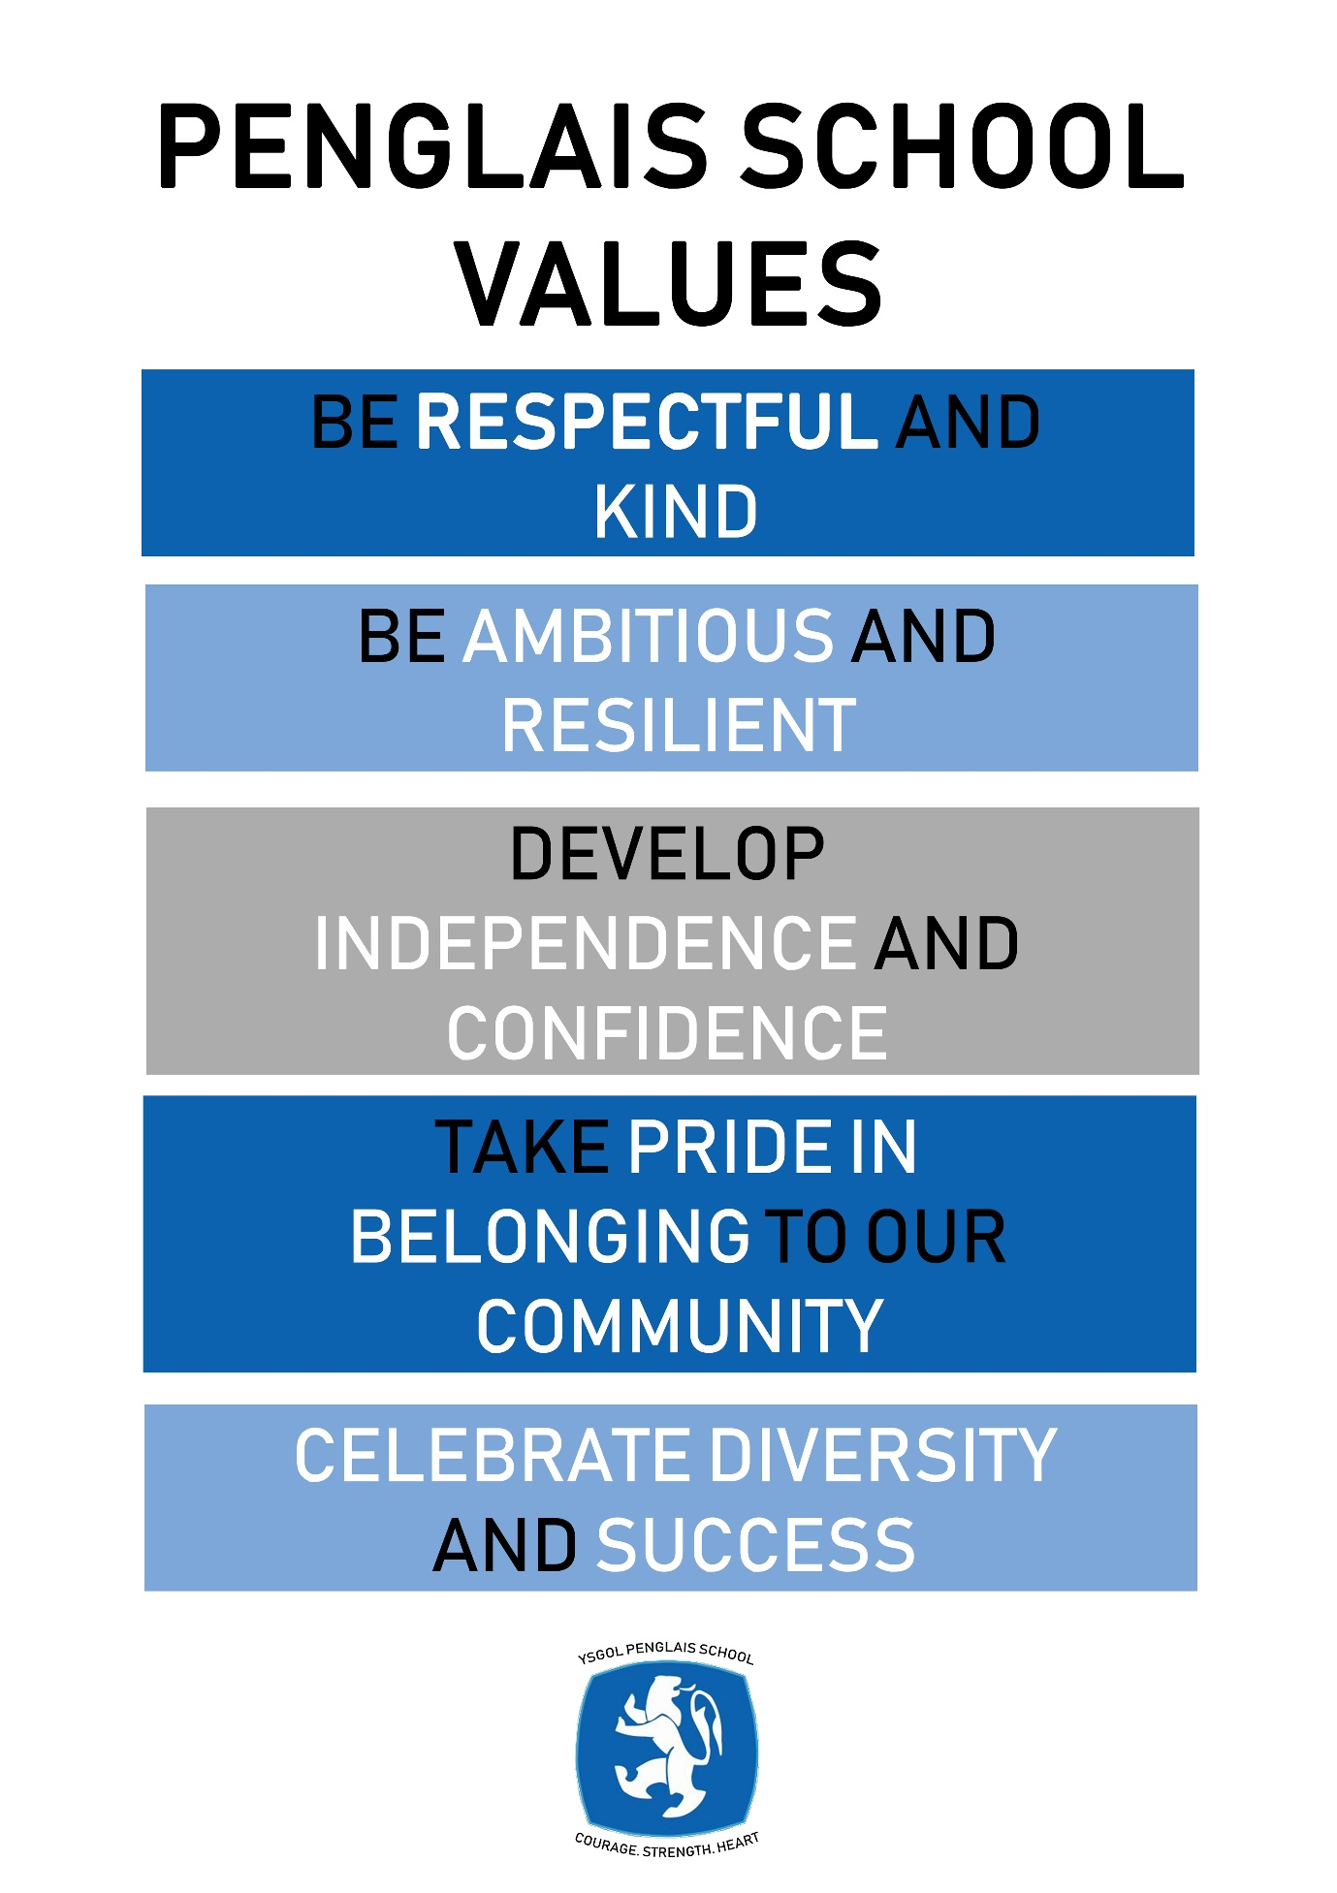
Please read these notes before completing the application form

It will help us if you follow these instructions:
- We would prefer you to fill in your application using Word or a word compatible format and submit it by email. Please include everything you wish the panel to consider on the form rather than in any separate document or covering email.

- Please give the full name and title of both your referees, and ensure that the full address, telephone numbers and email addresses are included. Your referees will be contacted if you are short-listed.

- If you are short-listed we will contact you by telephone or email

- Please submit your application form by 12 midnight by the date below to hcl@penglais.org.uk

- You will be asked to sign a hard copy if you are appointed

- Ysgol Penglais School is committed to safeguarding and promoting the welfare of students and expects all staff to share this commitment. All our staff are required to complete a DBS (Disclosure Barring Service) check and declare previous convictions.

- We are fully committed to equality of opportunity and aim for our staff to reflect the school community. It will help us to monitor the success of our recruitment strategies if you complete the ethnic monitoring information page of the application form. The information you provide will be treated as confidential and will not be made available to the short-listing panel.

Teaching Assistant Level 2 Grade: 4 scp 4; 13 hours per week, term time only £18,426 pro rata.

We seek to appoint a part-time Level 2 Teaching Assistant who will work with students who have support from the Additional Learning Needs (ALN) Department at Penglais. The main focus of your work will involve supporting students who have a wide spectrum of ALN needs. You will support the student in the classroom environment to allow them to effectively access their curriculum.

The right candidate will enjoy working in a busy environment. You will be required to use your own initiative to ensure that students can access the curriculum and that they are making good progress in their learning. This is a role that would suit an ambitious individual who has a genuine interest in supporting students to meet their potential.

Ysgol Penglais School has much to offer:

- a rapidly improving school with good relationships between staff and students
- a commitment to the professional development of all its staff to become outstanding teachers and leaders
- access to the bustling university town of Aberystwyth
- located on the beautiful Ceredigion coast, an area of natural beauty

For further details please contact Helena Clements (PA to the Headteacher) on 01970 624811or email hcl@penglais.org.uk

Ysgol Penglais School is committed to safeguarding and promoting the welfare of children, young people and vulnerable adults and expects all staff and volunteers to share this commitment. Successful candidates must be willing to undergo Enhanced DBS and other checks appropriate to the post.

Ysgol Penglais School is an equal opportunities employer.

Closing date: 27th July 2021
Interviews: Monday 2nd August 2021

Job Description – Teaching Assistant – Level 2

Job title: Teaching Assistant Level 1
Salary grade: Level 2 Grade 4 scp 4 £18,426
Hours and weeks: 13 hrs per week, term time only
Accountable to: SEN Co-ordinator/Assistant Headteacher

Core Purpose:

To work (at times, independently) under the guidance of teaching/senior staff to undertake work / care / support / outreach (within specialist areas) programmes ( to enable access to learning for students and to assist the teacher in the management of students and the classroom. Work may be carried out in the classroom or outside the main teaching area.

Key accountabilities | Key tasks
Support for students | - Supervise and provide particular support for students, including those with special needs, ensuring their safety and access to learning activities.  - Use specialist skills/training/experience to provide outreach support to students with special needs, ensuring their safety and access to learning activities.  - Assist with the development, implementation and review of Individual Education/Behaviour Plans and Personal Care programmes  - Establish constructive relationships with students and interact with them according to individual needs  - Promote the inclusion and acceptance of all students  - Encourage students to interact with others and engage in activities led by the teacher  - Set challenging and demanding expectations and promote self-esteem and independence  - Challenge and motivate students, promote and reinforce self-esteem  - Provide feedback to students in relation to progress, achievement, behaviour, attendance etc.  - Encourage students to interact with others and engage in activities led by the teacher  - Encourage students to act independently as appropriate
Support for the Teacher | - Create and maintain a purposeful, orderly and supportive environment, in accordance with lesson plans and assist with the display of students’ work  - Use strategies, in liaison with the teacher, to support students to achieve learning goals  - Assist with the planning and delivery of specific learning activities  - Monitor students’ responses to specific learning activities and accurately record achievement/progress as directed  - Provide detailed and regular feedback to teacher on students achievement, progress, problems etc.  - Promote good student behaviour, dealing promptly with conflict and incidents in line with established policy and encourage students to take responsibility for their own behaviour  - Establish constructive relationships with parents/carers  - Administer routine tests and invigilate exams and undertake routine marking of students’ work  - Provide clerical/admin. Support e.g. photocopying, typing, filing, money, administer coursework etc.
Support for the Curriculum | - Support students in gaining access to the curriculum  - Undertake structures and agreed learning activities/teaching programmes, adjusting activities according to student responses  - Undertake programmes linked to local and national learning strategies e.g. literacy, numeracy, KS3, early years recording achievement and progress and feeding back to the teacher  - Support the use of ICT in learning activities and develop students’ competence and independence in its use  - Prepare, maintain and use equipment/resources required to meet the lesson plans/relevant learning activity and assist students in their use
Support for the School | - Be aware of and comply with policies and procedures relating to child protection, health, safety and security, confidentiality and data protection, reporting all concerns to an appropriate person  - Be aware of and support difference and ensure all students have equal access to opportunities to learn and develop  - Contribute to the overall ethos/work/aims of the school  - Appreciate and support the role of other professionals  - Attend and participate in relevant meetings as required  - Participate in training and other learning activities and performance development as required  - Assist with the supervision of students out of lesson times, including before and after school and at lunchtime  - Accompany teaching staff and students on visits, trips and out of school activities as required and take responsibility for a group under the supervision of the teacher
Other | - Be aware of and comply with policies and procedures relating to child protection, health, safety and security and confidentiality, reporting all concerns to an appropriate person  - Be aware of and support difference and ensure equal opportunities for all  - Establish constructive relationships and communicate with other professionals  - Attend and participate in relevant meetings  - Participate in training and other learning activities and performance development as required  - Recognise own strengths and areas of expertise and use these to advise and support others  - Undertake other duties commensurate with the status of the post as may from time to time be determined by the Headteacher

This job description is not necessarily a comprehensive definition of the post. It will be reviewed at least once each year, but may be subject to modification or amendment at any time after consultation with the holder of the post

Person Specification - Teaching Assistant Level 2

Qualifications | - Good numeracy/literacy skills.  - Completion of DfES Teacher Assistant Induction Programme.  - NVQ 3 for Teaching Assistants or equivalent
Experience | - Experience of working with or caring for children or young people of a relevant age is desirable  - Training in the relevant learning strategies e.g. literacy  - First aid training/training as appropriate.
Skills | - Effective use of ICT to support learning.  - Use basic technology – computer, video, photocopier  - Understanding of relevant policies/codes of practice and awareness of relevant legislation.  - General understanding of national/foundation stage curriculum and other basic learning programmes/strategies.  - Basic understanding of child development and learning.  - Ability to self-evaluate learning needs and actively seek learning opportunities.  - Ability to relate well to children and adults  - Work constructively and flexibly as part of a team, understanding classroom roles and responsibilities and your own position within these
Qualities | - A willingness to develop your own professional skills and knowledge by attending appropriate courses / training  - A flexible, patient and hardworking approach to working as part of a team  - A demonstrable commitment to the safeguarding of students and child protection  - A demonstrable commitment to equal opportunities  - Excellent attendance and punctuality
Other | - Commitment to the school’s ethos, aims and its whole community

September 2021

