SCHOOL & CURRICULUM SUMMARY

December 2018

The Danes Educational Trust
The Danes Educational Trust currently comprises two schools: St Clement Danes School, an Outstanding school, and Croxley Danes School, a new 11-18 secondary school which opened in September 2017 using St Clement Danes as its blueprint. In its first year of opening, Croxley Danes School operated from within the St Clement Danes site in Chorleywood. In 2018/19 it is based in excellent temporary accommodation at Tolpits Lane, Rickmansworth, Watford whilst the permanent buildings are being constructed ay Baldwins Lane, Croxley Green. The school will move to its permanent accommodation in either Easter or Summer 2020. The date of the move will ultimately be determined by the school and the Department for Education (DfE) in the Autumn of 2019. Dr Josephine Valentine is the CEO of the Danes Educational Trust. She was Headteacher of St Clement Danes School for 20 years. She is a National Leader in Education, a DfE Advisor and has oversight of both schools. If appointed, you will benefit from teaching within an established, outstanding Trust whilst also contributing to the education of the first cohorts of students in a new school at an exciting stage in its development.

Croxley Danes School

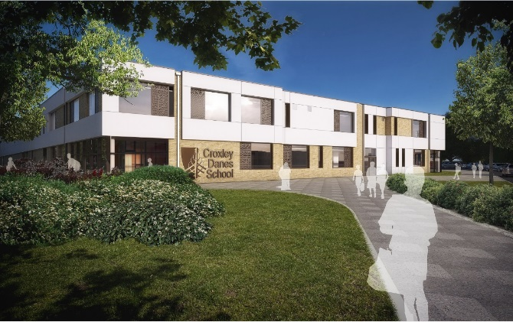

Mr Stephen Thompson, having served for 15 years on the Senior Leadership Team with Dr Valentine at St Clement Danes, as both Assistant Headteacher and then Deputy Headteacher, was appointed to the post of Headteacher at Croxley Danes School in December 2017. In 2018/19 the school is fortunate to benefit from extensive temporary accommodation at Tolpits Lane, which has far more capacity then is currently required for the 300 students attending the school and will easily accommodate the 480 students in 2019/20.

Our students are aspirational, confident and have excellent attitudes to learning. They are extremely proud of being the first cohorts of students in a brand new school and excited about the future. Staff overwhelmingly report that they are delightful to teach and fun to have in the classroom. Their behaviour is excellent.

In 2018/19, the students’ curriculum has been delivered through nine days per fortnight at Croxley Danes School and one day per fortnight at St Clement Danes, where the students access Technology Labs and the PE Facilities. The school has already undertaken the necessary curriculum planning for 2019/20; Technology lessons will be accommodated by developing the facilities at Tolpits Lane and negotiations are progressing well with a local secondary provider to access their extensive sports facilities to deliver PE lessons.

During 2019/20, the school will move to its permanent accommodation at Baldwins Lane in Croxley Green. The permanent site for the school comprises 12.3 hectares. This far surpasses the need for a six form entry school, therefore the space afforded to the students on site will, compared to other local schools, be second to none. Furthermore, the permanent school building has been meticulously designed to ensure both students and staff experience a first-class learning environment. More details about (and images of) the permanent site can be found here: https://www.croxleydanes.org.uk/714/baldwins-lane-information-about-the-permanent-site

Curriculum Summary

We currently have eight faculties: English, Maths, Science, Humanities, Modern Foreign Languages, Design (Art and Technology), Physical Education and Performing Arts (Music and Drama). When the students reach Key Stage 4, we will add Social Sciences to this list.

All Faculties currently have Faculty Co-ordinators. In September 2020, Heads of Faculty will be appointed to most Faculties. Over the course of the next five years a number of pastoral middle leadership roles as well as a variety of senior leadership posts will also become available, ensuring that aspirational staff will have opportunities to progress their career and assume additional responsibilities at the school.

All our Faculties use Schemes of Work which have been tried and tested at St Clement Danes, our sister school. As such, the students are following an identical curriculum and assessment framework at Key Stage 3 which facilitates progress comparisons with an established school which has outstanding student outcomes. Every data comparison to date demonstrates that the students have adopted the positive attitude to learning that is highly evident in our sister school and are making equivalent progress. When the students reach Key Stage 4 they will follow the same specifications at GCSE as St Clement Danes to facilitate the sharing of resources, knowledge and expertise, which should reduce workload whilst promoting positive academic outcomes. The school has high expectations of student behaviour, which is proving to be exemplary. To learn more about the curriculum and to download the KS3 curriculum booklet, please visit our website: https://www.croxleydanes.org.uk/198/ks3-amp-ks4-curriculum

There is a rich programme of Extra-Curricular activities and Student Participation Groups underway. Successful candidates will be encouraged to add to these opportunities for our students. In addition, many Faculties have already started to create links with the local community in Croxley Green where the school will be situated. Examples of this can be seen on our News Pages and Twitter Feed. We are keen for successful candidates, whether NQTs or on the Senior Leadership Team, to further develop these links. The current extra-curricular programme for our two year groups can be downloaded from our website: https://www.croxleydanes.org.uk/200/extra-curricular-1

Resources

Our school is fortunate to be extremely well resourced. There are interactive TVs in all classrooms and software has been purchased to support and facilitate learning and reduce workload: ActivInspire, Show My Homework and Mint Class have all been very well received by teaching staff. There is also considerable investment in curriculum software in all Faculties, for example - Accelerated Reader, Hegarty Maths, Kerboodle, and Active Learn to name but a few. Each Faculty will have its own dedicated ICT resources, either through a computing suite of 30 PCs or the provision of 30 laptops. Through a prudent expenditure and staffing plan, the school has been able to provide all the resources requested by staff whilst also developing significant reserves to develop financial resilience at a time when funding is a significant issue in most schools.
Accommodation

The school’s temporary accommodation is second to none, with the current building having been previously inhabited for five years by a Free School and therefore benefitting from significant investment by the DfE to develop the facilities. Over the course of the summer holidays a further £250,000 was invested to redecorate the entire building and replace the carpets. New furniture and ICT equipment was also installed and therefore the temporary accommodation has a fresh and vibrant feel which the staff and students enjoy. In addition to 20 classrooms (including science labs and Technology facilities) the temporary accommodation also has a dining hall, an assembly hall, changing rooms and staff offices – in fact, all the facilities one would expect to find in an established school building.

The funding envelope for the development of the permanent site and construction of the school building is approximately £25million and therefore the school will be able to provide first class facilities to create a rich learning environment, which will be populated by students and staff who demonstrate a ‘can-do’ attitude and enjoy celebrating one another’s successes. The building has been designed around the faculty system, in which classrooms within a faculty are grouped together, each Faculty benefiting from its own staffroom.

With the permanent site totalling 12.3 hectares, the playing fields will be extensive but also many of the aesthetic features of the site, such as an historic lime tree walk and other established shrubs and trees are being retained to create a landscaping effect which few other schools can offer. In addition to the playing fields, there will be dedicated tennis courts and (separate to the tennis courts) dedicated netball courts.

Our permanent site is situated within walking distance of Croxley Green underground station and a short bus ride from Watford town centre. Opposite the school is a parade of shops and several key bus routes serve the location. Croxley Green itself is a welcoming and cohesive community of which the school is already becoming a part. We hope that this relationship will only grow and flourish as we move into our permanent building.

Staffing

As a new school, we have an extremely keen, committed and cohesive staff group. In the first term on our new site, the active staff room committee have already organised two social events. We are looking for colleagues who want to make a difference to the lives of the families we serve whilst also developing their own interests and careers; we hope they will, like our current staff, also enjoy working at our school.

