Dear Colleague

Thank you for your interest in the position of Temporary Teacher of Mathematics, at Holmes Chapel Comprehensive School & Sixth Form College. The purpose of this letter is to give you some general information about the school and some specifics about the post.

The Post

We are looking for someone who is an outstanding practitioner and able to teach across KS3 and KS4.

We need a hard working individual who is intellectually capable and able to adapt to the changing educational landscape. A good knowledge of the mathematics curriculum is essential, alongside a passion for developing others and working with young people.

So if you are a great teacher; ambitious for the students you teach, hungry for career enhancement, intellectually capable and good with data, you should apply for this exciting role.

Academic standards are outstanding, with 88% of last year’s Year 11 gaining grade 4-9 in GCSE.

The School

Holmes Chapel Comprehensive School & Sixth Form College is a dynamic, innovative and ambitious Teaching School, National Support School and Academy with a national reputation for excellence. We work closely with the National College for Teaching and Leadership in modelling, promoting and disseminating best and next practice.

The future challenges and prospects afforded to all, especially by our Teaching School Status and position in a far-reaching alliance is central to our strategic vision.

The dashboard.ofsted.gov.uk. for HCCS shows that attainment and progress remain outstanding and it is our mission to make it world class.

As an outstanding school we are not subject to routine inspections. However at each HMI “interim assessment” our academic performance, student progress and attendance have been judged as `Outstanding’.

We, like most successful schools, maintain that success by regularly revisiting our values, vision and guiding principles in order to ensure that they remain apposite and relevant in a world that is changing so rapidly.

The ‘rainbow diagram’ below provides an immediate visual representation of “the basics” that contribute so much to the HCCS family and guide us as we strive for ever higher standards of progress and achievement.

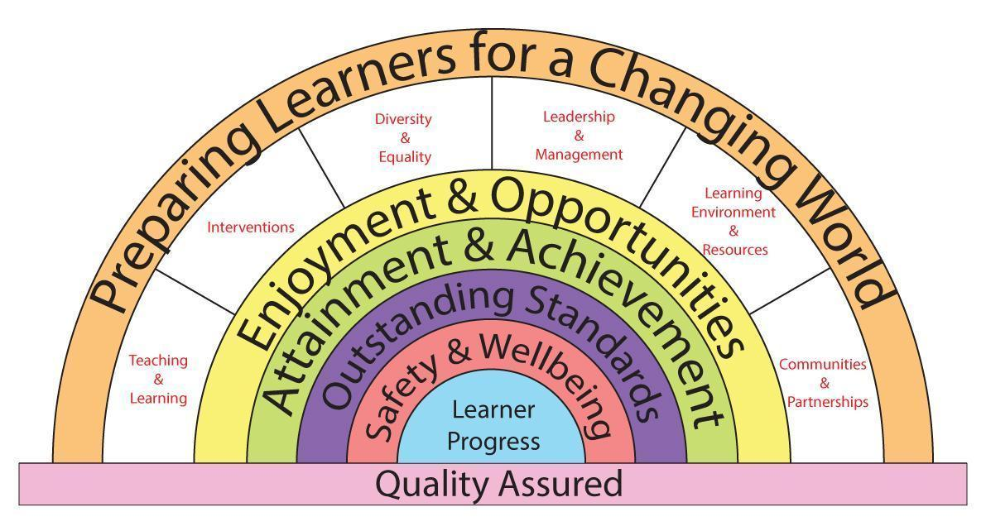

We have expressed our core values as a set of key principles which we use as our touchstones in designing our curriculum and in assessing its success and relevance to the needs of our learners.

Key Principles
The Curriculum at HCCS
1. Is about the development of the whole individual.
2. Ensures equality of opportunity in learning.
3. Provides personalised pathways and ways of learning.
4. Inspires drive, passion and commitment.
5. Promotes high standards, success and achievement.
6. Embodies responsibilities, entitlements, Safety & Wellbeing.
7. Develops respect, tolerance and courtesy.
8. Reflects the learners place in their communities.

The school serves a socially mixed, although generally prosperous rural community centered on the village of Holmes Chapel in Cheshire. Currently numbers on roll are 1253, including 207 in the Sixth Form. Our intake in September 2015 was 208 students. We have around 82 teaching staff, including myself as Executive Head Teacher.

We occupy an attractive site overlooking open countryside but close to modern, private housing estates and with easy access to the M6 at Junction 18. We have just completed building our new Sixth Form and Arts block with purpose built Theatre and our new 3G. AstroTurf pitch.

There are four super faculties within our school including:
- iSTEM comprised of ICT, Science, Design & Technology and Mathematics.
- Communication comprised of English and Modern Foreign Languages.
- Performance Studies comprised of Arts and Physical Education.
- World Studies comprised of Humanities and Social Sciences

The Learning Support Team operates across all super faculties and subjects.

Teaching groups change as students’ progress through the school. In Humanities, all students are taught in mixed-ability groupings.

Year 7
Teaching groups are mixed-ability except in Maths, where students are set on entry, and
Modern Foreign Languages, which are set in February of Year 7.

Year 8 & 9
Teaching groups are mixed ability in Science.

Years 10 & 11
Our curriculum consists of a core of maths, English, science and PE, together with options which are designed the meet the needs of our learners and which are tailored to provide maximum student satisfaction levels and a range of progression pathways.
In our Sixth Form College we offer a broad set of pathways made up from a choice of 30
Advanced Level subjects.

Learning Support is tailored towards the needs of individuals throughout the school including the sixth form and is very successful in doing so.

The school was awarded the Inclusion Quality Mark and OFSTED commented that at Holmes Chapel Comprehensive “Care, guidance and support are outstanding”. We are very proud of our supportive Respect Charter, which everyone in our school community is committed to and lives by. Care and support for our students is provided by the Student Services Team and delivered across the whole school through our highly effective House System.

The successful candidate will be an inspiring teacher who can motivate students across the ability range.

I hope it is clear, from the skills and competencies required, what will be expected from the successful candidate, and what qualities we will be looking for in the application and selection process. In applying for the post please write a separate, succinct (no more than 2 sides of A4), letter of application in which you address the skills and competencies required and also describe your philosophy and style of teaching.

I look forward to reading your application and welcoming a creative, energetic and inspirational teacher to our school community.

Yours sincerely
D Oliver
Executive Head Teacher

