 | Nene Park Academy  Mathematics Teacher  Main Teacher Payscale | 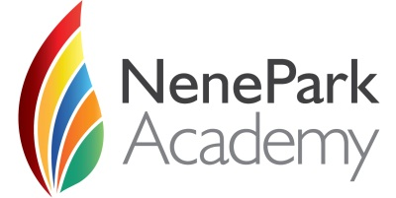
We are seeking to appoint a talented, dynamic and hardworking mathematics teacher to join our thriving department. The successful candidates will have excellent subject knowledge, be confident teaching KS3, KS4 and KS5. They should be an ambitious and dedicated professional who is able to work as part of a team. A willingness to promote extra-curricular activities and support learning outside the classroom will also be required.
Nene Park Academy opened in September 2011 and this is an exciting opportunity to join a dynamic, vibrant and rapidly improving academy. In September 2013 the academy moved into its new building with state-of-the-art facilities throughout with additional facilities added in 2018. If you want to work with wonderful students and committed staff, this is the Academy for you.
Nene Park Academy is proud to be part of the Cambridge Meridian Academies Trust along with North Cambridge Academy, Swavesey Village College, Stamford Welland Academy, West Town Primary Academy, Sawtry Village Academy, Ely College, Sawtry Junior Academy, Downham Feoffees primary, Bar Hill Primary and Lantern Primary school. This is an exciting time for the partnership. Having already made significant impact on progress and achievement, we are determined for the academy to be the school of first choice and a source of pride for its community
If you would like to discuss this opportunity, then please contact Sarah PAttison (Vice Principal) spattison@neneparkacademy.org
For any other queries, please contact Kellie Ward (Human Resources) kward@neneparkacademy.org
For application details visit ‘Current Vacancies’ within the ‘Contact Us’ section at www.neneparkacademy.org
The closing date for applications is Friday 21st February 2020.
Interviews will be held shortly after.
Nene Park Academy is rated as good in all school areas (Ofsted 2018).
Nene Park Academy, Oundle Road, Peterborough, PE2 7EA
The Academy is committed to safeguarding and promoting the welfare of children and young people and expects all staff and volunteers to share in this commitment. All staff will be subject to an enhanced check with the Disclosure and Barring Service.

