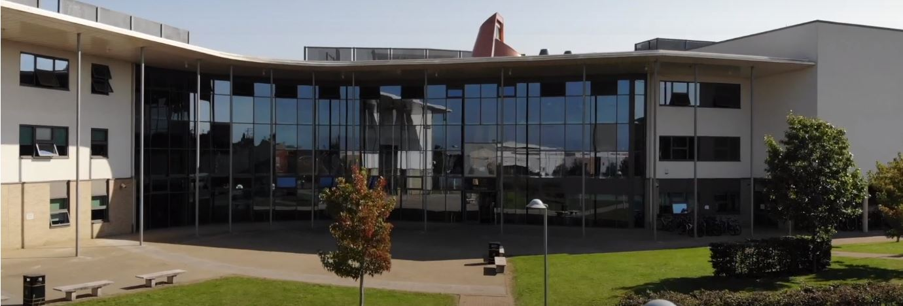
Application Pack
Assistant Head of Science
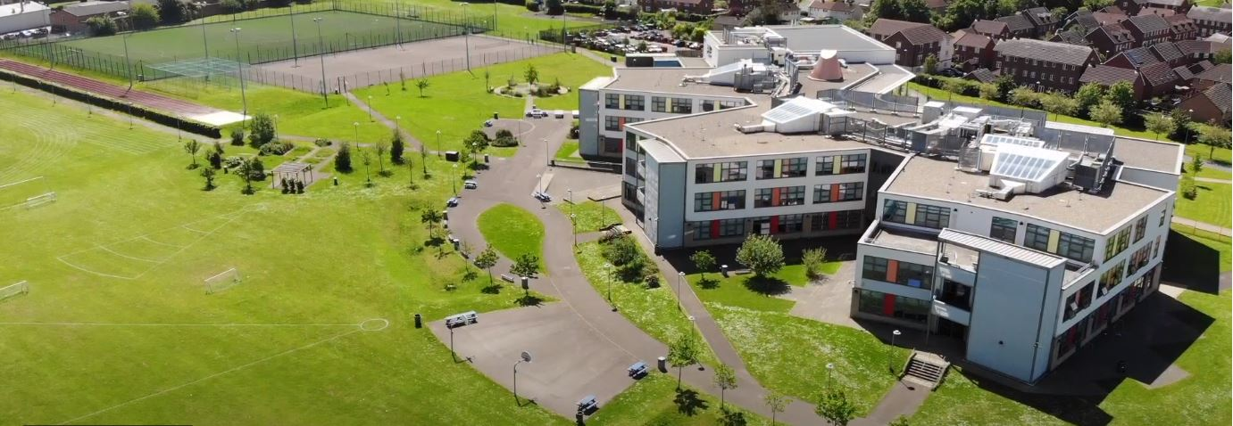
Where every member of our extended family realise their God-given potential, inspired by John 10:10. Jesus said ‘I have come so you may have life in all its fullness’.
2014 2018

www.asachelt.org

All Saints’ Academy, Cheltenham, Gloucestershire.
Principal: Mr Dermot McNiffe

Assistant Head of Science
Start date: April 2022 or before if possible
Salary: Academy Main/ Upper Scale Points 1-12/ Upper 1-3 (£25,714 - £41,604 per annum) plus TLR 2a £2,873 per annum
Hours of work: Full Time
Contract: Permanent
Closing date: 9am Monday 13th December

We wish to appoint an outstanding Assistant Head of Department to work within our Science Faculty to ensure the achievement of excellent outcomes for our students in Science.
The appointed candidate will work closely with the Head of Faculty to ensure that the academic delivery of the science subjects is of a high standard ensuring a rich curriculum experience for our students to achieve excellent progress.

All Saints’ Academy is one of the best GCSE performing non-selective secondary schools in the Cheltenham and Tewkesbury area, and it has been for a number of years now.

Following another Good judgement, Ofsted reported:

• All Saints’ Academy is an inclusive school.
• Leaders and directors have been successful in improving pupils’ life chances by ensuring that they have achieved well in recent years.
• Staff hold fast to the school’s values and ethos, which unite them in their drive to improve standards.
• There is a clear determination to support pupils and their families to overcome barriers.
Ofsted 2018

Sponsored by the Anglican Diocese of Gloucester, we are an Academy serving at the heart of our local community. All Saints’ Academy has a Life Vision, ‘Where every member of our extended family realise their God-given potential, inspired by John 10:10. Jesus said 'I have come so you may have life in all its fullness'.

We are an inclusive Church Academy who welcomes applications from all denominations and those of none.

What we offer:
- The Academy is in an attractive new building, within easy access to Cheltenham, Tewkesbury and the M5 with onsite parking and catering facilities
- Entry into the Teachers’ Pension scheme
- Free access to the onsite gym facility
- Access to our Employee Assistance Scheme
- Excellent CPD opportunities for career progression

The Academy is committed to safeguarding and promoting the welfare of children and young people, and expects all staff and volunteers to share this commitment. Successful applicants will be subject to enhanced DBS clearance.

To apply for this role please send a covering letter and a completed Teaching Staff Application Form to Katie Jordan, HR Manager at hr@asachelt.org

Interviews maybe held remotely depending on government guidelines at the time of interview. Full details will be emailed to the shortlisted candidates.

All Saints’ Academy is committed to ensure that all applicants and employees are given equal opportunities and that no applicants or employees are discriminated against on the basis of gender, gender reassignment, race, disability, pregnancy or maternity, sexual orientation, marital or civil partnership status, age or religion and belief.

Job Description

Post Title: Assistant Head of Science

Salary: Academy Main/ Upper pay scale plus TLR 2a

This Academy is committed to safeguarding and promoting the welfare of children and young people and requires all staff to share this commitment

Core Purpose:

Work with the Head of Faculty and other staff to devise and implement a range of strategies that will lead to high quality teaching and raise attainment.

Take an active role to realise the vision for the Academy.

Deliver education, care and support that ensure the whole child is supported, achieves, develops and succeeds.

Proactively support the activities and nature of a Church Academy with its Christian distinctiveness.

Reporting To: Head of Faculty

Core Duties
Leadership
- Under the direction of the Head of Faculty, line-manage and hold accountable staff in the department.
- Provide creative and strategic leadership across the department in line with the aims, values and vision of the academy.
- Ensure that policies, practices, targets and teaching/learning methods are informed by relevant national, local and academy data, research and inspection evidence.
- Be responsible with the Head of Faculty for creating and maintaining an exciting, innovative subject curriculum that puts the learner at the heart.
- Contribute to the department development plan in line with the Academy vision and improvement plan.
- Liaise with the Head of Faculty and other teachers in relation to student progress.
- Ensure all individual student needs are recognised and met through the department provision.
- Leading, developing and managing the Science curriculum.
- With the Head of Faculty set challenging targets and ensures the progress and outcomes for all students in subject area.
- Monitor and evaluate the performance of all staff and students in the department and ensure appropriate intervention occurs as a result.
- Ensure that outstanding standards of behaviour are established and maintained in lessons and the department.
- Ensure that there is a safe working and learning environment in which risks are properly assessed.
- Working with the Head of Faculty to establish and maintain self-evaluation and quality assurance procedures including:
- Interpreting and acting upon student performance/prior attainment data
- Work scrutiny
- Lesson observations and learning walks
- Moderating pupil standards of achievement and behaviour checking that all teachers of Science are planning lessons, assessing students work and setting homework in line with expectations and Academy polices.

Set high expectations which inspire, motivate and challenge students
- Establish a safe and stimulating environment for students, rooted in mutual respect
- Set goals that stretch and challenge students of all backgrounds, abilities and dispositions
- Demonstrate consistently the positive attitudes, values and behaviour which are expected of students

Promote good progress and outcomes by students
- Be accountable for students’ attainment, progress and outcomes
- Be aware of students’ capabilities and their prior knowledge, and plan teaching to build on these
- Guide students to reflect on the progress they have made and their emerging needs
- Demonstrate knowledge and understanding of how students learn and how this impacts on teaching
- Encourage students to take a responsible and conscientious attitude to their own work and study

Demonstrate good subject and curriculum knowledge
- Have a secure knowledge of the relevant subject(s) and curriculum areas, foster and maintain students’ interest in the subject, and address misunderstandings
- Demonstrate a critical understanding of developments in the subject and curriculum areas, and promote the value of scholarship

Plan and teach well-structured lessons
- Impart knowledge and develop understanding through effective use of lesson time
- Promote a love of learning and students’ intellectual curiosity
- Set homework and plan other out-of-class activities to consolidate and extend the knowledge and understanding students have acquired
- Reflect systematically on the effectiveness of lessons and approaches to teaching
- Contribute to the design and provision of an engaging curriculum within the relevant subject area

Adapt teaching to respond to the strengths and needs of all students
- Know when and how to differentiate appropriately, using approaches which enable students to be taught effectively
- Have a secure understanding of how a range of factors can inhibit students’ ability to learn, and how best to overcome these
- Demonstrate an awareness of the physical, social and intellectual development of children, and know how to adapt teaching to support students’ education at different stages of development.
- Have a clear understanding of the needs of all students, including those with special educational needs; those of high ability; those with English as an additional language; those with disabilities; and be able to use and evaluate distinctive teaching approaches to engage and support them.

Make accurate and productive use of assessment
- Know and understand how to assess the relevant subject and curriculum areas, including statutory assessment requirements
- Make use of formative and summative assessment to secure students’ progress
- Use relevant data to monitor progress, set targets, and plan subsequent lessons
- Give students regular feedback, both orally and through accurate marking, and encourage students to respond to the feedback

Manage behaviour effectively to ensure a good and safe learning environment
- Have clear rules and routines for behaviour in classrooms, and take responsibility for promoting good and courteous behaviour both in classrooms and around the Academy, in accordance with the Academy’s Ready to Learn Policy.
- Have high expectations of behaviour, and establish a framework for discipline with a range of strategies, using praise, sanctions and rewards consistently and fairly.
- Manage classes effectively, using approaches which are appropriate to students; needs in order to involve and motivate them
- Maintain good relationships with students, exercise appropriate authority, and act decisively when necessary

Fulfil wider professional responsibilities
- Make a positive contribution to the wider life and ethos of the Academy
- Develop effective professional relationships with colleagues, knowing how and when to draw on advice and specialist support
- Deploy support staff effectively
- Take responsibility for improving teaching through appropriate professional development, responding to advice and feedback from colleagues
- Communicate effectively with parents with regard to students’ achievements and well-being

PERSON SPECIFICATION

Assistant Head of Science

 | Essential | Desirable
Qualifications | - Graduate with good degree in a relevant subject.  - Qualified Teaching Status. | - Further professional qualifications in Science or relevant areas
Skills | - Excellent teaching skills.  - Ability to teach Science at GCSE and A-Level  - Ability to offer extra-curricular activities.  - Able to inspire, lead and support young people.  - Show initiative and approach challenges with a positive attitude.  - Able to use data effectively to assess prior attainment, track progress and set student targets. | - Ability to use technology as a learning and teaching tool and a motivator.  - Knowledge of examination specifications and requirements for Science.
General | - Flexible and enthusiastic attitude.  - Clear ability to relate to young people.  - A commitment to a positive culture of learning.  - Resilience to support and find ways to develop young people.  - Excellent communication skills.  - Experience of planning successful lessons.  - Clearly able to demonstrate the standards relevant to experience in teaching. | - Have ideas that you can turn into practice.  - Ability to work proactively in a team.  - Ability to self-review effectively and set appropriate performance targets.  - Willingness to organise and participate in school trips.  - Willingness to organise and participate in school productions and extracurricular activities

