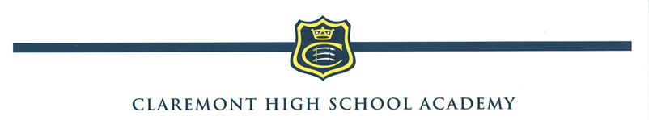

EXPECTATIONS OF A CLASSROOM TEACHER

- To teach to the syllabus prescribed by the Head of Department, using the scheme of work drawn up for the department and to prepare pupils for tests and examinations, using revision programmes, past examination papers etc. as appropriate.

- To plan and prepare work as appropriate.

- To maintain records of work covered for each set taught.

- To set prep on a regular basis, following the School’s prep timetable in the Lower School and according to the Head of Department’s guidelines in the Sixth Form.

- To mark pupils’ work regularly and to keep a record of each pupil’s marks in a mark book.

- To monitor pupils’ attendance at lessons and to follow up absences in writing with the appropriate Pupil Progress Manager.

- To provide a written report on each pupil at half term and at the end of each term (full reports).

- To keep classrooms, laboratories and equipment used in good order and to report any damage/faults, etc. to the appropriate person (usually the Head of Department).

- To contribute to the overall work of the department e.g. drawing up schemes of work, setting examination papers, participating in field trips or exchange visits. Covering classes for absent colleagues as direct by the Head of Department or Assistant Headteacher.

- In the case of absence, to notify the Head of Department and the Deputy Head and to set work for classes needing to be covered whenever possible.

- To attend all staff meetings called by the Head and parents’ meetings of all year groups taught.

- To keep abreast of developments in his/her subject area and to support the department’s contribution to the relevant targets of the School Development Plan by attending appropriate INSET and other courses.

