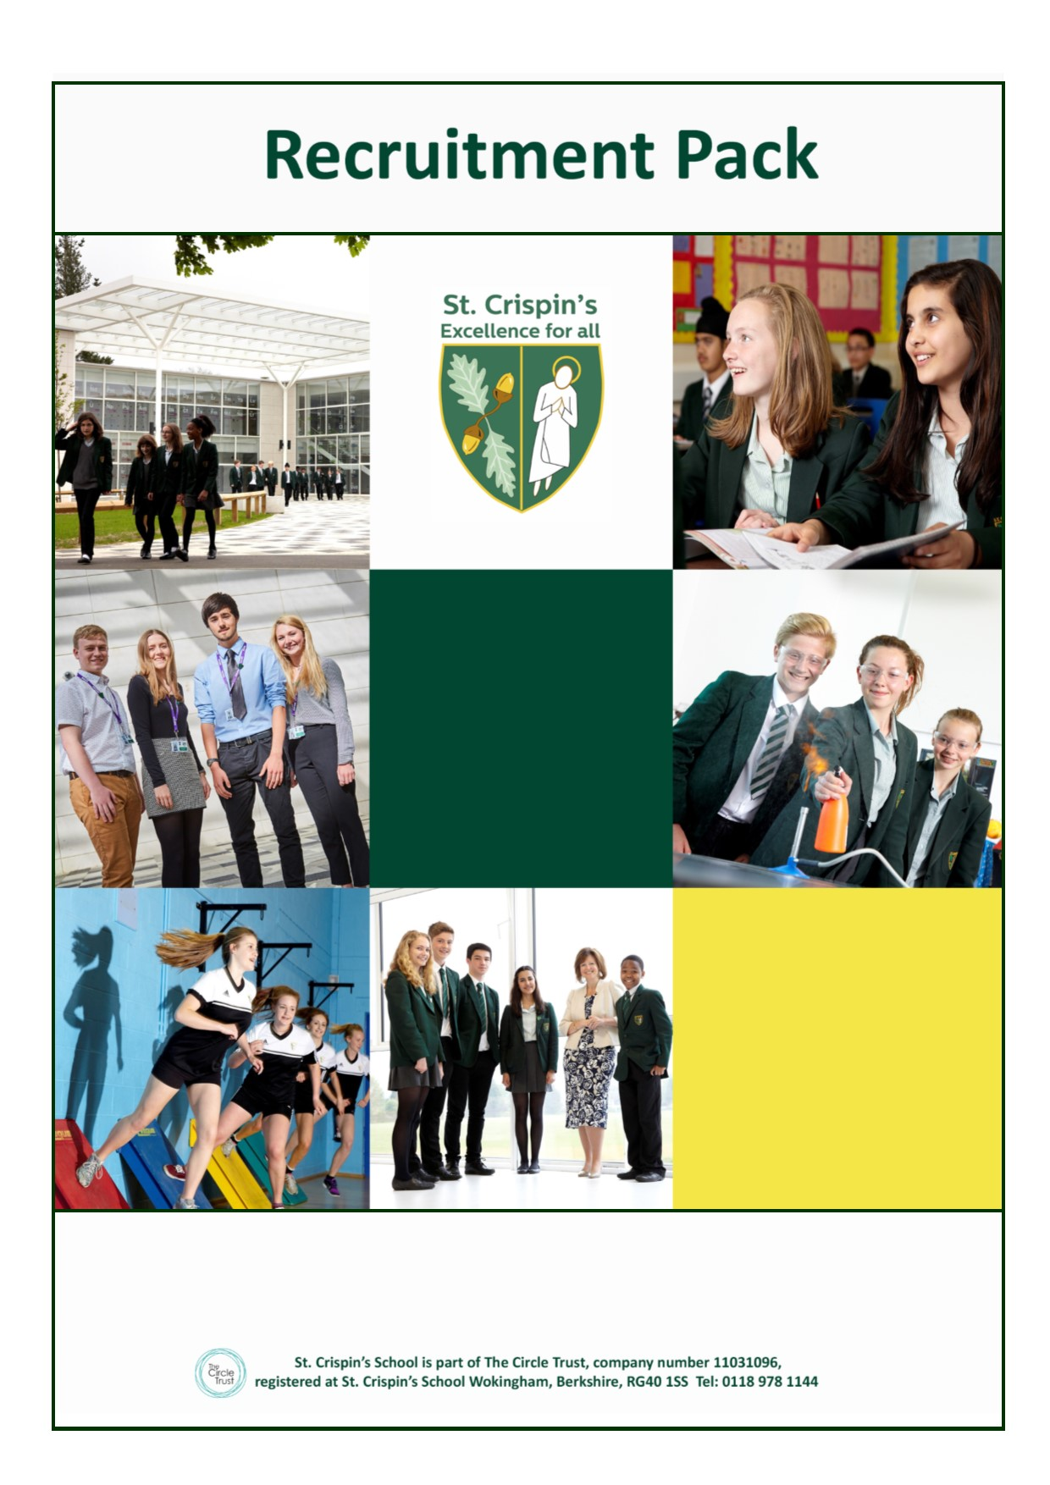
Teacher of Art and Photography
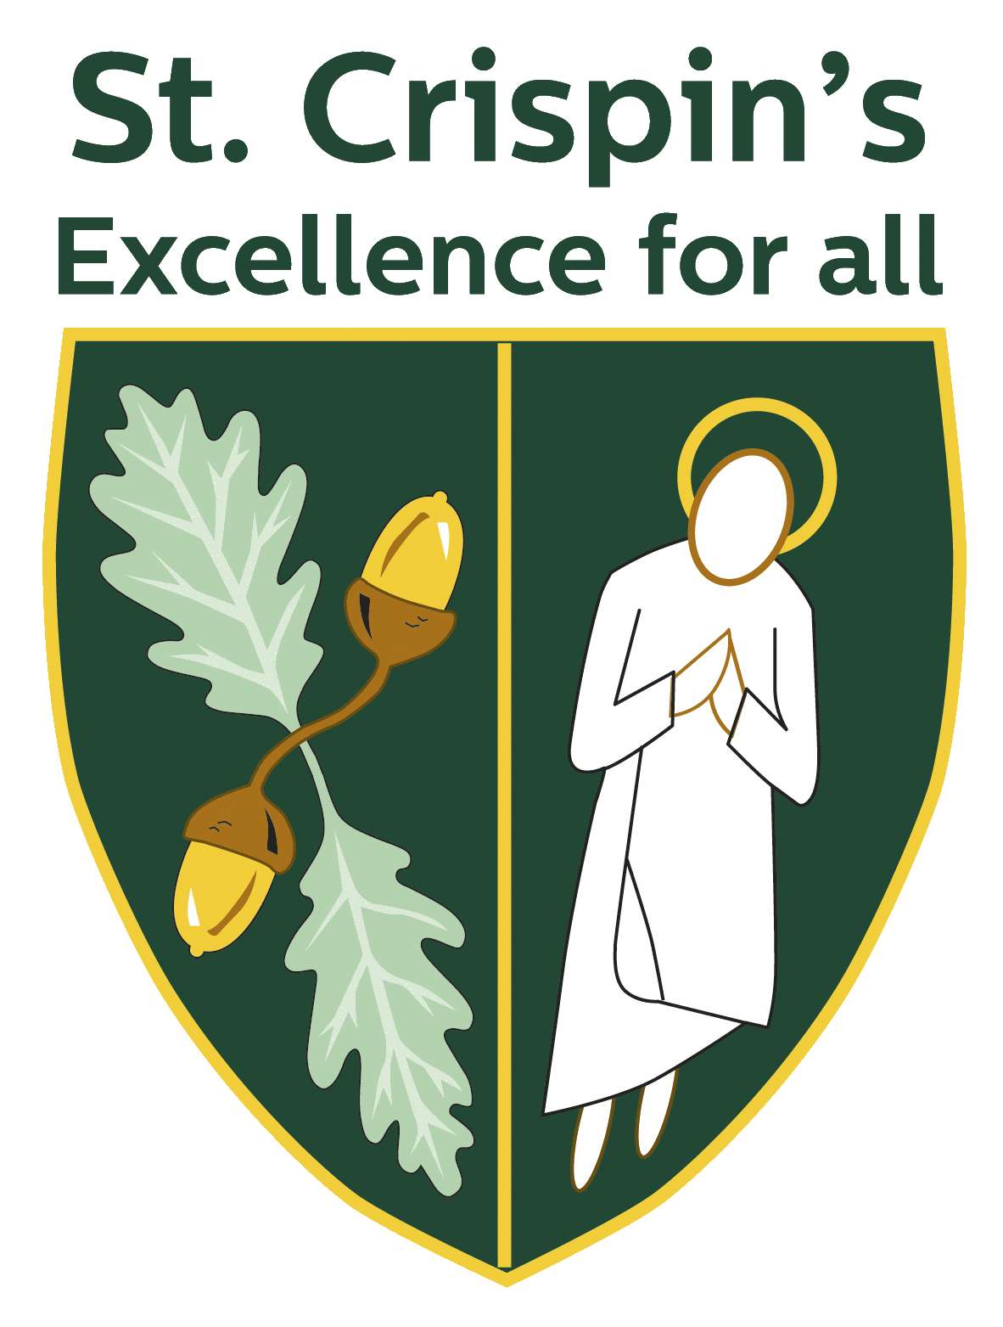
Teacher of Art and Photography

St Crispin’s School
Headteacher:
Ginny Rhodes
NOR 1174, 11-18
Mixed Comprehensive, London Road, Wokingham, Berkshire RG40 1SS
Tel: 0118 978 1144
www.crispins.co.uk

Teacher of Art and Photography
St. Crispin’s School – Wokingham, Berkshire
Permanent, full-time from 1.9.19
Main payscale

As a dedicated, ambitious teacher, you want to enjoy coming to work, be supported and valued.
At St. Crispin’s you will be part of a happy, friendly team. We are a high-attaining school with student behaviour that is described as exemplary (OFSTED 2017.)

This is a rare opportunity for an enthusiastic Art and Photography teacher to join our Art and Design Team.

Our ethos of “Excellence for All” encapsulates our commitment to do the very best for both students and staff. If you are looking for a vibrant learning environment with many opportunities to maximise your potential, be motivated and inspired, we would love to hear from you.

Visits to the school highly recommended!
Applications from new entrants to the profession welcomed.

To apply: TES QUICK APPLY or application form available at www.crispins.co.uk/vacancies.
Closing date: 9 am, Wednesday 24th April.– Please email your completed application form to Mel Knight, PA to Headteacher, at knightm@crispins.co.uk

For more information: Mel Knight on 0118 978 1144 or email: knightm@crispins.co.uk

This school is committed to safeguarding and promoting the welfare of children and young people and expects all staff and volunteers to share this commitment. Appointments are subject to enhanced CRB clearance and satisfactory employment references.

Job Description

Salary St Crispin’s main point scale (please refer to Pay Policy for detailed scale; this policy can be accessed via the school website.)

Aim and main purpose of the job:

Knowledge

- Demonstrate subject competence and to keep up-to-date his/her knowledge of the National Curriculum for 11-16 year olds in relation to their subject; and where relevant to the post, other examination courses at KS4 and Post 16.
- To attend continuous professional development activities when required to update his/her knowledge of the National Curriculum, syllabus changes and national initiatives which impinge directly on teaching, pastoral or other responsibilities.
- To keep informed about the key priorities identified in the School Improvement Plan, associated department development plans and his/her responsibilities agreed upon within it.

Planning, Teaching and Classroom Management

- To teach across a range of abilities and ages commensurate with his/her experience and skills and as agreed in consultation with the Headteacher and Head of Department.
- To plan lessons in accordance with the agreed departmental scheme of work and in line with the departmental teaching and learning policy.
- To plan lessons carefully with specific learning objectives and with special regard to prior attainment data, gender and race, fluency in English, DSEN (including IEPs).
- Use a variety of teaching approaches that identify, build upon and develop pupil learning styles, and the ability to learn independently.
- To set clear targets for pupil improvement and monitor progress towards these.
- To work effectively with Learning Support Assistants to plan lessons and individual support for pupils with specific learning difficulties.
- To set appropriate homework in line with school and departmental policies.
- Establish and maintain good standards of pupil behaviour in the classroom by implementing consistently and fairly the School Behaviour Policy.

Monitoring, Assessment, Recording and Reporting
- To assess how well learning objectives have been achieved and use this assessment to improve aspects of teaching.
- To develop the expertise to be able to recognise the level at which a pupil is achieving, and make accurate and valid assessments using school and departmental policies and procedures.
- To mark work on a regular basis in line with school and departmental policies and guidelines.
- To make careful records of attendance and pupil progress following carefully the departmental guidelines; mark books and pupil work should be available for scrutiny as required from time to time.
- To liaise effectively with pupils’ parents/carers through informative oral and written reports on pupils’ progress and achievements according to the school’s assessment and reporting schedule.
- To discuss with parents/carers appropriate next steps in learning for their child, and encourage them to support their child’s learning.

Other Professional Responsibilities
- To undertake the role of form tutor, if required to do so, and follow the guidance given by the Head of Year in relation to carrying out this role.
- To undertake supervisory duties before school, at break or after school as required.
- To attend department, year and other school meetings as required.
- To contribute to the work of the department.
- To support colleagues in maintaining the school’s behaviour policy.
- To maintain appropriate standards of professional appearance and conduct.
- To raise issues of concern with his/her line manager or with the appropriate member of SLT.
- To maintain the Professional Standards for teachers.
- To follow the school performance management system.
- The post holder is responsible for ensuring that the school safeguarding/child protection policy is adhered to and concerns are raised in accordance with this policy.
- To carry out tasks as reasonably required by the Headteacher.

Details of Line Management
Teachers are line managed by Heads of Department (and Heads of Year in respect to their work as a tutor.)

Notes:
Whilst every effort has been made to explain the accountabilities of this post, each individual task undertaken may not be identified.

This job description is current, but following consultation with you, may be changed by the Headteacher to reflect or anticipate changes in the job, which are commensurate with the salary and job title.

Art and Design Department Information

Department description and information for candidates:
Thank you for your interest in this post. The Art and Design department was newly formed in September 2018 to bring together a fluidity of skills across Art, Photography, Product Design, Textiles and Food Technology. We are a vibrant department with a committed staff.

The ethos of the department is built creative thinking, sound research and critical analysis, high quality resolutions and the development of individual talent through skills acquisition. Students are challenged to improve their own individual standard and extension through independent study. Art and Photography students’ work is regularly selected for exhibition in local firms and community centres and we have a thriving robotics club. The team support each other and take an active involvement in all aspects of curriculum design. We encourage reflective practice and regularly share successes and support each other when challenges arise.

Curriculum overview
At KS3, students follow a balanced curriculum in full class sets for Art and Graphics (3 hours a fortnight) with smaller class sets for Food Technology, Product Design, and Textiles specialisms (2 hours a fortnight). The smaller technology classes are on a carrousel system. They cover a number of specialist areas, which provide a broad range of opportunities to develop both technical dexterity and life skills. Drawing is also regarded highly as a foundational skill and students are set regular objective drawing tasks and taught technical drawing to develop their capabilities as artists and designers.

At KS4, students follow Edexcel courses in Art and Design, Photography and Product Design and the Eduqas WJEC Level 1/2 Hospitality and Catering. There is a diversity of course structure to meet the needs of the exam specifications and students are encouraged to develop independent working practices to maximise their attainment.

At KS5 students can follow AQA endorsements in Fine Art, Graphic communications, Three Dimensional Design and Photography. The courses are tailored to each cohort and there is access to high quality materials and photographic equipment to support effective learning. There is a permanent sixth form studio with allocated studio spaces for A’ Level Art, Graphic communications and Three Dimensional Design students to enable independent study.

Resources and rooming
The department consists of 11 classrooms / workshops (with specialist facilities available such as a well-equipped photography studio and darkroom, sixth form studio spaces, technology workshops to facilitate work in wood, textiles, systems, CAD and Food Technology, suites of computers dedicated to departmental use and a kiln for ceramics).

Extracurricular Art
Casual clubs and support sessions for exam classes run at the discretion of the staff.

Janet Barkat
Head of Art and Design

Policy Statement
St Crispin’s School is an Academy school within The Circle Trust. As part of your application to join us, we will gather and use information relating to you. Information that we hold in relation to individuals is known as their “personal data”. This will include data that we obtain from you directly and data about you that we obtain from other people and organisations. We might also need to continue to hold an individual’s personal data for a period of time after the recruitment process, even if you are unsuccessful. Anything that we do with an individual’s personal data is known as “processing”.
This document sets out what personal data we will gather and hold about individuals who apply for a position with us, why we process that data, who we share this information with, and your rights in relation to your personal data processed by us.
What information do we process during your application process?
We may collect, hold, share and otherwise use the following information about you during your application process.
Up to and including shortlisting stage:
- your name and contact details (i.e. address, home and mobile phone numbers, email address);

- details of your qualifications, training, experience, duties, employment history (including job titles, salary, relevant dates and working hours), details of driving licence (if relevant for role), membership of professional bodies and interests;

- your racial or ethnic origin, sex and sexual orientation, religious or similar beliefs;

- information regarding your criminal record;

- details of your referees;

- whether you are related to any member of our workforce; and

- details of any support or assistance you may need to assist you at the interview because of a disability.

Following shortlisting stage, and prior to making a final decision

- information about your previous academic and/or employment history, including details of any conduct, grievance or performance issues, appraisals, time and attendance, from references obtained about you from previous employers and/or education providers;*

  - confirmation of your academic and professional qualifications (including seeing a copy of certificates);*

  - information via the DBS process, regarding your criminal record, in criminal records certificates (CRCs) and enhanced criminal records certificates (ECRCs), whether you are barred from working in regulated activity;*

  - your nationality and immigration status and information from related documents, such as your passport or other identification and immigration information;*

  - medical check to indicate fitness to work;*

  - a copy of your driving licence (or other appropriate documentation as listed on the Home Office list);*

  - if you are a teacher, we will check the National College of Teaching and Leadership (“NCTL”) Teachers Services about your teacher status, whether you are subject to a prohibition from teaching order and any other relevant checks (for example Section 128 direction for management posts and EEA teacher sanctions);* and

  - equal opportunities’ monitoring data.

You are required (by law or in order to enter into your contract of employment) to provide the categories of information marked (*) above to us to enable us to verify your right to work and suitability for the position. Without providing us with this information, or if the information is not satisfactory, then we will not be able to proceed with any offer of employment.
If you are employed by us, the information we collect may be included on our Single Central Record. In this scenario, a further privacy notice in relation to data we collect, process, hold and share about you during your time with us, will be issued to you.
Where do we get information from about during your application process?
Depending on the position that you have applied for, we may collect this information from you, your referees (details of whom you will have provided), your education provider, any relevant professional body, the Disclosure and Barring Service (DBS), NCTL and the Home Office, during the recruitment process.
Why do we use this information?
We will process your personal data during your application process for the purpose of complying with legal obligations, carrying out tasks, which are in the public interest, and taking steps with a view to entering into an employment contract with you. This includes:
- to assess your suitability for the role you are applying for;
- to take steps to enter into a contract with you;
- to check that you are eligible to work in the United Kingdom or that you are not prohibited from teaching; and
- so that we are able to monitor applications for posts in the Academy to ensure that we are fulfilling our obligations under the public sector equality duty under the Equality Act 2010.
How long will we hold information in relation to your application?
We will hold information relating to your application only for as long as necessary. If you are successful then how long we need to hold on to any information will depend on type of information. For further detail, please see our Retention and Destruction Policy.
If you are unsuccessful, we will hold your personal data only for six months, after which time it is securely deleted.
Who will we share information with about your application?
We will not share information gathered during your application process with third parties, other than professional advisors such as legal as HR advisors.
Rights in relation to your personal data
All individuals have the right to request access to personal data that we hold about them. To make a request for access to their personal data, individuals should contact:
Debra Briault. St Crispin’s School, London Road, Wokingham. RG40 1SS briaultd@crispins.co.uk
Please also refer to our Data Protection Policy for further details on making requests for access to personal data.
Individuals also have the right, in certain circumstances, to:
- Object to the processing of their personal data
- Have inaccurate or incomplete personal data about them rectified
- Restrict processing of their personal data
- Object to the making of decisions about them taken by automated means
- Have your data transferred to another organisation
- Claim compensation for damage caused by a breach of their data protection rights
If an individual wants to exercise any of these rights then they should contact
Debra Briault. St Crispin’s School, London Road, Wokingham. RG40 1SS briaultd@crispins.co.uk
The law does not oblige the school to comply with all requests. If the school does not intend to comply with the request then the individual will be notified of the reasons why in writing.
Concerns
If an individual has any concerns about how we are using their personal data then we ask that they contact our Data Protection Officer in the first instance. However, an individual can contact the Information Commissioner’s Office should they consider this to be necessary, at https://ico.org.uk/concerns/.
Contact
If you would like to discuss anything in this privacy notice, please contact The Circle Trust Data Protection Officer.
Mr A Hinchliff, c/o St Crispin’s School, London Road, Wokingham, Berkshire. RG40 1SF andy@thecircletrust.co.uk

