Welcome to Science
at All Hallows

We are a large, successful and friendly team. We aim to develop the scientific thinking of students, nurture their natural curiosities and encourage them to be brave enough to try out new ideas. The main focus of the teachers in our department is to plan and teach interesting and purposeful lessons which help our children achieve the best they can.
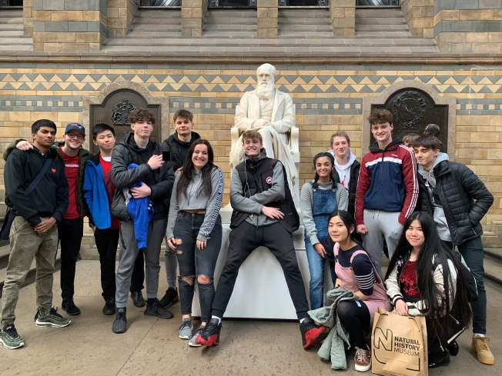
Our team currently consists of nine full time teachers and four part time teachers. We are supported by a team of four dedicated technicians and a link HLTA. We have eight full size teaching labs and two smaller labs in the main school, and two full size Sixth Form teaching labs.

At Key Stage 3, students have three science lessons per week in Years 7 and 8, increasing to 4 in Year 9. Each Science teacher teaches across all Science disciplines. At present, we follow the Pearson exploring Science scheme. This is fully resourced with both support and differentiated materials, an online textbook for all students and extensive opportunities for further multimedia activities.

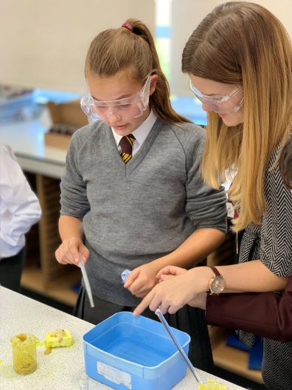
At Key stage 4, all students follow the AQA Science GCSE course. The majority are entered for Science:Trilogy. Around one quarter of the year group will study Triple Science. As in Key Stage 3, the course is fully resourced with a wealth of support material and an online textbook via Kerboodle. Staff teach subjects in which they have expertise wherever possible. The students have separate teachers for Biology, Chemistry, and Physics.

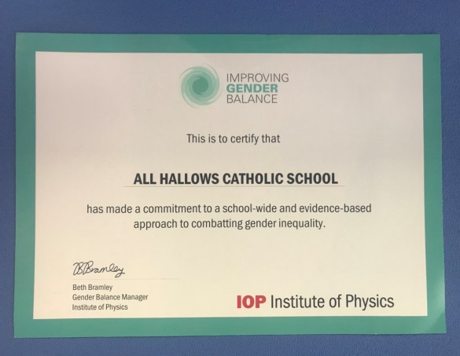
We have a long tradition of A-Level teaching in the department and offer A-Levels in the three Sciences and Psychology. Many students go onto to study science related degrees. The opportunity to teach across all three Key Stages will be available to any suitable candidates.

Outside of normal lessons, we offer a host of extracurricular opportunities for students. These range from Key Stage 3 Science Club to external competitions such as the Surrey SATRO Problem Solving Challenge. We organise trips for students to Winchester Science Centre, Marwell Zoo, CERN, the Natural History Museum in London and the Smithsonian Institute in Washington, DC. We also welcome visiting lecturers to the school, and students have the opportunity to attend Master Classes at institutions such as the University of Southampton and the University of Surrey. We have close links with the Institute of Physics who provide regular Inset for non-specialists, as well as hosting hub events with neighbouring schools.
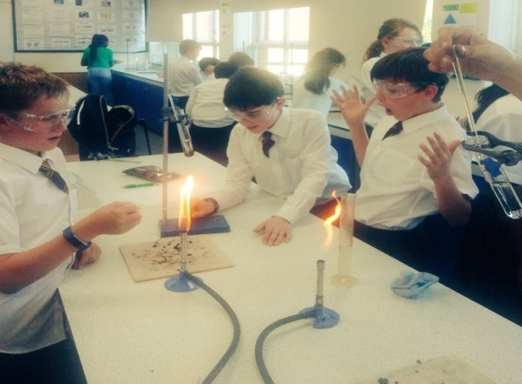
In recent years we have trained and supported teachers new to the profession. We are able to provide excellent training opportunities, which have led to rapid career development for some of our trainees. We are also keen to develop new ideas within the department and are always receptive to adopting ideas and techniques that have proved successful in other schools.

We would love to hear from any potential All Hallows teachers, and would encourage a visit to the department to see how we work together. Should you have any questions or queries, please do not hesitate to contact the school or via the Head of Science at s.spreadborough@allhallows.net.

