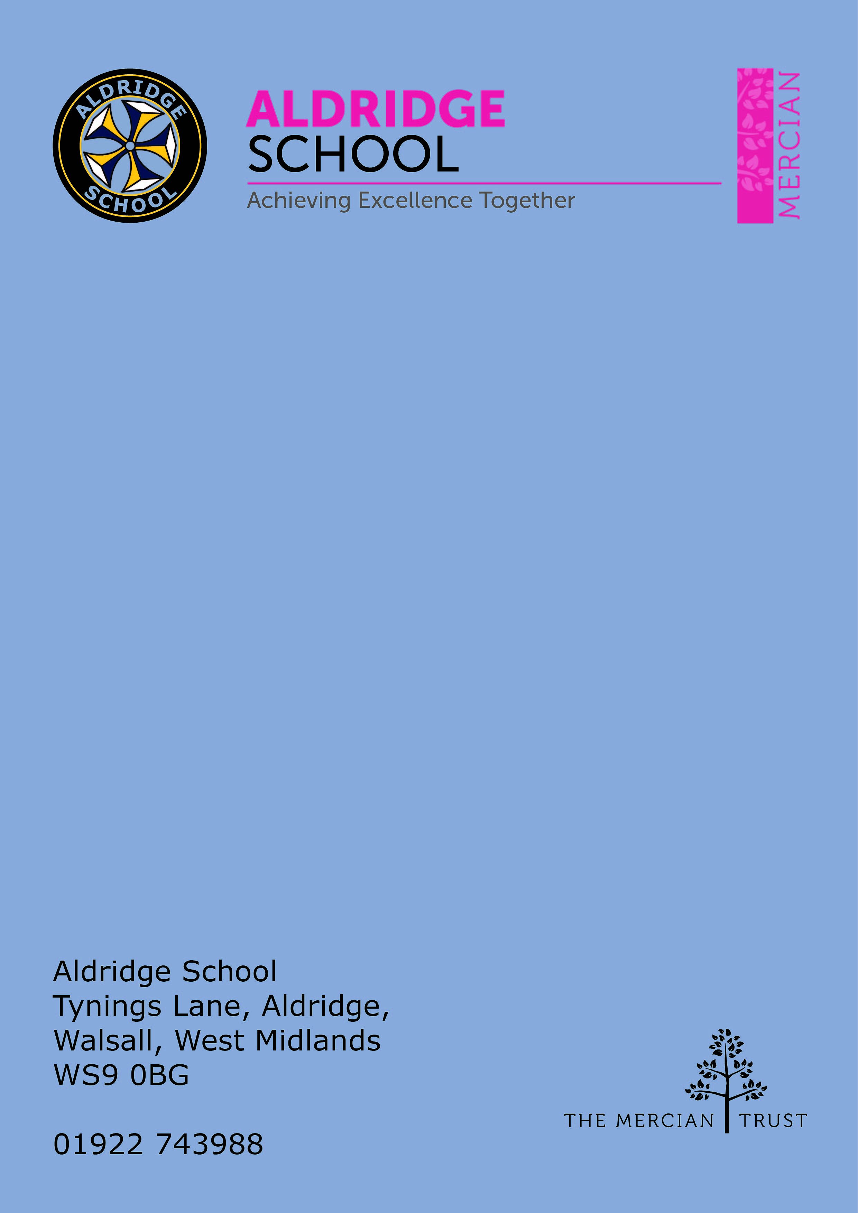

Application Pack

PLC Manager


About Aldridge School – a Founder Academy of the Mercian Trust

About The Mercian Trust

Person Specification
How to Apply

Job Description

About Aldridge School

Thank you for taking the time to find out more about Aldridge School. This pack is intended to give you information about this role and our school's broader vision and ethos. Further background information is available in our Prospectus and Sixth Form Prospectus on our website.

We are a comprehensive school of over 1500 students situated near the centre of Aldridge village. We believe that it is our responsibility to work to meet the needs of every individual student, challenging them to achieve their best, supporting them to become responsible young adults and preparing them for their next steps into the world of work or further education.

Aldridge School is a good school (Ofsted 2022). It is a school which is proud of its traditions and successes which have been achieved through hard work and high expectations. In particular, we encourage our students to be Respectful, Responsible, Resilient and Ready to learn in order that they will be happy and successful at school and in the wider world beyond.

Aldridge School has a dedicated, talented and conscientious team of staff who work together to provide a high standard of teaching, excellent pastoral care and professional support services. Our broad curriculum is designed to meet national expectations, be relevant and interesting, support our students in achieving the best possible standards in external examinations and to equip them with the skills they need to be successful in adult life.

At Aldridge School we have a popular and thriving Sixth Form. We are very proud of our students' success with over 80% securing places at some of the top Universities and on Higher Apprenticeships last year. We offer a very broad range of both academic and vocational courses at level 3, ensuring that Aldridge School Sixth Form is an option for a wide range of students.

We also enjoy strong links with surrounding primary schools, working with students in Years 5 and 6 including work in Science, Maths, English, Performing Arts and Enterprise. We are proud of our community and we work hard to promote this pride in all our partnerships, so that we can make sure that future students from these schools enjoy an easy, enjoyable transition to Aldridge School.

Students at Aldridge School are friendly, polite and respectful. Strong relationships between staff and students contribute significantly to ensuring that students are happy and feel safe.

If you would like to find out more, please contact us to arrange a visit to see our school at work. We look forward to meeting you.

Benefits of Working at Aldridge School

- Teachers are all provided with a laptop to support their teaching
- 21/25 periods of teaching per week maximum, less as an ECT
- No pressure to "put on a show" in lessons. A culture of typicality is reinforced by no lesson grading (outstanding, good etc.)
- No need to write lesson plans of any kind
- Everyone has the highest expectations of behaviour, with all staff reinforcing those expectations
- A clear system of sanctions which is applied consistently so staff don't have battles with students
- Senior Leadership are very visible
- Excellent pastoral support offered through House Offices
- CPD tailored specifically to staff needs, based off their feedback
- Time for staff to put new things into action
- Non-hierarchical approach to professional development - there are things a senior leader can learn from an NQT and vice versa
- Targeted support plans for teachers who are struggling
- Regular Staff, Faculty and Pastoral briefings to support good communication
- Comprehensive support for ECTs with dedicated mentors and regular meetings
- Performance Management is tailored to faculty and individual needs. Data targets are not used punitively but aspirationally. We begin from the assumption that everyone will get the pay rise unless they haven't done all they can to improve student outcomes
- We are constantly streamlining all systems and processes so they take less time
- Open door Senior Leadership Team - no concern is ever too small
- Countless opportunities to get involved with the wider life of the school - Duke of Edinburgh, school performances, sports teams, music
- Contributions of staff recognised through 'Above and Beyond' draws each half term


The Mercian Trust

Aldridge School is an academy in The Mercian Trust.

The Mercian Trust brings nine very different and individual schools together as a single Multi-Academy Trust or MAT.

The nine schools are unique in their identity and united by their ambition to offer the best possible future for their students.

The nine schools are:
- Aldridge School
- Queen Mary's Grammar School
- Queen Mary's High School
- Shire Oak Academy
- The Ladder School
- Walsall Studio School
- Q3 Academy Great Barr
- Q3 Academy Langley
- Q3 Academy Tipton

Each School has its own distinct ethos and approach, but we have this over-arching aim in common: we prepare all our students to enjoy life to the full by inspiring them to:

- Realise their potential as learners
- Thrive in the world of work
- Make a positive contribution to the local, national and international community

The Mercian Trust respects the autonomy of its member schools but, through collaboration, fosters strengths that are greater than the sum of its parts. Working together as a Multi Academy Trust provides a framework for sharing expertise and enthusiasm, resources and ideas.


Job Description

Post: PLC Manager
Responsible to: Assistant Headteacher for Alternative Provision and Safeguarding
Salary: MPS 1-6

The role would include joining the Teachers’ Pension Scheme

PURPOPSE:
To manage the onsite Personal Learning Centre, PLC, a small, detached classroom base for students who are struggling in the main school setting. The role would be student facing, delivering some aspects of the curriculum and leading a small team of HLTAs to support with the delivery of the curriculum to the students based in the PLC.

PRINCIPAL DUTIES AND RESPONSIBILITIES
- Assess students’ needs and plan an appropriate timed programme of intervention that may include lessons in the PLC, lessons in the main school and external provision off site
- Utilise the school based support systems we have, such as the school counsellor, the library, EBSA support, school mentors, Year Leaders etc
- Communicate with wider school staff about the students and their needs
- Influence the practice of other staff, by providing training and support for how to work with the students in the wider school
- Link with external agencies to review the quality of their provision, student attendance and engagement
- Promote the PLC as a whole school initiative across the school; informing staff, students, parents of what happens there
- Manage the PLC daily
- Teach as required within the PLC timetable
- Develop and maintain links with families and other agencies

ESSENTIAL/DESIRABLE QUALIFICATIONS
The successful candidate must have:
- QTS, no specialism is required, but the role will require you to be flexible and facilitate the work in subjects across the wider curriculum
It would be beneficial if the successful candidate could offer the following:
- Experience of teaching students with emotional, behavioural and social problems
- KS3 and KS4 experience
- Ability to drive the school mini bus
- Forest School trained
- Experience of working with the Prince’s Trust, Duke of Edinburgh Scheme, gateway qualifications such as NCFE/Btec
- Or a desire to train in any of the above


Person Specification

Qualification Criteria
- Qualified to degree level or above
- Possesses QTS status or equivalent

Experience
- Evidence of successful practice as a teacher in a secondary school or equivalent
- Experience of continually improving teaching practice to increase student achievement and progress
- Evidence of continually improving the teaching and learning of their subject through assisting with schemes of learning and extra-curricular/enrichment activities

Knowledge
- Understanding of the teaching strategies needed to establish high aspirations with regards to results and behaviour
- Evidence of working with educational research to facilitate learning
- Knowledge of the current legal requirements, national and school policies and guidance on the safeguarding and promotion of the well-being of children and young people

Leadership
- An ability to lead by example
- Effective team worker and leader
- Possesses high expectations for accountability and consistency
- Motivation to continually improve standards and inspire excellence
- Possesses an empathy and the ability to listen
- Commitment to the safeguarding and welfare of all students

Teaching and Learning
- Effective and adaptable ICT skills
- Numerate so that data analysis can be facilitated
- Effective communication skills
- Possesses energy, enthusiasm, resilience and perseverance
- A commitment to educational research in order to facilitate learning
- Excellent classroom teacher with the ability to reflect on lessons and continually improve their own practice
- Effective and systematic behaviour management, with clear boundaries, sanctions, praise and rewards
- Thinks strategically about classroom practice and tailoring lessons to student's needs
- Understands and interprets complex student data to drive lesson planning, achievement and progress
- Excellent planning and organisational skills
- The ability to produce correspondence/documents, appropriate for a specific audience and in well-written English, ensuring the tone is appropriate to the purpose


How to Apply

Salary
MPS 1-6

Closing Date
9.00 am Wednesday 12th July 2023

Start Date
September 2023

Visits to School
For further information, please contact the school either by email info@aldridgeschool.org or by telephoning on 01922 743988 ex 2224

Applying
Apply through TES application system.
