
JOB DESCRIPTION

JOB TITLE: 0.5 Work Experience Coordinator – Foundation Studies

CONTRACT: 18.5 hours per week, term time over 37 weeks per year

AREA: Foundation Studies – Based at Blossomfield Campus with visits to Stratford and Woodlands Campuses approximately once a month.

REPORTS TO: Work Experience Manager

GRADE / SALARY: Support Staff Scale 5, points 24 to 26, £26,537 to £28,086 pro rata Actual salary £11,016.37 to £11,659.41 per annum

POST NO SS409

CLOSING DATE: Wednesday 29th November 2023

DBS: Enhanced DBS check with children’s barred list check
______________________________________________________________________

PURPOSE:

To identify, secure, and monitor work experience opportunities for learners on full time programmes of study within Foundation Studies. To act as a liaison point between College staff, students and employers. In addition to assist in the administration of placements, ensuring that risk assessments are in place and audit requirements are met.

PRINCIPAL DUTIES:

- To establish and maintain links with relevant stakeholders and employers to provide suitable work experience and work related opportunities in a variety of settings for students on Study Programmes on all levels.

- To ensure that all referrals for work experience/ placements are followed up and students are matched to appropriate placements, (for example – where students self- source their own work experience, or there is a referral from the Employer Services Team or other College / curriculum leads).

- To ensure that relevant Health and Safety risk assessments are in place.

- To communicate effectively with personal tutors and Heads of School to ensure effective co-ordination and evaluation of work experience.

- To track that all students on programmes of study within the campus complete either an external work experience placement, or appropriate activity to develop their employability skills.

- To maintain records and documentation in accordance with internal and external auditing requirements.

- To support and promote Equality and Diversity to ensure equality of opportunity for all students, visitors and staff and the elimination of discriminatory practices.

- To adhere to policies, procedures and values of Solihull College & University Centre.

- To undertake all mandatory training in a timely manner as required e.g. Safeguarding, Prevent.

- To actively promote equality, diversity & inclusion and to champion anti-racist practice.

- To support the college to become a Sustainable Net Zero organisation by 2030 and support the delivery of it’s Sustainability Strategy.

- To undertake necessary Health and Safety responsibilities, duties and training as required by the post.

- To undertake necessary Data Protection responsibilities, duties and training as required by the post.

- To undertake other duties as may be required commensurate with the level and responsibility of the post.

EQUAL OPPORTUNITIES:

Solihull College & University Centre & University Centre is committed to a comprehensive policy of Equal Opportunities. All employees are required to abide by this policy and ensure its compliance throughout the College.

SAFEGUARDING:

Solihull College & University Centre & University Centre is committed to ensuring a safe environment for all students and expects all staff to engage fully with this commitment.

CORE VALUES:
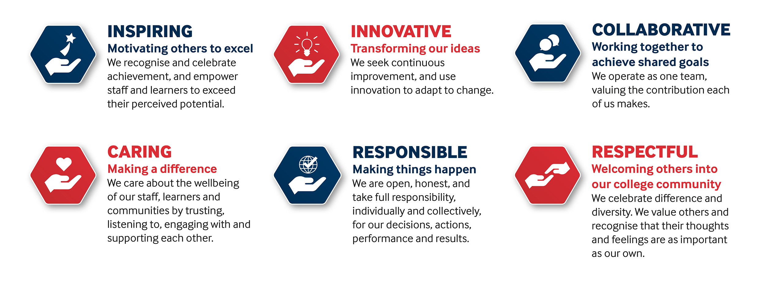

SOLIHULL COLLEGE & UNIVERSITY CENTRE

PERSON SPECIFICATION

JOB TITLE: 0.5 Work Experience Coordinator – Foundation Studies

SALARY: Support Staff Scale 5, points 24 to 26, £26,537 to £28,086 pro
rata, actual salary £11,016.37 to £11,659.41 per annum

POST NO: SS409

SPECIFICATION | ESSENTIAL | DESIRABLE
EDUCATION /  TRAINING | Level 3 qualification  Level 2 qualification in English and Maths | Degree or equivalent  IT qualification  Health and Safety qualification
RELEVANT  EXPERIENCE | Administrative experience  Experience of employer engagement | Experience of working in an educational setting
SKILLS /  APTITUDES | Proficient in the use of Microsoft Office  Ability to work with others  Ability to work under pressure and meet deadlines  Ability to prioritise and act on own initiative within tight timeframes  Effective communication and interpersonal skills  Strong IT skills  An awareness of sustainability and climate change and how it applies to Further Education | Knowledge of Health and Safety requirements in the workplace
OTHER  REQUIREMENTS | Ability to work flexibly to meet employer needs  Willing and able to work across all campuses  A commitment to the Safeguarding of Young People and Vulnerable Adults and an awareness of the Government ‘Prevent’ strategy.  Commitment to the College’s Values | General awareness of cultural diversity  Full Driving Licence

