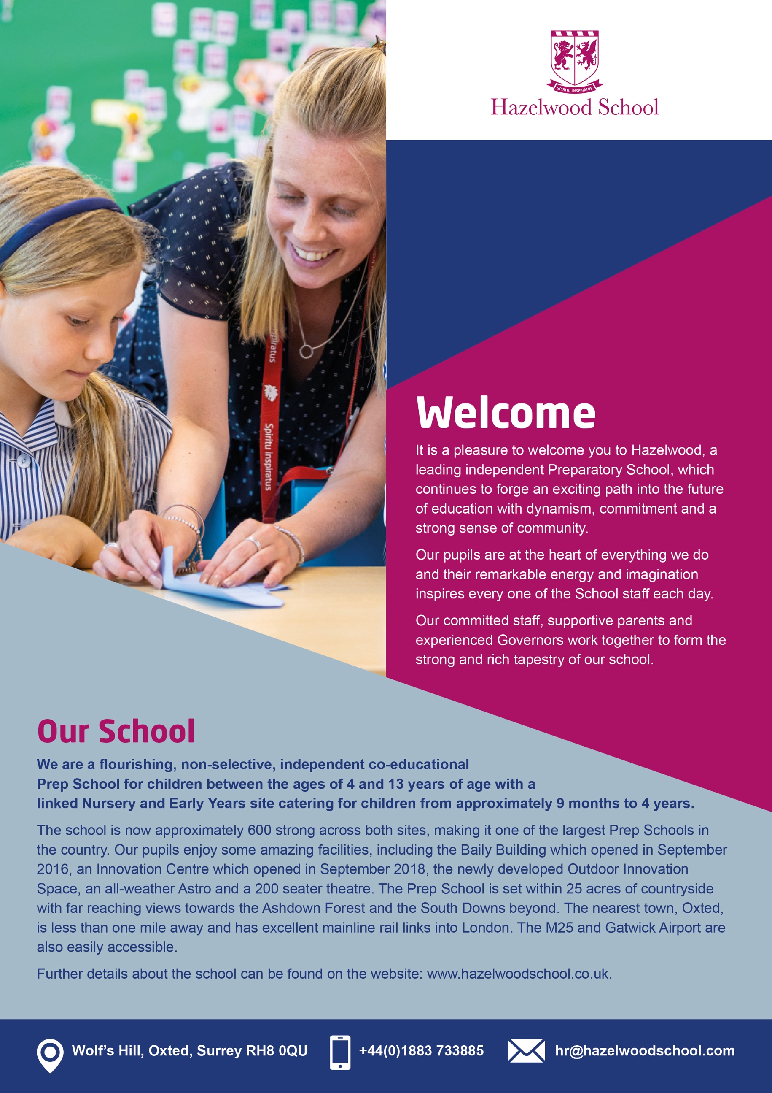

Teaching Assistant

Our Pupils  Our pupils have remarkable energy, imagination and consistently achieve incredible feats both inside the classroom and out. Academically, our pupils achieve excellent results across all key stages and secure senior school places at a vast range of schools, many pupils gaining highly competitive scholarships.  At Hazelwood, we have an unshakeable belief in the potential of every child. Whilst we play an important part in preparing our children for life, we place equal importance in them living in the present and enjoying the here and now; being part of this as educators is a privilege. We strive towards our pupils leaving Hazelwood being confident in who they are, honest about themselves, focused on what is important, resilient in all situations, able to care for and be sensitive to the needs of others and committed to their path and their community whilst retaining a sense of balance and humility.  It is an offence to apply for this role if you are barred from engaging in regulated activity relevant to children. |  |   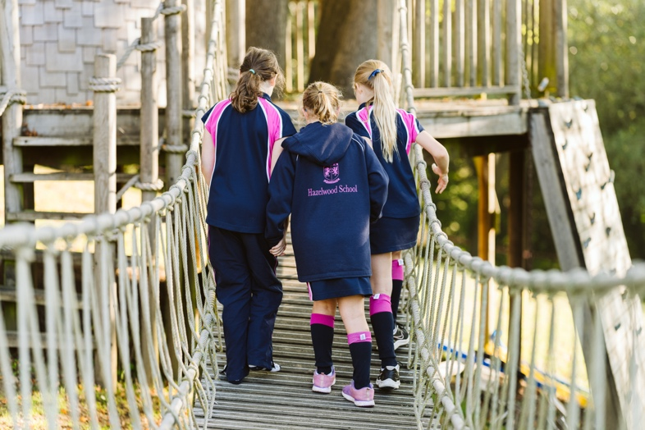

_{Employee Benefits}
Free lunch  Onsite parking  CPD  Pension  Use of staff gym |  | Swimming pool  Fees discount


Appointment of  Teaching Assistant  Hazelwood School are looking to employ a highly motivated, passionate and proactive Teaching Assistant for Year 2.  This is a crucial role where you will have a direct and enduring impact on every child you work with. Qualifications and experience are desirable, but not essential. You will have excellent communication skills, a willingness to learn and the desire to be part of a high performing team.  Supporting the children’s learning and assisting the teaching staff, sometimes working on your own initiative, you will be required to bring energy and patience to the role. You will also support the children with their educational, physical and social development.  This is a term time post working 32 hours per week Monday, Tuesday, Wednesday and Friday from 8am to 1:30pm and Thursdays from 8am to 6:00pm |  | 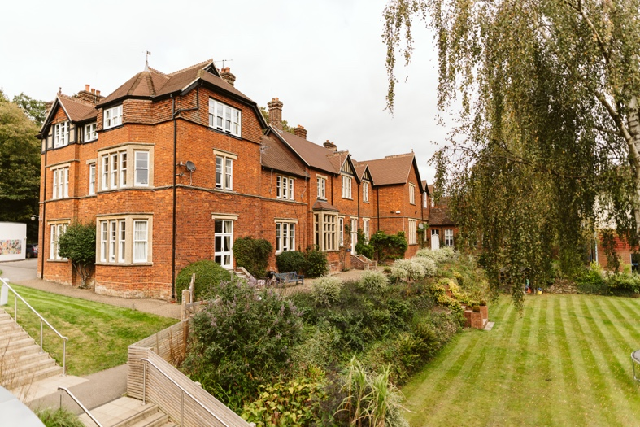  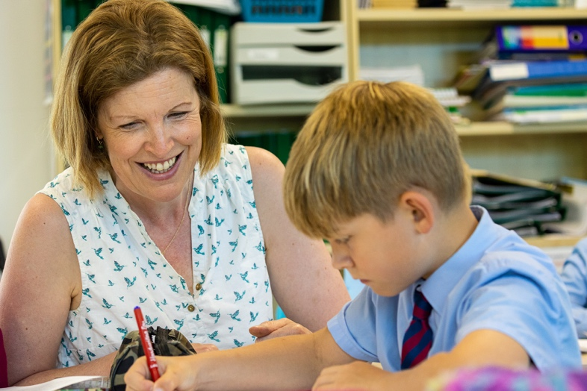  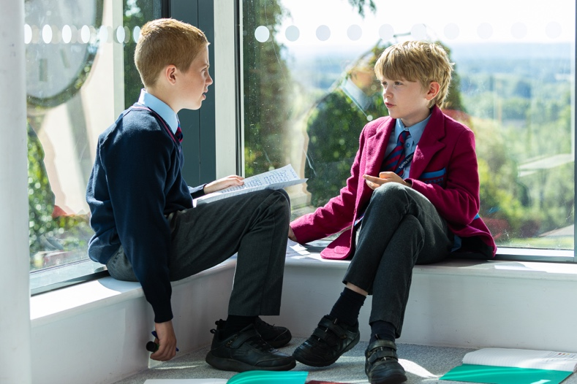

Main responsibilities

Responsibilities will include but are not limited to.

Academic and pastoral care

- To aid pupils to learn as effectively as possible both in group situations and on their own by, for example:
- Supporting and assisting the teaching staff with the educational, physical and social needs of the children.
- Being actively involved in the whole planning cycle and contributing towards reviews of pupils’ progress as appropriate.
- Assisting the teacher in providing a full range of stimulating activities for the children as part of their physical, intellectual, emotional and social development.
- Motivating and encouraging the children as required by providing levels of individual attention, reassurance and help with tasks as appropriate to their needs
- Using praise, commentary and assistance to encourage the pupil to concentrate and stay on task
- Liaising with the SENCO and other professionals as required
- Consistently and effectively implementing agreed behaviour management strategies
- To supervise a whole class during the short term absence of the teacher
- To look after the welfare of the children by.
- Attending to their health, welfare and safety at all times, including when in external play areas, toileting and cleaning incontinent or sick children.
- Dressing minor wounds, dealing with their health requirements as necessary, subject to training and instruction provided.
- To support and implement the agreed aims of the school.
- To be aware of confidential issues linked to home/pupil/teacher/school
- To comply with legal and organisational requirements for maintaining the health, safety and security of yourself and others in the learning environment
- To take part in training activities offered by the school to further knowledge.
- To support playground/break time supervision
- To accompany the teacher and child on educational visits.
- To assist in the upkeep of different areas of the school.

Professional Standards

Reporting to the Class Teacher, the Teaching Assistant will:

- Attend staff meetings and in-service training courses as required.
- Work flexibly as part of a team and to take shared responsibility for ensuring adult: child ratios are always maintained through regular staff rotas and over-time, when needed and agreed in advance.
- Keep completely confidential any information regarding the children, their families or other staff which is acquired as part of the job.
- Keep up to date with current good practice.
- Undertake any other reasonable duties as directed by the Class Teacher
- Ensure that they appear smart and professional (details of which will be provided at induction).

Communication lines

This role reports to the Class Teacher

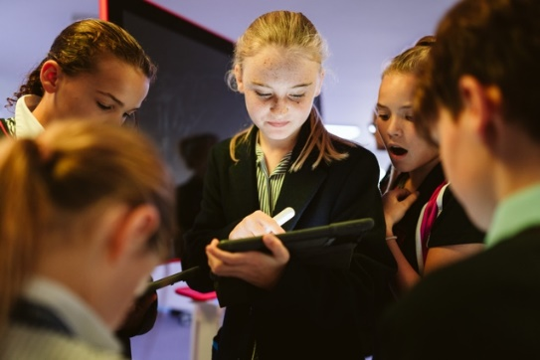  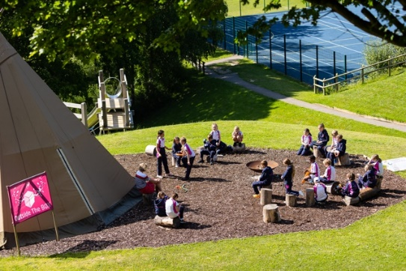 |  | 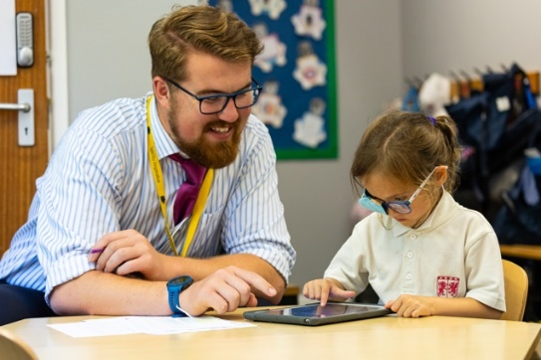  


Application Process

The school is committed to safeguarding and promoting the welfare of children and young people. Applicants must undergo child protection screening, including checks with past employers and the Disclosure and Barring Service.

Applications

Applications should be made via the TES website. The Hazelwood School page of the TES website can be found at www.tes.com/jobs/employer/hazelwood-school-1039690

Please ensure you fully complete all sections of the application form, including the Supporting Statement which should set out how your proven relevant experience relates to this role.

For safer recruitment purposes application forms need to be completed in full and CV’s will not be accepted.

References

References may be taken up before being shortlisted, please indicate on your application form if you have any objection to us contacting the referee prior to interview.

Safeguarding Duties and Responsibilities

The school is committed to safeguarding and promoting the welfare of children and young people and expects all staff and volunteers to share this commitment. The successful applicant will be expected to uphold this duty with regard to all children and young persons for who they are responsible and with whom they come into contact. This role is a teaching role involving extensive contact with and responsibility for children.

Dates

Closing Date: Tuesday 26th November 2024 at 23.59

Interview Date: to be confirmed

Interviews and appointment may be made prior to the closing date if a suitable candidate is found.

More information

For more information on the role, or to come and visit Hazelwood School prior to applying then please contact HR on recruitment@hazelwoodschool.com

Hazelwood School Competencies

Building Relationships

To foster and promote positive, trusting and professional relations within and beyond the school community.

Professionalism

Shows consideration and respect for others and embraces diversity within the Hazelwood community. Demonstrates excellent professional knowledge and passion for their job role whilst maintaining high expectations of themselves and others.

Communication

The ability and drive to share and receive information (both written and verbal), seek advice and liaise with the staff, children, parents and others within the Hazelwood community.

Planning and Organisation

The ability and desire to plan and organise effectively to meet the needs of all.

Adaptability and Flexibility

To demonstrate a willingness to be open to change, to be approachable and pro-active in all aspects of
your role.

Teamwork

The ability and desire to work cooperatively with others, recognising and supporting team members. Understanding that there are many varied teams within Hazelwood, involving students, staff, parents, Governors and Community constituents.

Big Picture Thinking

To be able to see the school as a whole and not just your department’s perspective. To contribute to the whole school vision by driving for the change and innovation it promotes, maintaining the highest of expectations from yourself and those around you.

Leadership

To influence and maximise the effort of others towards the achievement of our school vision and to translate this vision into reality.
