

**A message from the Executive Principal**

***Thank you for your interest in working with us, we can***

***promise you both a rewarding and exciting career.***

**New College Durham Academies Trust comprises of two large academies, Consett Academy and North Durham Academy, located some six miles apart in North West Durham. New College Durham, is our lead sponsor and both academies are located in multi million pound new builds, offering unrivalled state of the art facilities for our students and communities in Consett and Stanley.**

**Consett Academy** is a **successful,** **over-subscribed** school with 1408 students including 140 in the Sixth Form exclusively studying A’ levels.

**North Durham Academy** is a **rapidly improving** school, which aims to deliver excellent education from Yr7 to Yr13. *“Decisive action from the executive principal and other senior leaders has brought about urgent and necessary improvements in the quality of teaching.”* NDA Ofsted inspection, October 2018.

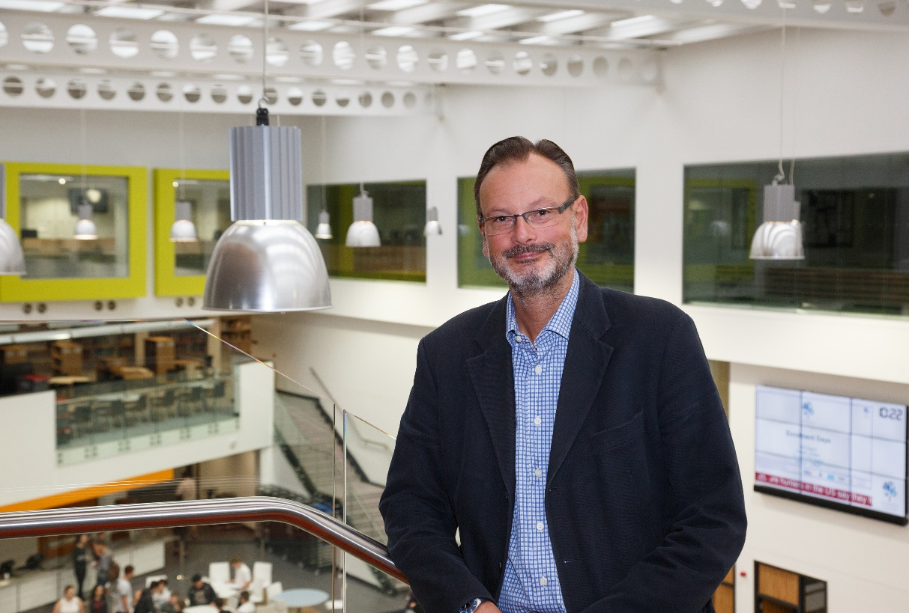Since March 2017, I have had the rare privilege of leading these two academies and over this period I have seen for myself the passion and commitment from the students, staff and parents; we are all focused on improving standards. We have a renewed aspiration to ensure all our young people achieve their potential regardless of their ability.

Our vision is simple ‘***Students First’*** based on the three core principles of **Inclusion, Progression** and **Excellence.** In all that we strive to do we never forget the core purpose of our business: to teach, nurture and encourage our young people to achieve their best. Students at both academies are extremely proud of their community and school and understand modern British Values and freely share their values with their peers in other countries.

This is a particularly exciting time to join us as we explore many different ways in which we can work in collaboration across the Trust, to drive improvement at both academies. Whilst the educational landscape is challenging, for the right individual this presents an unrivalled opportunity to make a real difference and a lasting contribution to our journey in becoming outstanding providers of education. We firmly believe in lifelong learning and can provide a bespoke CPD package to support your professional development.

The Trust is totally committed to supporting the improvement journey of its academies. *“Trust members demonstrate a strong understanding of the school and they are very clear about the strategic and operational role they play. They are acutely aware of how their responsibilities differ from the local governing body. This is because there is a clear scheme of delegation in place.”*

NDA Ofsted inspection, October 2018.

Both new builds are a forward thinking statement of a new vision for education in our area. With bespoke, innovative teaching and learning spaces which demonstrate a commitment to removing any barriers to learning – equipping them with the required skills through cutting-edge ICT for the job market of tomorrow.

We seek to recruit practitioners who have the potential to become outstanding and have a particularly good track record across both academies in our strong NQT programme.

If you share our vision and aspirations for the young people of Derwentside, we would be delighted to hear from you. Please feel free to come and see for yourself during the working day.

We look forward to receiving your application.



***Kevin Reynolds MA***

**Executive Principal**