Dear Applicant,

I am delighted that you are interested in applying for a position at Rhyddings Business and Enterprise School. I hope this and other information will enable you to make an informed decision about whether or not Rhyddings is the school for you. As part of this process, may I also suggest that you make an appointment to come and visit our school?

We draw our students from a variety of economic, social and ethnic backgrounds in the communities of Oswaldtwistle and Accrington. We are committed to the success of all students, the vast majority of whom consistently outperform predictions and expectations.

We were visited by Ofsted in June 2014 and were deemed ‘Good’ across all areas. They commented on: the strong relationships which exist; the positive respectful behaviour; the quality of preparation and teaching and the progress of our students.

At Rhyddings, we are committed to moving our staff forward through CPD and give them opportunities to contribute to and take an active role in school development. We encourage regular review and innovative risk taking within the curriculum. We also have well developed ITE and NQT partnerships which provide effective, ongoing training.

We have recently restructured staffing at the school to continue the well established principle of distributed leadership; this was done as a positive part of the process of moving the school back into a position of financial stability, which it now is. Despite austere times we have constantly worked to improve the learning environment for both students and staff. Notable recent work has involved completely new toilet facilities for everyone, major heating reconstruction and an imaginative update and redesign of the decor and displays throughout the school.

Although school specialisms are a thing of the past, we remain committed to ‘Enterprise’ and it is used to pursue our desire to work positively with our local primaries and wider community, further enhancing opportunities for all.

We value excellence in all aspects of school life having achieved recognition in ICT, Healthy Schools status, the Learning Excellence Award, and most recently, Arts Mark Gold status. The latter gained through our performance based ‘Evolve’ department and whole school embracing of the Arts.

At Rhyddings we recognise the importance of safeguarding and promoting the welfare of and opportunities for children. We expect all who work here to share this commitment and to be enthusiastic about young people and their futures. If you would like to help us ensure that all our students and staff are able to learn and celebrate success, I look forward to receiving an application from you.

Yours sincerely
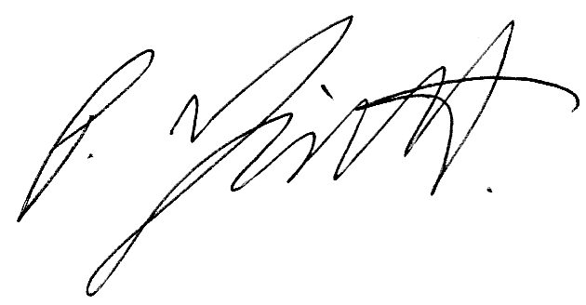
Paul Trickett
Headteacher

