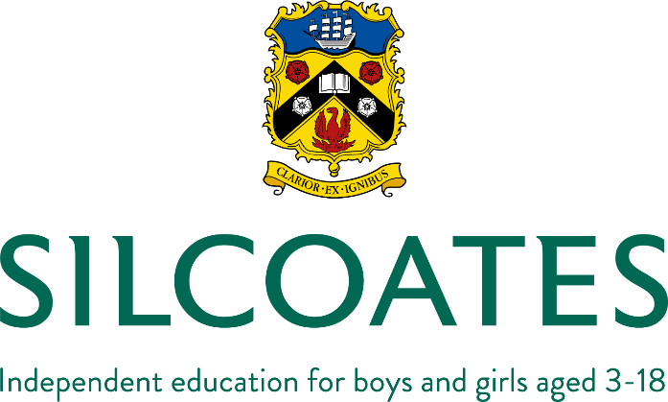

JOB DESCRIPTION

Job Title: | Academic Administrator | Reports to: | Deputy Head (Academic)
Date Last Reviewed: | March 2019

PURPOSE OF ROLE
- To provide support to the Deputy Head (Academic) to maintain the efficiency and effectiveness of the School’s academic provision.
- To work alongside the Data & Exams Manager and provide support where required.
- To assist the Heads of Department in developing their departmental areas and documentation.
- To have specific day-to-day responsibility, and a degree of autonomy, for the administration of the teaching cover rota, the School's Careers programme and the teaching staff’s Professional Development Programme, under the overall guidance of senior members of staff.

DUTIES
- To be a key member of the Academic teams within Silcoates and contribute to the efficiency and dynamism of the education we provide.
- To be responsible for the completion and distribution of the Senior School teaching staff’s cover rota.
- Under the overall guidance of the Deputy Head (Academic), to administer the Professional Development Programme from initial planning of the cycle to the collection of documentation and the timetabling of meetings with members of the SLT.
- Under the overall guidance of the Deputy Head (Pastoral) and the Assistant Head of Senior School, to administer the School's Careers programme. This will include the day-to-day provision of information for teachers and pupils to our 'standalone' events, such as the Careers Fair, 'A Day in the Life' and other one-off events.
- To assist the Heads of Department in preparing departmental documentation, such as departmental handbooks and annual performance reviews.
- To liaise with Heads of Department on their presentation of departments, such as the ensuring the high quality of display and equipment in departmental areas.
- At key 'pinch points' in the School calendar, to provide administrative support for the Data & Exams Manager and to deputise where necessary.
- Assist with the administration and co-ordination of internal and external examinations.
- Collate regular lesson observations, work scrutiny and annual performance review paperwork, provide reports on these and chase outstanding returns.
- Record requests for training, book training and assist the Deputy Head (Academic) in tracking the training budget
- Assist in the arranging of internal staff training days ('INSET days') as required.

PERSON SPECIFICATION
Essential

- GCSE Maths and English at grade C/4 or above [or equivalent]
- Experience in a high volume administrative environment
- Excellent administrative and organisational skills
- Experience of inputting data to a high level of accuracy
- Thorough working knowledge of Microsoft Word and Excel
- Strong written and verbal communication skills
- Confident and articulate communicator
- Strong analytical ability and attention to detail
- Ability to work on own initiative and be self-motivated
- Ability to maintain strict confidentiality
- Ability to adhere to deadlines and prioritise own workload
- Experience of working effectively and supportively within a team
- Willingness to work flexibly if and when required, to meet the needs of the school
- Willingness and ability to adapt to a wide range of duties [appropriate to this post] in response to changing circumstances and demands within school
- Compliance with policies and procedures relating to safeguarding, health and safety, confidentiality and data protection
- Committed to continuing personal and professional development

Desirable
- Experience of working in a busy school administration environment
- Experience of using SIMS, or other school management information system(s)
- Knowledge and/or experience of the public examinations system

OTHER REQUIREMENTS
- Full time (ideally 7.30am-3.30pm), term time only plus ten additional days.
- Flexible approach to working hours.
- To take part in CPD and appraisal.
- To undertake such other appropriate duties as may be deemed necessary by the Headmaster.
- You will be required to work a minimum of ten days per annum outside of school term time. These will be required to be the Wednesday and Thursday of each GCSE and A-Level results week and at least one day within October half term, in addition to the regular staff training days.

