CLASSTEACHER APPLICATION PACK

Recruiting for: January 2020, April 2020 or September 2020

THE VIRIDIS FEDERATION OF ORCHARD, SOUTHWOLD & HOXTON GARDEN PRIMARY SCHOOLS

Dear Applicant,
Thank you for your interest in the position of a class teacher at Viridis Schools. I hope that you will find this information pack helpful. If you would like to learn more about our schools partnership, we would be delighted to answer any questions you may have. Our contact details are in this pack and we can offer tours of all three school sites so you can meet our children and staff and see first-hand what we do. Our school websites also offer much information about our staff, curriculum and the way that we work.

Orchard, Southwold and Hoxton Garden Schools are in the vibrant and diverse community of Hackney, East London with easy transport links into and out of Central London. With a joint pupil roll of over 1300 pupils, we are a very successful organisation with a passion for making a difference. We provide a very rich and exciting curriculum and a no excuses culture for low standards. Because of this, our pupils achieve well above national averages regardless of their starting points and Ofsted have been full of praise about our provision.

Orchard & Southwold have been in partnership since January 2012 with Hoxton Garden joining us in April 2014. We have a joint Governing Body and strong links to our Local Authority. Each school has its own leadership team who work together with the common aim of giving children the very best. We have set an ambitious vision for the future and have very high standards for what can be achieved with the benefits of a shared expertise. We have a skilled team of highly committed and professional teachers and leaders. Staff from all three schools meet weekly to share ideas, with common systems and a shared curriculum. We take our role in raising the aspirations of our children and meeting the ambitions of our staff very seriously.
Contents
- Welcome!
- What are we looking for?
- What do we offer?
- How to apply
- Job description & person specification

As our school roll grows and staff move to promoted positions, we are looking to recruit class teachers in KS1, KS2 & Early Years who are looking to further develop their skills and talents. First and foremost, we are looking for practitioners who are confident, self-reflective and who have the energy and skill to make the difference that our children deserve. We have a commitment to developing expertise and a number of professional development programmes to suit teachers at different stages in their careers. We can offer the possibility of leadership roles for applicants with the right talents and experience. If you are hardworking, reflective, resilient and looking for a new challenge or somewhere to start your teaching career then we would love to hear from you.
Detmold Road London E5 9NL

Ivy Street
London N1 5JD
Holcroft Road London E9 7BB

recruitment@vs.hackney.sch.uk
Rachel Davie
Executive Headteacher

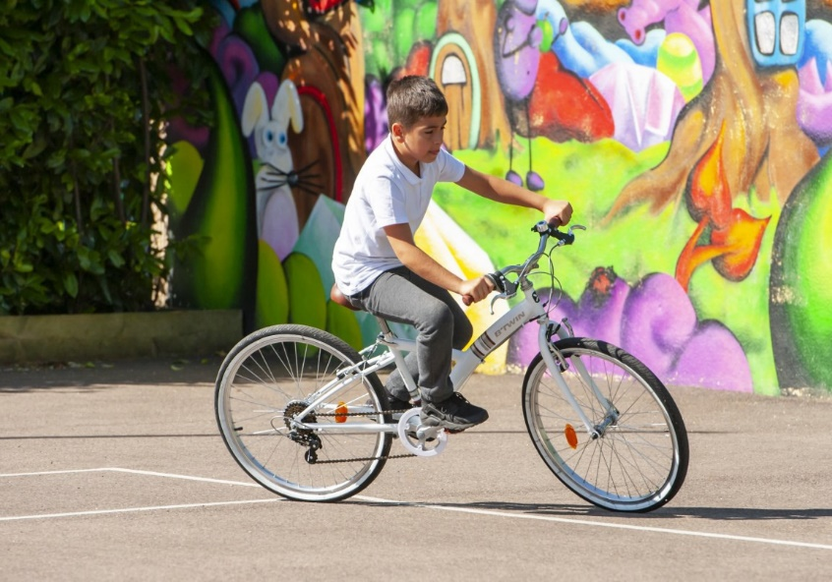
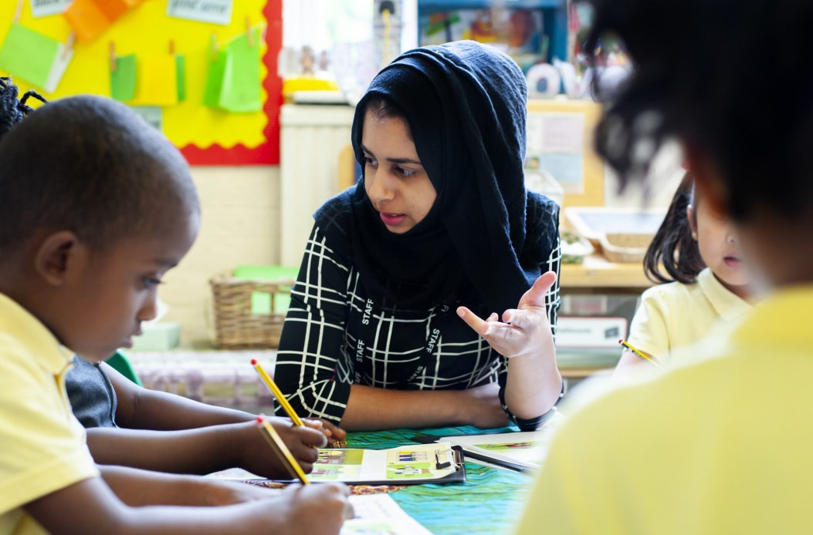

Why work with us?
.

- We are a professional, friendly and happy team of teachers and support staff

- We offer a dynamic and exciting environment with the chance to make a real difference

- We are an organisation that is keen to nurture and develop the expertise of its staff.

- We have children who are shown how to learn from the very start

- We serve communities that deserve the best.

- We offer opportunities for leadership and leadership development.
We are looking for teachers to join us who:

- Are self-reflective and seeking to be the best at their profession

- Have a professional outlook and thrive on challenge

- Have a passion for teaching and are ambitious for children and making a difference

- Genuinely enjoy the company of children and can see the fun as well as the serious side of teaching

- Enjoys working with other people and being part of a team

Our schools are committed to safeguarding and promoting the welfare of children and young people and expects all staff and volunteers to share this
commitment. We welcome applications from all sections of the community, regardless of gender, race, religion, disability, sexual orientation or age.

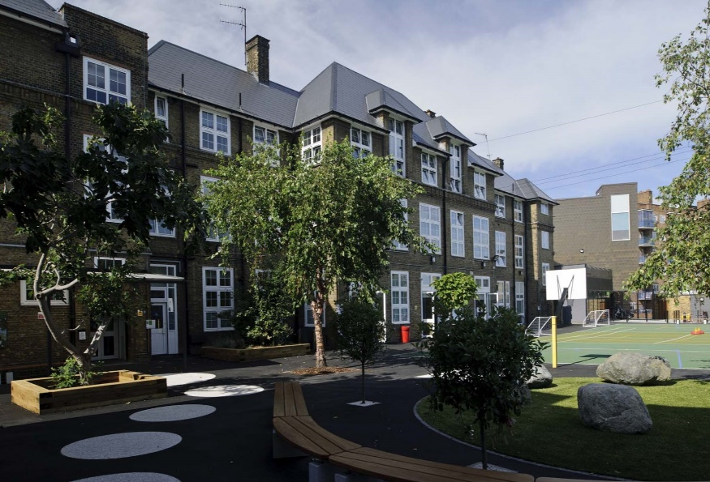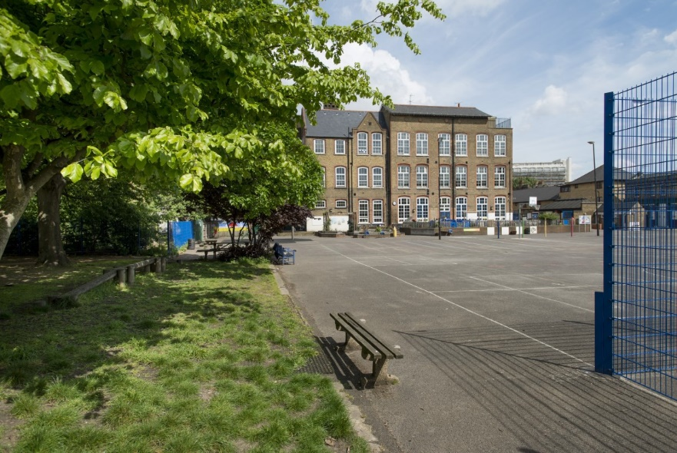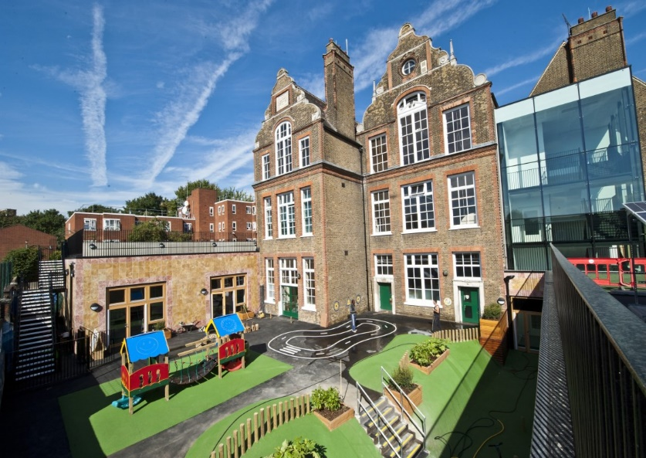

HOW TO APPLY
- Read the job description and person specification carefully.

- Complete the application form either electronically or print it off and hand write it.

- Ensure your supporting statement relates to the competencies outlined in the person specification.

- Email your competed application to Mrs Beverley Shore at
recruitment@vs.hackney.sch.uk
or send by post:
Recruitment
c/o Southwold Primary School Detmold Road
London E5 9NL

- Please make sure that your application form indicates the name & address of the school where you have most recently taught and the age group that you currently working (if applicable).

Interview Dates:
Week Beginning:
2nd December 2019
3rd February 2020
4th May 2020

Our Schools are committed to safeguarding and promoting the welfare of children and expects all staff to share this commitment. Our schools are committed to safeguarding and promoting the welfare of children and young people and expects all staff and volunteers to share this commitment. Successful candidates will be required to complete an enhanced DBS disclosure.

We welcome applications from all sections of the community, regardless of gender, race, religion, disability, sexual orientation or age. Should you have any queries or would like to arrange to visit our schools please contact Mrs Beverley Shore at Southwold on: 0208 806 5201 or email her: recruitment@vs.hackney.sch.uk
We look forward to receiving your application!

CLASS TEACHER JOB DESCRIPTION
Grade: MPS/UPS/LPS/ Full Time/Permanent

Main activities & responsibilities:
The current School Teachers’ Pay and Conditions document describes duties that are required to be undertaken by teachers in the course of their employment. In addition, certain particular duties are reasonably required to be exercised, and completed in a satisfactory manner. It is the contractual duty of the post holder to ensure that his/her professional duties are discharged effectively.

Essential Qualifications
- Educated to degree level
- Qualified teacher status

Experience
Will have had some experience of teaching in a multicultural inner city environment, ideally in more than one year group.

Particular Specific Responsibilities
- The post holder is responsible to their line manager for his/her duties, responsibilities and teaching tasks.
- The post holder will interact on a professional level with all colleagues establish and maintain good working relationships which will promote the development and effective delivery of the school curriculum and maximise children’s achievement.
- The post holder will be responsible for the supervision of the work of support staff and any students who may be on teaching practice or work placement.
- The post holder undertakes the teaching of the pupils in his/her class and the associated pastoral and administrative duties in respect of those pupils as well as the general responsibilities in the school as agreed with the Headteacher.

Other Responsibilities
In addition, to undertake such duties of a similar nature as may be reasonably directed by the Headteacher from time to time. The duties and responsibilities of the post may vary from time to time according to the changing needs of the school.

Person Specification
- To be flexible and versatile in attending to the needs and requirements of children.
- Excellent organisational skills, ability to meet time-related deadlines and ability to prioritise.
- Ability to work under pressure and on own initiative.
- Ability to develop interpersonal relationships with children and staff.
- Identify underperformance in pupils and take appropriate action to rectify.
- Supervision of children in an assertive but fair and reasonable manner.
- To be able to praise, encourage and develop potential of children to raise attainment.
- Teaching all pupils in your class according to their educational needs and acknowledging that every lesson counts.
- Creating a well-ordered and secure environment that will ensure the educational well-being of individual children within the group.
- Making effective use of ICT to enhance learning and teaching.
- Undertaking careful planning and delivery of the curriculum.
- Ensuring careful and ongoing assessment of the pupils learning to inform further planning.
- Ensuring that the curriculum is differentiated to mean that tasks and activities are matched to the ability of the children and henceforth allowing them to make progress at the right pace and level.
- Completing all assessments and records as determined by school policy in a timely fashion.
- Working with school leaders to track the progress of individual children and intervene where pupils are not making progress.
- Working with school leaders to complete and teach individual pupil plans where pupils have specific needs, (IEPs).
- Ensuring that equal opportunities are implemented in the classroom and throughout the school.
- Developing and maintaining positive relationship with parents, which involve them actively in the classroom and in the learning process.
- Participating in planning and staff meetings.
- Contributing to the whole school ethos by taking a leading role in display particularly in own classroom and designated whole school areas as agreed with the Headteacher.
- Contributing towards the development of the school and implementation of whole school policies.
- Contributing and co-operating with other staff and professional agencies as appropriate to the needs of the children.
- Undertaking in-service training for further development as a teacher.
- Undertaking other duties, which may be reasonably assigned by the Headteacher to ensure the smooth running of the school.

