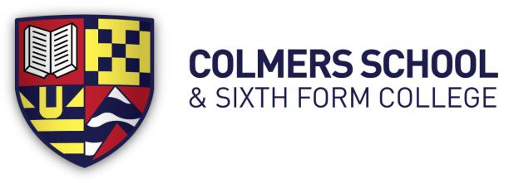
Bristol Road South, Rednal, Birmingham, B45 9NY
Headteacher: Ms E Leaman
Telephone: 0121 453 1778
11-19 Mixed Comprehensive School – 1145 on roll

TEACHER OF ICT / Digital Media
Mainscale
Required for: Easter 2020 or sooner

The Governors of this dynamic 11-19 school are seeking to appoint an enthusiastic and energetic Teacher of ICT and Digital Media. This post is suitable for an
experienced or newly qualified teacher. The successful candidate will join a collaborative team of highly committed teachers, on a mission to develop confident, curious and resilient learners.

Ideally, you will be a specialist in ICT and Digital Media who is also comfortable teaching Computer Science. We are looking for a colleague who understands the importance of digital literacy and is passionate about inspiring our students, equipping them with the knowledge, skills and understanding they need as 21st Century learners. We are currently expanding our ICT offer to students and there will be opportunities for you to influence and shape the way we take this important agenda forwards across our school.

You would be joining Colmers at an exciting time in our development as we embark
on a new-build project that will provide new, specialist ICT facilities from 2020.
This role will offer the successful candidate exciting challenges, which will be both
rewarding and fulfilling, supporting you to achieve your own personal career goals and aspirations.

Colmers School is committed to safeguarding and promoting the
welfare of children and young people and expects all staff to share this commitment.
An enhanced DBS check is required for all successful applicants

For further details and an application pack please see the school website www.colmers.school

Closing Date: Monday 27th January 2020 at 4pm

