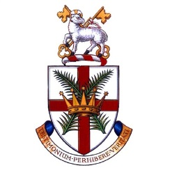
Welcome to the Religious Education

Department at All Hallows
The RE department is a large, highly valued, and high performing core subject at All Hallows. We are a popular department amongst the student body due our relentless focus on serving our students in the spirit of Christ.
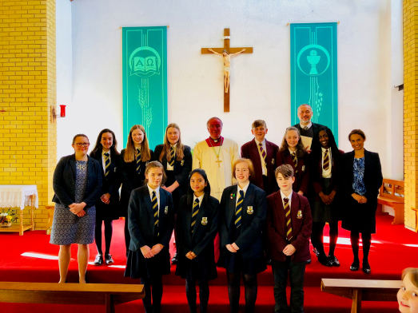
RE is taught across key stages 3-5. All students study GCSE AQA B Religious Studies which includes; Catholic Christianity & Islam. We also have two A level classes studying Philosophy, Ethics & Developments in Christian Thought. In addition, we teach an RE-Visit course to all Sixth Form students too. Every year a number of students go on to read Philosophy/Theology at Russell group universities.
As a department, we have a tradition of success (81% 9 - 4, 37% 9 – 7, 85 at 7 or above and 187 at 4 or above at GCSE in 2018 & 57% A*-B at A level) but we are constantly working on improving learning & teaching, by sharing out the planning of high quality & engaging lessons to suit the needs of our students.
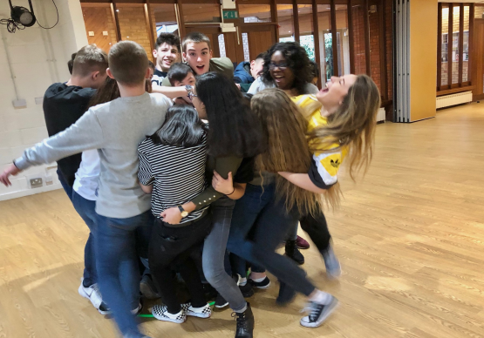
Our vision is simple…We want to be the best RE department in the country, period! We have high expectations of our students, but our students equally expect exciting and engaging lessons in return. In our Section 48 Inspection (2016) we were graded as ‘Outstanding’ & we continue to strive for more. If you too are looking to be a part of a team who go the extra mile to ensure this is the case, then we would love to hear from you!
We pride ourselves on not only delivering a rigorous & stimulating curriculum, but we also contribute to the wider life of the school through our Chaplaincy work. We are currently developing a Student Chaplaincy Team called ‘GIFT’ who support the spiritual life of the All Hallows community. We also run trips for KS3 & KS4 and are looking to plan our next cultural tour of Rome next academic year.
At All Hallows, we are privileged to serve wonderfully behaved students who are eager to learn and take ownership of their learning. All teachers are supported & actively encouraged to aim for promotion with the help of a strong & dynamic leadership team who provide lots of opportunities for professional development.
For more information or to arrange a visit, please do not hesitate to contact me via c.houghton@allhallows.net
Lotty Houghton-Neave (Head of Religious Education)

