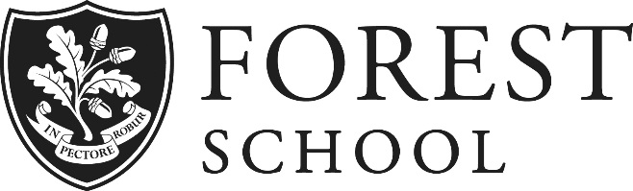
Human Resources Assistant
Full-Time/Fixed Term

THE ROLE

Forest School has recently moved to a centralised HR function and the Human Resources Assistant is regarded as a key part of the School’s continuing development of the HR Department. This vacancy offers the opportunity to be involved in a growing HR Department to develop a whole school HR strategy and to play a major role in this journey to drive the HR agenda throughout Forest. It is envisaged that the HR Assistant will form close working relationships with the School Leadership Team, especially the Deputy Warden and the Bursar. The post is for a fixed term of one year, after which there may be an opportunity for a permanent position in this department.

We want an enthusiastic, capable and confident person to provide a high quality administrative service and to manage the HR systems and processes under the oversight of the HR Director. The successful candidate must have honesty, integrity, excellent administration skills and will be a strong team player, capable of multi-tasking and able to work under pressure with minimal supervision.

KEY RESPONSIBILITIES

- Manage the entire recruitment process from job advertisement to successful onboarding of new starters. This includes drafting job adverts, liaising with TES and/or recruitment agencies, communicating with applicants, interviewing and drafting new hire documentation including contracts/agreements for staff, volunteers and consultants.
- Work with the HR Director and other team members to ensure best practice is followed through the development of secure, accurate and effective HR records. Tasks would include updating HR policies and employee databases/files with starter, leaver, absence, remuneration, performance, and job role information.
- Keep up to date with employment law by reading and attending seminars and assist the
HR Director and other team members to ensure compliance with legislation, guidance and good practice, Independent Schools Inspectorate (ISI) requirements and the School’s HR policies.
- Direct managers to the correct procedures to handle employee relations issues in accordance with School policies.
- Be accountable for the administration of HR information systems at Forest School, with a view to ensuring that data gathered is used to provide meaningful management information.
- Liaise with other departments as and when required e.g. payroll team for remuneration changes.
- Take a proactive role in developing Human Resources at Forest School – put forward ideas, develop tools, work closely with colleagues at all levels of the School.

PERSON SPECIFICATION

- Excellent organisational skills to work in a fast-paced environment where you have to think on your feet.
- Previous work experience as an HR Assistant or similar role, ideally within an educational setting.
- Educated to Degree level with appropriate CIPD qualifications and membership.
- Strong communicator with a friendly professional manner and superb business writing skills.
- Knowledge of HR best practice and complex policy drafting.
- Calm under pressure and a strong work ethic that respects confidentiality at all times.
- Excellent IT skills to carry out HR database and analytical work as well as formal letter/report writing (advanced user of MS-Office Excel and Word preferred).
- Ability to prioritise work and manage time effectively – you will be responsible for the HR Director’s mailbox and diary management.

SUMMARY OF KEY BENEFITS

Salary: Competitive and will depend on experience (more for an exceptional candidate)

Term: One Year post commencing September 2017

Normal Working Hours: 8am to 5pm, Monday to Friday (8.30-3.30 during School Holidays)

Holidays: 30 days (plus Bank Holidays)

Pension: Contributory Pension Scheme 11% Employer Contribution

Other benefits: All staff are entitled to a generous discount on School fees for qualifying children. There is a swimming pool, fitness suite and tennis courts on site that can be used by staff and a free lunch may be taken in the School dining hall. There is limited parking available on site. The School pays one half of the employee’s premium for Healthcare under their scheme. All staff are covered under the Schools Personal Accident policy both at home and abroad. Death in Service benefit is 2 x your annual salary.

