

**Health and Personal Care Assistant**

**Candidate Information Pack**

**2024-2025**

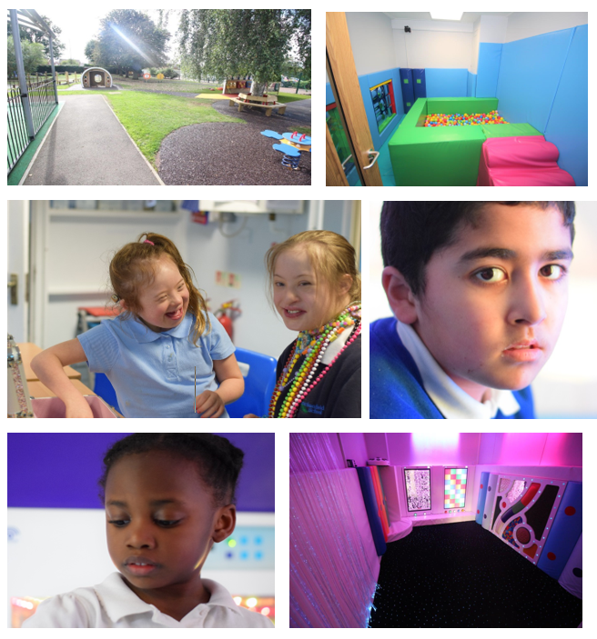**Contents**

Within this pack you will find both information and advice on applying for a role within Brackenfield SEND School.

* Welcome from the Headteacher & about Brackenfield SEND School
* Job Advertisement
* Job Description and Person Specification
* How to Apply
* Outline of Selection Process
* Safeguarding and Checks

headteacher

trish turner

Thank you for your interest in applying for the post here at Brackenfield SEND School. The school has expanded over the last 9 years from 62 pupils to 210 at this current time. Within this time our designation has also been changed from 4yr-16yrs to 3yrs-19yrs. We are now taking on the next phase of development as a school. We are opening a second premises on the same road as our existing site, where there is also have planned expansion work to add further capacity. This will support an additional 70 pupil places (including Post 16). Due to this, we are extending the current staffing structure including leadership. This is an exciting opportunity to join our passionate and experienced team.

As a school we meet the needs of children from our local community and surrounding areas, with complex learning, communication and physical needs. Pupils attend the school from Derbyshire, Derby City and Nottinghamshire, Nottingham City, Leicestershire and Rutland local authorities.

Brackenfield is an oversubscribed South Derbyshire special school for children from 3-19 years old. Over the last 9 years we have streamlined our offer to become a specialist school for pupils with severe and complex learning needs and we have a growing population of children with profound and multiple learning needs and disabilities. All our pupils are significantly cognitively impaired operating developmentally between 0 – 6 years of age. We support pupils’ learning and journey into adulthood through a curriculum based on life skills and skill generalisation. The school benefits from a dedicated Children’s Services Team which oversees safeguarding and family support, a Health Care Team, which support the medical and care needs of our pupils and a Therapies Team, including onsite Speech and Language Therapists (SALTs) and Occupational Therapists (OTs) which support with assessment and interventions. These teams work with our highly skilled teaching team to shape the provision around our young people.

Brackenfield was last inspected November 2024 by Ofsted in a graded inspection. Inspection findings showed that Brackenfield SEND school is Outstanding in all 5 areas of the Education Inspection Framework. Please read out latest Ofsted report <https://reports.ofsted.gov.uk/provider/25/113031>

Our vision is to support our pupils to reach their potential and become functionally and emotionally literate young adults. Through a curriculum with functional life skills at its core, we are developing our pupils to become young adults who can safely navigate and contribute to society- with independence appropriate to their needs. We are fully committed to the safeguarding of all pupils, this is embedded through all aspects of school life, with strong home-school links. We are committed to developing pupil voice to enable our students to make positive choices, share their opinions and preferences whilst demonstrating an understanding of British Values. We have strong belief and ethos of character education, which is used to support our pupils development a self-recognition of character, alongside providing a curriculum that is ambitious and designed to give our young people the knowledge, self-belief and cultural capital they need to succeed and be happy in life. Pupils leave Brackenfield being the best version of themselves. We work with pupils and families to ensure that pupils are happy, safe and reach their potential during their time with us.

The East Midlands SEND Training Hub is an integral part of Brackenfield Special School and has been created to support and formalise our outreach work to schools, (both mainstream and special). The hub provides and brokers high quality training and provides work experience and professional placements for education and health professional/students/graduates.

Job advert

health and personal care assistant

The Headteacher and Governors of Brackenfield School are seeking to appoint a Personal Health Care Assistants to support the personal, intimate, and health care needs of pupils across the school. This person will be part of the Children’s Services team and will work under the Health and Personal Care Manager.

Our pupils are aged between 3 to 16 and all have communication or cognition needs. Many pupils require support with independent life skills and have complex medical needs. The successful candidate will be someone who can follow systems and procedures to ensure the health, first aid and intimate care needs of pupils are met across the school. The successful candidate may have experience in medical or health care environments and working with vulnerable adults or young people. The successful applicant will also promote the school ethos through high levels of expectation, being an adaptable team player and able to work with little direction.

Visits to the school are welcomed. Please call the school on 0115 9733710 to arrange a visit.

Please see job specification and job description for full responsibilities. We would like to encourage applicants to come to look round the school and meet the staff and students.

Brackenfield School is committed to the safeguarding of all children. Due to this post having access to children and/or vulnerable adults, the successful candidate will be required to undertake a Disclosure and Barring Service check. The possession of a criminal record will not necessarily prevent an applicant from obtaining this post, as all cases are judged individually according to the nature of the role and information provided. Brackenfield SEND School is committed to promoting equality of opportunity, preventing unlawful discrimination in all of its activities and to valuing diversity.

|  |  |
| --- | --- |
| Weeks of employment per year | 39 (39th week is disaggregated CPD) |
| Hours per week | 30 hrs |
| Working day pattern | Monday to Friday |
| Start and finish times | 08:45am - 14:45pm |
| Grade | Derbyshire Pay Scales Grade 6 |
| Full time equivalent Salary | Grade 6 (£25,183) |
| Pro-rata salary | £17,484.24 |

If you would like more information please contact [HR@brackenfield.derbyshire.sch.uk](mailto:HR@brackenfield.derbyshire.sch.uk)

Job description

Health and Personal Care Assistant

|  |  |
| --- | --- |
| Level Purpose | To provide a practical support service |
| Typical Reporting Line | Health and Personal Care Manager |
| Typical Supervisory Responsibility | None |
| Setting | Maintained Special School |
| Generally  Representative  Accountabilities &  Responsibilities | Typical Tasks:   * Working in the school to support health, first aid and intimate care needs * Implement and deliver programmes to progress independent living skills * Deliver information to staff, parents and any other relevant parties |
| Typical Knowledge,  Skills & Experience | * Typically Level 2 qualification and practical knowledge and experience in relevant environment * Ability to employ practical, technical skills and experience. * Knowledge of school policies and procedures including, Safeguarding, Health & Safety, Management of Health Needs and Medication |
| Additional Work Elements | * May be physical effort in standing, lifting and carrying * May regularly work with children and young people who have behavioural issues * May have to physically intervene with children and young people who exhibit violent or aggressive behaviour |

person SPECIFICATION

**Experience**

|  |  |
| --- | --- |
| Relevant experience in meeting the personal care and health needs of people | Essential |
| Ability to follow policy and procedure | Essential |
| Experience of working with people with SEND | Desirable |

**Knowledge, Training & Qualifications**

|  |  |
| --- | --- |
| Level 2 Qualification | Essential |
| A criminal records check is required as part of the recruitment process | Essential |
| **Person Attributes** | |
| * Interpersonal skills * Ability to understand the SEND of a child and use this understanding to support effectively * Ability to work on own initiative with little day-to-day supervision * Organisation, prioritisation and time-management skills * A proactive approach to developing own knowledge and skill * Resilience and excellent attendance to work | |

how to apply

Please apply for this post via the Derbyshire Local Authority website: [Derbyshire - Jobs and careers](https://jobs.derbyshire.gov.uk/)

**Online applications**

There are a number of benefits for you from applying online which include:

The information you give us when you register on the job site, and before you apply for a job such as in the 'employment history' section, is automatically included in your online application, saving you time - you can update the information held in these sections whenever you need to.

You can part complete an application form, save it and come back to it, and work on it and submit it later or on another day - you can also print off a copy at home. Applying online gives you access to your application form, advert, and any other recruitment documents throughout the recruitment process, even after the job has closed.

You can track the progress of your application online, for example, to see if you have been shortlisted. You'll receive communications about the recruitment process more quickly, by email rather than letter, including any invitations to interview.You'll be able to view any communication as soon as it is sent to you by logging into your account.

You can search for specific types of jobs and then set up a job alert which will ensure you receive an email anytime a similar post is advertised

**Other ways to apply**

There are still ways to apply if you're unable to do so online. If you do apply offline, please provide your email address if you have one, as this will ensure we send you any communication by email so you receive it as quickly as possible. You can complete either a PDF or Word version of our online application form. These are attached to: [Ways to apply - Derbyshire County Council](https://www.derbyshire.gov.uk/working-for-us/jobs/ways-to-apply/ways-to-apply.aspx)

This form can be printed out, completed by you and then sent by post to:

HR Recruitment Services Team

Derbyshire County Council

County Hall

MATLOCK

Derbyshire

DE4 3AG

Or completed as a Word document and emailed to [jobs@derbyshire.gov.uk](mailto:jobs@derbyshire.gov.uk)

If applying by post or email please make sure that:

* the vacancy reference number is entered on the form
* we receive your application before the closing date

You can request an application pack by telephone.

You can also request an application pack by contacting Call Derbyshire tel: 01629 533190, quoting the reference number of the vacancy.

Please make sure there is enough time between you requesting an application pack and the closing date as it will take a minimum of 2 working days to receive your pack through the post.

Completed applications should be returned to:

HR Recruitment Services Team

Derbyshire County Council

County Hall

MATLOCK

Derbyshire

DE4 3AG

**Help to complete your application**

If you have any problems filling in either your registration or your application form, email [jobs@derbyshire.gov.uk](mailto:jobs@derbyshire.gov.uk)or tel: 01629 535118 and select option 1.

**Help if you're disabled**

We are a Disability Confident Employer. If you're disabled and looking for employment with us, we're keen to hear from you. If you meet the essential criteria for a job, we guarantee to give you an interview.

If you need advice or support with your application or need the recruitment documents in another format such as audio, Easy Read or braille, or wish to discuss related issues, please contact the Disability Employment Service email [disabilityemploymentservice@derbyshire.gov.uk](mailto:disabilityemploymentservice@derbyshire.gov.uk)

They offer general help with job searches, applications and reasonable adjustments.

selection process

brackenfield send school

**Shortlisting**

All shortlisting is completed by a panel; with at least one person holds safer recruitment training. Shortlisting is completed by RAG rating against the following criteria:

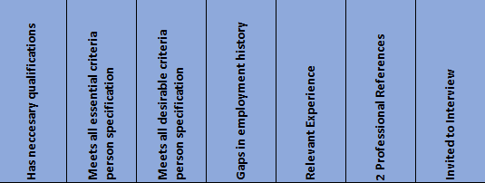

After shortlisting, successful applicants will be invited to interview. In the case of a large field of successful applicants there might be an informal discussion via Microsoft Teams before being bought forward to interview at the school. References will be requested prior to applicants being bought forward to interview.

**Interview Process**

The same panel members from shortlisting also take part in the interview day. This day may include:

* Tour of the School
* Pupil Panel
* Staff Panel
* In Tray Tasks
* Formal Interview
* Time in classes / Teaching (for Teaching and Learning based posts)

During the interview process each question is RAG rated by each panel member using the below RAG.

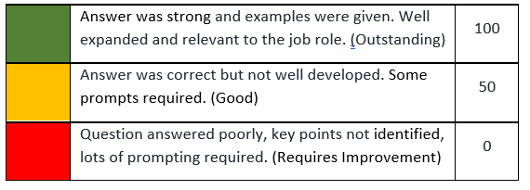

All elements of the day are taken into consideration as well as the application form and references prior to decisions being made.

safeguarding and checks

COMPULSORY checks for all applicants

Brackenfield SEND School and Derbyshire County Council are committed to safeguarding and promoting the welfare of all its pupils. We expect all staff, volunteers and agency staff to share this commitment.

**Digital Checks after shortlisting:**

As part of Brackenfield’s commitment to safeguarding pupils and the school, there will be pre-employment checks online, including:

Hr Admin to complete online searches Checklist:

* Google search of full name, maiden name/ previous name and name/, job title
* Google search on news tab of full name, maiden name/ previous name and name/, job title
* Use Brackenfield social media account to search Facebook, Instagram, Twitter, LinkedIn, YouTube, TikTok
* Screen shot evidence/ save hyperlinks, looking for: any relevant evidence which suggests that the individual may not be suitable to work with children should be identified. Relevant evidence may include offensive or inappropriate behaviour, jokes or language, discriminatory comments or inappropriate photos etc. Affiliation with certain online groups, or the responses to posts made by others may also indicate that the individual is unsuitable to work with children.
* Record date and time or search completed
* Findings will be reviewed by a Designated Safeguarding Lead
* Questions related to content will be added to interview questions to be queried with interviewee

The successful candidate will be required to undertake a Disclosure and Barring Service (DBS) check. The possession of a criminal record will not necessarily prevent an applicant from obtaining this post, as all cases are judged individually according to the nature of the role and information provided.

Brackenfield SEND School’s Safeguarding Policy applies to all adults, including volunteers and agency staff, working in or on behalf of the school. Each pupil’s welfare is of paramount importance. We recognise that some children may be especially vulnerable to abuse e.g. those with special educational needs and disabilities, those living in adverse circumstances. We recognise that children who are abused or neglected may find it difficult to develop a sense of self-worth and to view the world positively. We recognise that some children who have experienced abuse may harm others. We will always take a considered and sensitive approach in order that we can support all students within our academies.

The school pays full regard to the latest [DfE ‘Keeping Children Safe in Education’](https://www.gov.uk/government/publications/keeping-children-safe-in-education--2) guidance. We ensure that all appropriate measures are applied in relation to everyone who works for the school who is likely to be perceived by the students as a safe and trustworthy adult including volunteers and agency staff.

As part of our safer recruiting practises, we scrutinise applicants; verify their identity, academic or vocational qualifications, obtain professional and personal references, check full employment history and ensure the applicant’s health and physical capacity is suitable to undertake the role. Interviews and DBS checks are also undertaken. This post is exempt from the Rehabilitation of Offenders Act 1974 and therefore all convictions, cautions and bind-overs, including those regarded as “spent” must be declared.

If you are currently working with children, either paid or voluntary, your current employer will be asked about disciplinary offences, including those related to children or young people (whether disciplinary sanction is current or time-expired), and whether you have been the subject of any child protection allegations or concerns and, if so, the outcome of any investigation or disciplinary proceedings.

If you are not currently working with children, but have done in the past, that previous employer will be asked about these issues.

Where neither your current or previous employment has involved working with children or young people, your current employer will be asked about your suitability to work with children and young people, although it may be answered “not applicable”, where appropriate, if your work has not brought you in to contact with children or young people.