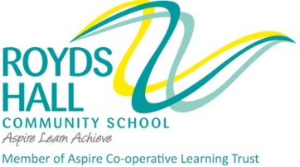
KIRKLEES METROPOLITAN COUNCIL

SERVICE- CHILDREN AND YOUNG PEOPLE

PERSONNEL SPECIFICATION

POST TITLE : Assistant Headteacher – Well-being ROYDS HALL COMMUNITY SCHOOL
ATTRIBUTES | ESSENTIAL | DESIRABLE | HOW IDENTIFIED
EDUCATION AND QUALIFICATIONS | - Qualified teacher status  - Evidence of appropriate  professional development | - Evidence of further studies | - Application form  - Interview
KNOWLEDGE AND UNDERSTANDING | - Familiarity with current national initiatives and developments in educational leadership  - Awareness of research regarding how and why learning takes place | - Experience of classroom based research | - Application form  - Interview
EXPERIENCE | - A proven track record in raising achievement within his/her own teaching  - A proven track record in monitoring and raising achievement across a faculty or whole school area.  - Experience of raising achievement through intervention in teaching process | - Experience of raising achievement through school specialism/ professional networks | - Application form  - Interview
 | ESSENTIAL | DESIRABLE | HOW IDENTIFIED
STRATEGIC DEVELOPMENT | - Experience of School Improvement planning  - Clear evidence of whole school impact through recent work | - Experience from a variety of settings | - Application form  - Interview
TEACHING AND LEARNING | - Experience of monitoring classroom performance across school  - Outstanding classroom practitioner  - Use of ICT to support learning | - 11-16 experience  - Experience of coaching others  - Recent training in evaluating teaching and learning | - Application form  - Interview
MOTIVATION AND PERSONALITY | - Commitment to a comprehensive and holistic education  - Sense of humour  - Sensitivity towards others  - Self-motivated  - Initiative  - Supportive of the ethos of Royds Hall Community School as a Co-operative Trust School and a Through-School | - Hobbies and interests  - Maintains a good work/life balance and a healthy lifestyle | - Interview

