

**SEN TEACHING ASSISTANT**

**Salary Single Status Grade 3 £18,065.00 pa pro rata**

30 hours per week – term time only

Permanent post

**INFORMATION FOR APPLICANTS**

**CONTENTS**

1. Letter from Headteacher
2. Job Description
3. Person Specification

April 2019

Dear Applicant

**SEN Teaching Assistant**

Thank you for your interest in this post. I hope that you find the enclosed information useful and that you are motivated to join our college at a very exciting time.

We are proud of our college. We have talented and highly motivated pupils and staff. Our staff team work tirelessly to ensure that teaching is the best it can be and everyone has a role to play in this. We support each other and there is an open, friendly and collegiate atmosphere within our staff team. We believe it is crucial that new members of the team are welcomed and supported.

Well behaved and hard working our pupils have achieved outstanding results year on year at our college. As a consequence of this we are:

* An Investors in People Gold Award School, which translates that we invest heavily and value the development of all our staff.
* An inclusive Church of England School with the benefits of links with The Diocese of Chichester and the opportunity to promote strong lasting values based on the Christian faith.

Understandably this letter and our website only gives a flavour of the college. We therefore encourage visits for prospective candidates to see our college in action. We do understand however that visits are not always possible or practical and you would not be at a disadvantage if you are unable to visit the college.

**The Post**

We are urgently looking to employ an experienced and enthusiastic Teaching Assistant committed to supporting pupils, to assist in promoting the learning of all pupils, including but not exclusively, those with special educational needs. The successful applicant will support individuals and groups of pupils in and out of class.

You will need to hold a Teaching Assistant qualification, have good communication skills and excellent literacy and numeracy skills (GCSE or equivalent, Grade C or above). You should have experience and understanding of SEN and the educational system and current developments.

The duties of the post will include: delivering tailored teaching activities to pupils; making sure the pupils you support are able to engage in learning and stay on task during the lesson or activity; listen to pupils read and read to pupils as a class; guide and monitor pupil progress; provide support during exams or school trips; coordinate specific areas of teaching support once you have the right level of experience.

We are especially interested in a Teaching Assistant with experience of delivering Speech and Language intervention.

**We offer you**

* Excellent career development opportunities



* A geographical location, being situated near Sovereign Harbour, Eastbourne’s award winning Marina. It is part of several miles of beautiful coastline, including the South Downs National Park, the white cliffs of Beachy Head and 1066 country
* A friendly, supportive and caring staff team
* A fabulous staff room with complimentary tea and coffee
* A café that serves at breakfast, break and lunch using freshly sourced ingredients
* Local Government Pension Scheme
* Free flu vaccine
* Highly visible supportive senior leaders
* Great pupils – you can make a massive difference to them
* Training

**Your Application**

Completed application forms should be emailed directly to the college addressed to Mrs Sandie Windsor, Head of Personnel, SWindsor@stcatherines.college, and arrive by no later than **noon on Wednesday 24 April 2019.**

If you wish to accompany your application form with a letter of application this must be no more than two sides of A4 please. In your letter of application you should clearly address the relevant sections of the Person Specification for this post and may find it helpful to use headings. We are committed to safeguarding and promoting the welfare of children and young people, successful applicants will need to undertake an enhanced DBS clearance.

I am conscious of the time and effort it takes to submit an application and am grateful for your interest. St Catherine’s College is a college with a bright future and a good atmosphere within which to work. I am keen that we appoint quality candidates to join what is, I believe, one of the best staff teams in any school. If I can be of any assistance or provide any further information, please do not hesitate to contact me.

Yours faithfully



Solomon Berhane

Headteacher

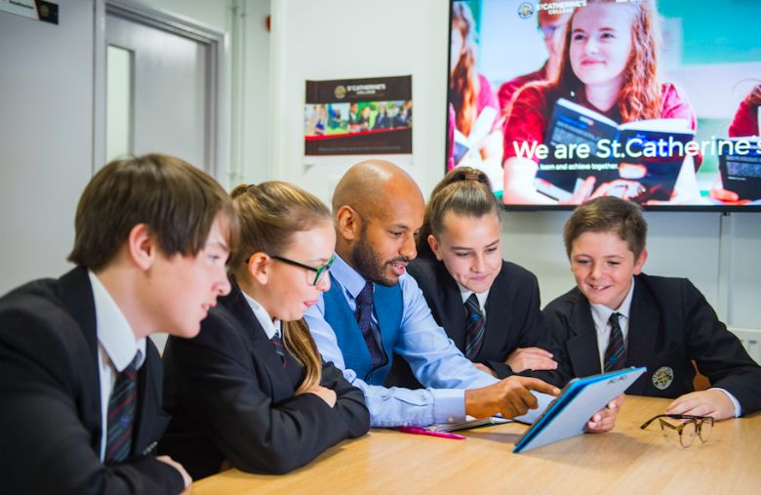



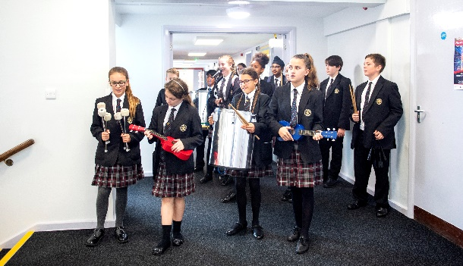

**JOB DESCRIPTION**

**POST: Teaching Assistant**

**GRADE: Single Status Grade 3 Spinal Column 7**

**RESPONSIBLE TO: SENCO**

**30 hours per week, term time only**

**Main Purpose of the Job**

To assist in promoting the learning and personal development of all pupils, including, but not exclusively those with special educational needs.

**Main Functions**

1. To aid pupils to learn as effectively as possible both in group situations and on their own by, for example:

* Clarifying and explaining instructions
* Ensuring the pupil (s) is able to use equipment and material provided
* Motivating and encouraging the pupil (s) as required by providing levels of individual attention, reassurance and help with learning tasks as appropriate to pupil’s needs
* Assisting in weaker areas, e.g. speech and language, behaviour, reading, spelling, numeracy, handwriting / presentation etc
* Using praise, commentary and assistance to encourage the pupil to concentrate and stay on task

1. To support pupils to complete the work set to the best of their ability, engaging in the lesson materials with enthusiasm.
2. To promote the acceptance and inclusion of the pupil (s) with SEN, encouraging pupils to interact with each other in an appropriate and acceptable manner.
3. Monitor the pupil’s response to the learning activities and, where appropriate, modify or adapt the activities as agreed with the teacher to achieve the intended learning outcomes.
4. Give the pupil(s) feedback on achievements in order to reinforce and develop self-reliance and self-esteem.
5. To support the pupil(s) in developing social skills both in and out of the classroom.
6. To provide regular feedback on the pupil(s) learning and behaviour to the teacher / SENCO, including feedback on the effectiveness of the behaviour strategies adopted.
7. Under the direction of the teacher, carry out and report on systematic observations of pupils to gather evidence of their knowledge, understanding and skills upon which the teacher makes judgements about their stage of development.
8. To be available on occasions to be involved in college trips and other activities
9. To use the school’s system (SIMS) for recording progress and maintaining pupil records.
10. Where appropriate, to know and apply positive handling techniques.
11. To prepare work and activities in advance of the lesson (within employed hours) where appropriate.
12. To know and apply school policies on Child Protection, Health & Safety, Behaviour, Teaching and Learning, Equal Opportunities etc.
13. To be aware of confidential issues linked to home/pupil/teacher/school.
14. To comply with legal and organisational requirements for maintaining the health, safety and security of yourself and others in the learning environment.
15. To undertake such other reasonable duties as may be required within the College.

This job description sets out the duties of the post at the time it was drawn up. The post holder may be required, from time to time, to undertake other duties within the college as may be reasonably expected, without changing the general character of the duties or the level of responsibility entailed. This is a common occurrence and would not justify a reconsideration of the grading of the post.

**PERSON SPECIFICATION – TEACHING ASSISTANT**

|  |  |  |
| --- | --- | --- |
| **Attributes** | **Essential** | **Desirable** |
| Qualifications and training: | 🗎Good standard of education particularly in English, Mathematics and ICT.  🗎Teaching Assistant NVQ level 2 or 3 | 🗎Further educational qualifications |
| Knowledge, Understanding &  Experience: | 🗎Awareness of the requirements for maintaining the health, safety and security of yourself and others in the learning environment  🗎Any relevant experience of working with children and young people | 🖂Experience of supporting children in a school or classroom environment including those with special educational needs  🗎Experience of using information technology to support pupils in the classroom. |
| Skills and Abilities: | 🖂🗹Ability to establish positive relationships with pupils and empathise with their needs  🗎Ability to demonstrate active listening skills  🖂Consistently and effectively implement college behaviour management strategies  🖂🗹Use language and other communication skills that pupils can understand and to which they can relate  🗎Ability to provide levels of individual attention, reassurance and help with learning tasks as appropriate to pupils’ needs, encouraging the pupil to stay on task.  🗣Ability to demonstrate developed interpersonal and communication skills  🖂Ability to work under pressure  🗹Ability to demonstrate initiative  🗣Ability to show sensitivity and objectivity in dealing with confidential issues  🗣Monitor the pupils response to the learning activities and, where appropriate, modify or adapt the activities as agreed with the teacher to achieve the intended learning outcomes  🖂Ability to work effectively and supportively as a member of the school support team. |  |
| Personal Qualities: | 🖂A commitment to equal opportunities, inclusion and comprehensive education.  🖂A positive and enthusiastic work ethic.  🗣Willingness to positively promote the School’s aims and Christian ethos.  🗎Willingness to participate in further training and developmental opportunities. | 🗎Good health and attendance record |

**Criterion assessment by:** 🗎 = application form; 🖂 = letter of application; 🗣 = interview; 🗹observation