Presdales School
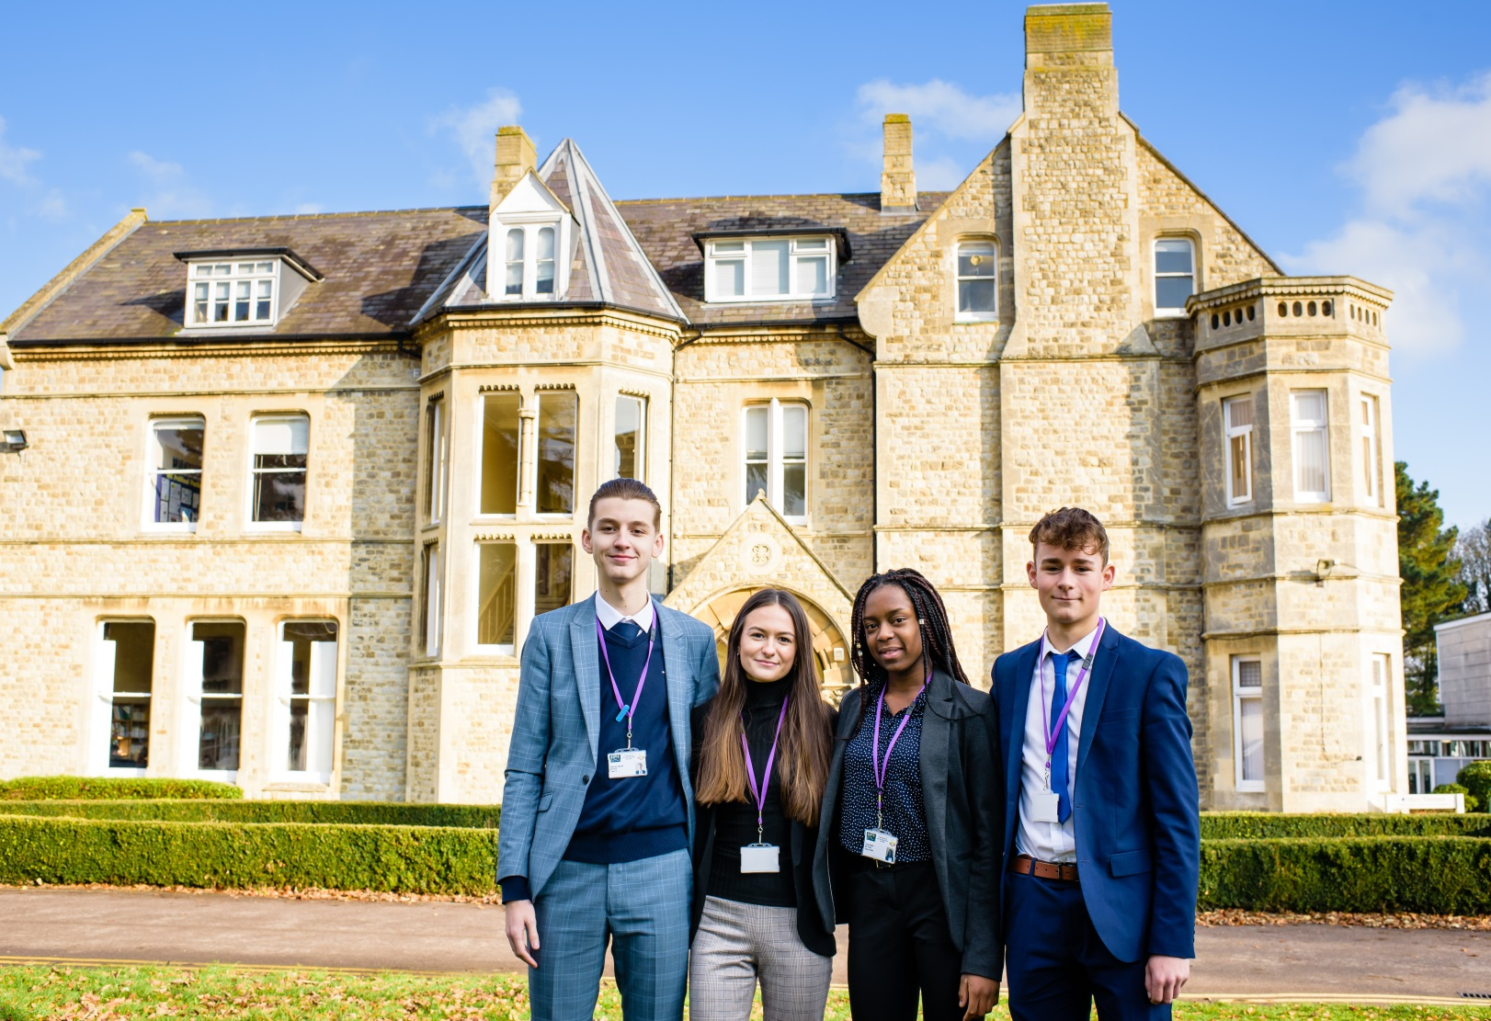

Candidate Information Pack
Teacher of Geography
(FT or PT, one year fixed term contract)

Presdales School – Teacher of Geography
Information for candidates

Start date: September 2019
Part-time or Full-time, one year fixed term contract

Thank you for your interest in joining our team of outstanding staff. Please find enclosed in this pack general information about the school and specific information about the post.

Presdales is a high achieving, all-girl, non-selective 11-18 school (boys are accepted into the sixth form). We aim to provide an outstanding education that enables all students, regardless of their background and starting point, to achieve and surpass their academic potential. We are committed to the development of independent minded young people who have active and creative minds. We expect our students to acquire a sense of understanding and compassion for one another and to have the courage to act on their beliefs. We will equip our students with the skills and attributes to empower them to lead happy and successful lives, enabling them to make a meaningful contribution to our global society. Our core values, for all our school community, are Ambition, Creativity, Equality, Integrity, Kindness and Resilience.

Presdales has been graded as ‘Outstanding’ by Ofsted in the last four inspections. Student achievement is high, with 92% of girls achieving a grade 4 or higher in both English and Maths, and an attainment 8 score of 58. 53% of our students achieved the EBacc measure with a strong pass. Our A Level results are equally impressive, with an average score of above 40 points per entry. We have an intensive extra-curricular programme which offers students a chance to develop their leadership and team building skills as well as numerous trips during the year. This year we launched our new House system. We have six houses; Curie, Frank, Nightingale, Pankhurst, Parks and Windsor.

We are looking to appoint a Geography teacher with strong subject knowledge, and an infectious enthusiasm for learning, to support the continuing development of the Geography curriculum and to join a dynamic and forward thinking department.

The post holder will be an innovative and forward thinking individual, who has a problem solving approach and a positive outlook. You will be able to inspire a love of Geography into our students. We will expect you to teach students across the full age and ability range present in the school in order to ensure the highest possible standards of student achievement, personal development and wellbeing.

I do understand and appreciate the time and effort it can take to complete an application for a job such as this; thank you for considering Presdales School.

Matt Warren
Headteacher
Presdales School
Teacher of Geography

Start date: September 2019
Part-time/Full-time, one year fixed term contract
MPS/UPS

We are looking to appoint an energetic and inspiring Geography teacher

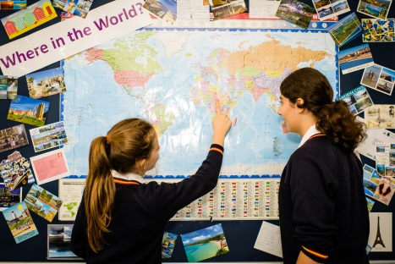
Presdales is an outstanding all-girls 11-18 school, with boys in the sixth form. We are a school which values all students, irrespective of their age and ability and helps them to exceed expectations through high quality teaching and learning and the opportunity to take part in a wide variety of activities which will enrich their educational and personal development beyond the classroom.
We provide a caring environment where all students are supported, as well as challenged, to ensure that there is no limit to their potential. We prepare our students for a world that is constantly changing by encouraging them to be independent learners who are determined, confident and who never give up. Alongside academic excellence there is a strong focus on enjoyment, excellent behaviour and respect for all.
The school is committed to safeguarding children and young people. All post holders are subject to a satisfactory enhanced Disclosure and Barring Service (DBS) check.

Closing date for applications: 9.30am Monday 20th May 2019
(we reserve the right to close applications before this date, so early applications are advisable)
We expect to interview: w/c 20th May 2019

Please submit:

- A letter of application outlining how you meet the person specification
- A completed application form (available on the school website)

You can post your application to the school, or send by email to recruitment@presdales.herts.sch.uk
Please note that CVs will not be accepted

Prospective applicants are welcome to visit the school prior to the application process. Please contact the Head’s PA at the above email address if you wish to arrange a visit

Person Specification – Teacher of Geography

We are looking for a candidate who is able to demonstrate the following essential or desirable requirements

Qualifications
- A good honours degree
- Qualified teacher (QTS)
- A commitment to on-going professional development with evidence of further study or professional training
Knowledge and Experience
- Enthusiasm and passion for teaching
- Excellent classroom practitioner
- Knowledge of current educational developments in subject and implications
- Good understanding of how students learn and how to engage all levels of learner
- Good understanding of how to use assessment to raise standards of achievement
- Good subject knowledge
Skills and Abilities
- Able to communicate well, both in writing and orally
- Excellent organisational skills
- Good ICT skills and be able to use them in own teaching
- Able to manage time effectively and work to deadlines
- Ability to develop good personal relationships with students, staff and parents
Personal Qualities
- Committed to safeguarding and promoting the welfare of young people
- Excellent record of attendance and punctuality
- Ability to work well within a team
- Enthusiastic
- Ability to work under pressure and meet deadlines
- The ability to motivate others
- Positive attitude
- Self-motivated and hardworking
- Creative
- Sense of humour

Job Description –Teacher of Geography

Vision and Purpose

- To teach across the age and ability range, as and when experience allows, and to provide a learning environment that enables all students to make progress regardless of their starting points

- To share the responsibility of all staff to ensure that our students are challenged, encouraged, nurtured and developed as all-round young people

Main Responsibilities

- Teach across the full range of age and abilities, as and when experience allows

- Committed to safeguarding and promoting the welfare of young people

- Monitor and evaluate the progress of students in your classes in line with school policies, and lead on actions within your classes to address underachievement

- Plan and deliver lessons that are in line with the departments curriculum

- To maintain good order and discipline in line with the school’s behaviour policy

- Actively engage in the performance management process

- Communicate effectively both orally and in writing with students, staff, parents and governors

- Have a commitment to your own continued professional development

- Keep up to date with your subject knowledge

- Attend all relevant meetings as required in order to fulfil your role and responsibilities

- Be a form tutor as required

- Ensure that all students have equality of opportunity

- Promote the school’s ethos and culture within the department and wider community

- To comply with the school’s Health and Safety policy

Whilst this job description is current, and every effort has been made to explain the main duties and responsibilities of the post, each individual task may not have been identified. Employees will be expected to comply, following consultation, with any reasonable request from the Headteacher to carry out tasks and duties that are of a similar level, but not specified in the job description.

