
JOB DESCRIPTION

JOB TITLE: Library Information Assistant

REPORTS TO: Library Services Coordinator

AREA: Library

GRADE/SALARY: Support Staff Scale 3, points 18 to 19 £22,107 to £22,844 per annum

POST NO: SS229

CLOSING DATE: Monday 6th May 2024

DBS: Enhanced Disclosure with children’s barred list

PURPOSE

The post holder will assist with the effective day-to-day running of the library services and support staff and students in the use of information sources (electronic and print) and learning technologies within the libraries.

PRINICIPAL DUTIES:

- To assist with the effective day-to-day running of the library services, including shelving, counter work, cataloguing, book processing, and other general library duties as required.

- To support the Subject Librarians in the delivery of our information skills programme.

- To support the Subject Librarians in the promotion of printed and electronic information resources.

- To contribute to the development of our VLE.

- To provide cover in the open access centres and libraries at all three sites when required, including supporting students and staff in the use of Microsoft Office applications and other learning technologies used in the College.

- To assist with the day to day running of the Library Management System, Heritage Cirqa, as required.

- To work one late night if required (currently 6pm at Woodlands or 7.30 pm at Blossomfield).

- To manage student behaviour, ensuring that the atmosphere within the libraries is welcoming, purposeful and conducive to study.so that all users have a positive experience.

- To adhere to policies, procedures and values of Solihull College & University Centre.

- To undertake all mandatory training in a timely manner as required e.g. Safeguarding, Prevent.

- To actively promote equality, diversity & inclusion and to champion anti-racist practice.

- To support the college to become a Sustainable Net Zero organisation by 2030 and support the delivery of its Sustainability Strategy.

- To undertake necessary Health and Safety responsibilities, duties and training as required by this post.

- To undertake any necessary Data Protection responsibilities, duties and training as required by the post.

- Such other duties as required which are broadly consistent with the general functions and grading of this position.

EQUAL OPPORTUNITIES:

Solihull College & University Centre is committed to a comprehensive policy of Equal Opportunities. All employees are required to abide by this policy and ensure its compliance throughout the College.

SAFEGUARDING:

Solihull College & University Centre is committed to ensuring a safe environment for all students and expects all staff to engage fully with this commitment.

CORE VALUES:
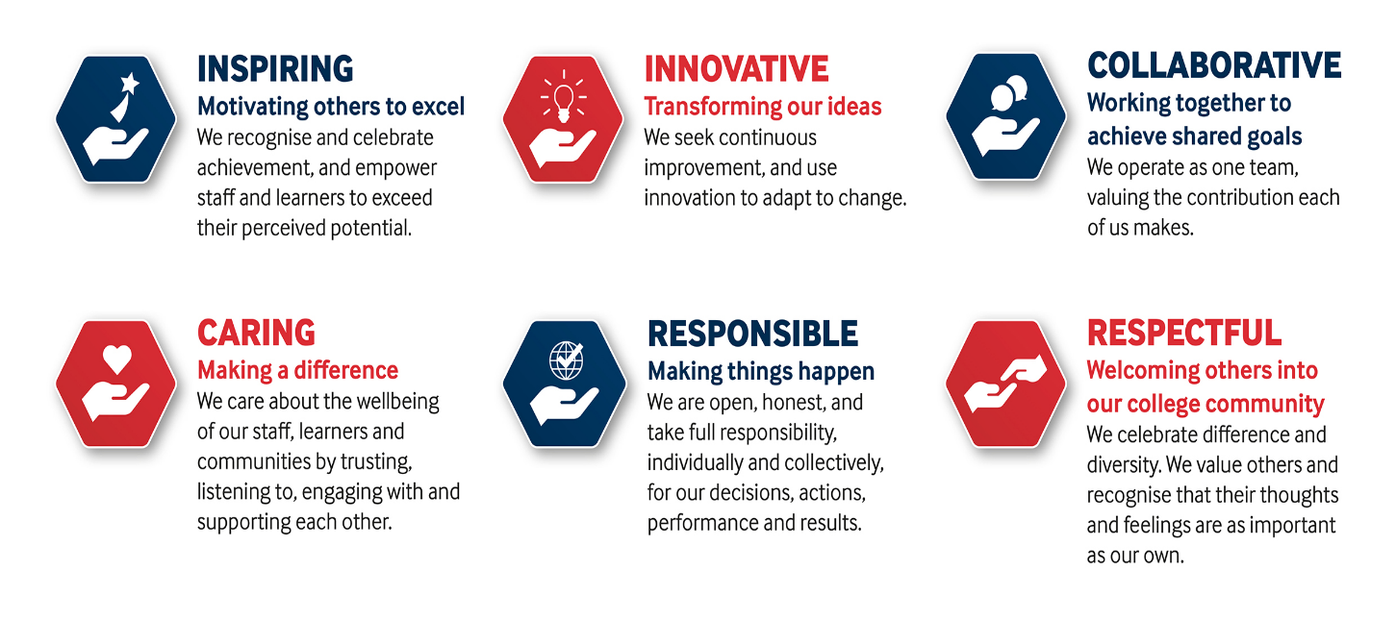

SOLIHULL COLLEGE & UNIVERSITY CENTRE
PERSON SPECIFICATION

JOB TITLE: Library Information Assistant

SALARY: Support Staff Scale 3, points 18 to 19 £22,107 to £22,844 per annum

POST NO: SS229

SPECIFICATION | ESSENTIAL | DESIRABLE
EDUCATION/  TRAINING | 5 GSCE’s including English and Maths  2 A-levels or equivalent | Customer care qualification  IT qualification NVQ Level 3 or equivalent  Information and library studies NVQ/C&G or equivalent  Teaching qualification
RELEVANT EXPERIENCE | Experience of working with young people  Experience of working in a customer-orientated environment | Recent public or academic library experience  Delivery of formal or informal training  Using computer systems or databases
SKILLS / APTITUDES | Effective communication skills  Excellent people skills  Committed team-worker  Accuracy and attention to detail  Ability to use initiative  Confident and outgoing personality  Positive attitude  Good general IT skills  An awareness of sustainability and climate change and how it applies to Further Education | Ability to work calmly under pressure  Moodle or VLE administration
OTHER  REQUIREMENTS | Ability and willingness to travel between College sites  Strong commitment to Equal Opportunities  A commitment to the Safeguarding of Young People and Vulnerable Adults and an awareness of the Government ‘Prevent’ strategy  Commitment to the College’s Values | Interest in learning technologies  Flexible approach to working hours, including evening working

