
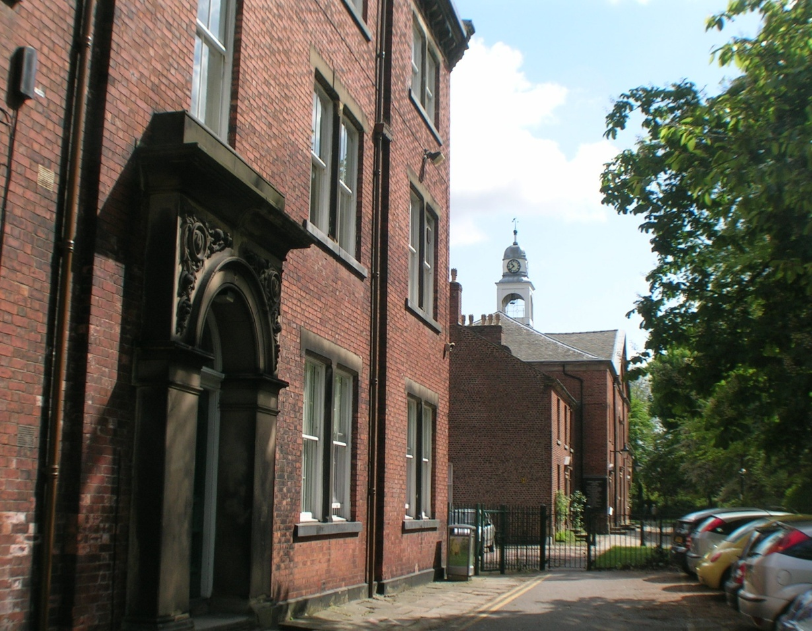
VICIT + AGNUS + NOSTER
+ EUM + SEQUAMUR +

Fairfield High
School for Girls

Fairfield Avenue Droylsden
Manchester
M43 6AB

Headteacher:
Mr B Hesketh

www.fairfieldhigh.
tameside.sch.uk

Email: admin@fairfieldhigh.
tameside.sch.uk

Tel: 0161 370 1488
Fax: 0161 371 1620

February 2018

Dear Potential Applicant

Post of Mathematics Teacher - Required for September 2018
Thank you for your interest in the above post. I hope the information provided and, more generally, on our website will be helpful in the construction of your application.
The application form should be completed in full. In the section ‘how do you meet the selection criteria’ please link your skills, knowledge, experience and personal qualities to the requirements of the post, as described in the job description and person specification. We want you to tell us why you are the right person for the job.

The successful candidate will be expected to deliver National Curriculum Mathematics across both Key Stage 3 and Key Stage 4 and contribute to a highly inclusive and successful extra-curricular programme. The ability to teach other subjects would be an advantage. To be successful in this application, you must be able to demonstrate that you can motivate and inspire pupils of all ages and abilities and actively contribute to the high expectations and achievements of the Mathematics Faculty. Your teaching record should be at least the equivalent of ‘good’ or better over time.
We offer excellent support and CPD, including a powerful, whole school focus on the development of learning and teaching. This is an excellent opportunity for an ambitious person. This post would suit an NQT or a more experienced colleague. Applicants of all backgrounds are encouraged to apply.
The school is committed to safeguarding and promoting the wellbeing of all children and expects our staff and volunteers to share this commitment. This post will involve sensitive child protection issues. Candidates invited for interview must be able to demonstrate a deep understanding of these matters. The successful candidate will be subject to an enhanced DBS check.

Shortlisted candidates will be notified as soon as possible after the closing date, which is 9.00am on Monday 12th March 201. References will be taken up at this point. Interviews are likely to take place in the week commencing Monday 12th March 2018. If you do not hear from us within 14 days of the closing date, please assume that your application has been unsuccessful.

Fairfield is a great place to work. We are an outstanding school with high standards and expectations. However, we acknowledge that there is always room for improvement. If you wish to work in such an environment, please give us your serious consideration.
If you require any further information, or an informal discussion about the post, please do not hesitate to contact us.
Good luck with your application.
Yours sincerely

Mr B Hesketh
Headteacher

