

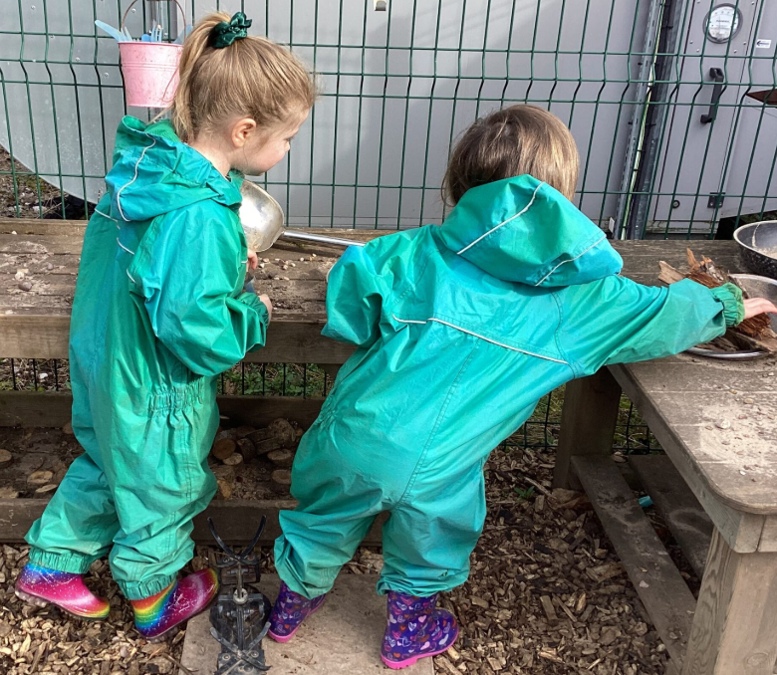

Applicant Information Pack


Welcome

Thank you for your interest in the Full Time Early Years Lead position at Tudor Grange Primary Academy Yew Tree. We are delighted that you are considering joining our vibrant and dedicated team. Our school is committed to fostering a nurturing and inclusive environment where every student can thrive academically, socially, and emotionally.

As a prospective Early Years Lead, you will play a pivotal role in shaping the future of our school. We are looking for a visionary leader who is passionate about education and dedicated to inspiring both students and staff. Your leadership will be crucial in driving our mission to provide high-quality education and to cultivate a love of learning in every child.

In this application pack, you will find detailed information about our school, the role, and the qualities we are seeking in our next Early Years Leader. We hope this pack provides you with a comprehensive understanding of our values, goals, and the exciting opportunities that await you here.

We look forward to learning more about you and how your experience and vision align with our aspirations. Thank you for considering this opportunity to make a significant impact on our school community.

The academy is part of the Tudor Grange Academies Trust which includes: Tudor Grange Academy Solihull; Tudor Grange Academy Worcester; Tudor Grange Primary Academy St James; Tudor Grange Primary Academy Haselor; Tudor Grange Academy Redditch; Tudor Grange Samworth Academy, Tudor Grange Robert Smyth Academy; Tudor Grange Academy Kingshurst; Tudor Grange Primary Academy Meon Vale, Tudor Grange Primary Academy Perdiswell, Tudor Grange Primary Academy Hockley Heath and Tudor Grange Primary Academy Langley.

Opportunities within the Trust are readily available to outstanding practitioners who are keen to explore career progression. As part of our commitment to CPD, we have planned seven INSET days for 2025-6, three of these being joint with the other Academies within the Trust to allow for meaningful collaboration.

At the heart of what we do is the belief that all children should be given the opportunity to flourish and make a valuable contribution to the academy and the wider community. We celebrate the individuality of our children and are committed to giving all our pupils opportunities to achieve through the experience of a rich and engaging curriculum. We believe that the achievements, values and well-being of all our children matter and that it is important that pupils are supported to develop the skills to be resilient in the face of challenge.

We welcome individuals to site to tour the school prior to making an application. To book a tour please contact Claire Johnson Office Manager on 0121 704 2067

We look forward to meeting with you.

Catherine O’Donoghue

Principal

Advertisement

Early Years Lead: MPS - UPS
Closing Date: Friday 16th May 9am
Planned interview date- Monday 19th May

Start date: September 2025.

Contract time: Full Time - Permanent
Salary: MPS - UPS
Suitable for ECTs: No

Job Description

The following Job Description outlines the skills and the experience required for the post at TGPA Yew Tree.

School culture and behaviour
Under the direction of the Principal, the Early Years Lead will:
- Create a culture where pupils experience a positive and enriching school life
- Uphold educational standards in order to prepare pupils from all backgrounds for their next phase of education and life
- Ensure a culture of staff professionalism
- Encourage high standards of behaviour from pupils, built on rules and routines that are understood by staff and pupils and clearly demonstrated by all adults in school
- Use consistent and fair approaches to managing behaviour, in line with the school’s behaviour policy

Teaching, curriculum and assessment
Under the direction of the Principal, the Early Years Lead will:
- Establish and sustain high-quality teaching across all subjects within the Early Years Foundation Stage Curriculum, based on evidence
- Ensure teaching is underpinned by subject expertise
- Effectively use assessment and robust tracking of engagement in continuous provision to inform strategy and decisions
- Ensure the teaching of a broad, structured and coherent curriculum
- Establish curriculum leadership within the Early Years Foundation Stage at Yew Tree and ensure the environment reflects this
- Use valid, reliable and proportionate approaches to assessing pupils’ knowledge and understanding of the EYFS curriculum
- Ensure the use of evidence-informed approaches to ensure all pupils make a strong start with their reading progress
- Interpret and analyse data, including pupil records and assessment data: monitoring progress and taking appropriate action

Additional and special educational needs (SEN) and disabilities
Under the direction of the Principal, the Early Years Lead will:
- Promote a culture and practices that enables all pupils to access the curriculum
- Have ambitious expectations for all pupils with SEN and disabilities
- Make sure the school works effectively with parents, carers and professionals to identify additional needs and provide support and adaptation where appropriate
- Make sure the school fulfils statutory duties regarding the SEND Code of Practice.

Organisational management and school improvement
Under the direction of the Principal, the Early Years Lead will:
- Establish and sustain the school’s ethos and strategic direction together with the governing board and through consultation with the school community
- Establish and oversee systems, processes and policies so the school can operate effectively
- Ensure staff and pupils’ safety and welfare through effective approaches to safeguarding
- Manage staff well with due attention to workload
- Ensure rigorous approaches to identifying, managing and mitigating risk
- Allocate financial resources appropriately, efficiently and effectively
- Identify problems and barriers to school effectiveness, and develop strategies for school improvement that are realistic, timely and suited to the school’s context
- Make sure these school improvement strategies are effectively implemented
The Early Years Lead will take a key leadership role in the operational management of the Early Years Foundation Stage on a day-to-day basis.

Professional development
Under the direction of the Principal, the Early Years Lead will:
- Ensure staff have access to appropriate, high standard professional development opportunities
- Keep up to date with developments in education
- Seek training and continuing professional development to meet needs
- Take a leading role in performance management
- Lead, develop and enhance the teaching practice of others through monitoring the quality of teaching and learning and sharing judgements with teachers and support staff as appropriate
- Support Early Career Teachers
- Through peer coaching and the demonstration of excellent classroom practice, work with colleagues to develop their teaching skills ensuring quality of provision throughout the whole school
Governance, accountability and working in partnership
Under the direction of the Principal, the Early Years Lead will:
- Understand and welcome the role of effective governance, including accepting responsibility and reporting to the Local Governing Body and Executive Governance Team as required.
- Ensure that staff understand their professional responsibilities and are held to account
- Ensure the school effectively and efficiently operates within the required regulatory frameworks and meets all statutory duties
- Work successfully with other schools and organisations
- Maintain working relationships with fellow professionals and colleagues to improve educational outcomes for all pupils
- Liaise with the Principal on a fortnightly basis updating on initiatives, developments and actions related to teaching and learning and pupil progress
Core Leadership Qualities
• Clear and consistent vision and values
• An excellent practitioner
• Ability to motivate and empower others
• Positive attitude to continuous improvement
• Flexible leadership styles
• Leading by example
• Effective communication skills
• A willingness to embrace change and recognise new educational developments
• Positive and respectful relationships across the school community
• Uphold public trust in school leadership and maintain high standards of ethics, behaviour and professional conduct

Leadership Team at Tudor Grange Primary Academy Yew Tree

Principal: | Mrs Catherine O’Donoghue
Deputy Head of School  Leadership Team | Miss Christina Allen  Miss Kate Williams Miss Beverley Khosla
SENCO | Mrs Catherine O’Donoghue
Director of Primary Standards: | Miss Sarah Deakin

Why Work for Us?

Competitive salaries
We offer competitive salaries for both teaching and non-teaching staff based on the type and level of role you do. We ensure we are treating people fairly across the Trust as well as remaining competitive. Your starting salary will be determined by the pay range for your role, your experience as well as external market conditions.

Pension Scheme
All contracted members of staff will be automatically enrolled into a pension scheme with either the Teachers Pension Scheme or the Local Government Pension Scheme (whichever is appropriate). You do not pay tax or National Insurance on your contributions and TGAT adds a generous employer contribution, which varies depending on your salary. All staff are entitled to opt-out of the pension scheme should they wish to do so.

Flexible and Family Friendly Policies
We understand that our employment policies need to be flexible and responsive in order to promote diversity and equality, and to attract and retain the highest quality workforce. We offer flexible working opportunities and policies that are often in excess of statutory minimums.

Employee Assist Program (EAP)
Our EAP is a confidential employee benefit designed to help you deal with personal and professional problems that could be affecting your home life or work life, health and general wellbeing. Our EAP service provides a complete support network that offers expert advice and compassionate guidance for you and your close family 24/7. It covers a wide range of issues including legal, finance, property and childcare as well as offering counselling and support if required

Continuous Professional Development
TGPAYT and Tudor Grange Academies Trust is committed to CPD for all staff. Staff have access to a range of internal CPD, as well as opportunities to engage in CPD led by external providers.

Recognition
We are proud to have a range of schemes, which recognise the achievements of our staff and show our appreciation of their contributions.


About our School

Tudor Grange Primary Academy Yew Tree offers a caring and stimulating and balanced education for all of our children. We are an inclusive, one form entry primary school that strives to ensure that all children achieve their full potential. Our aim is to provide a safe, supportive and welcoming place in which children can progress and enjoy learning. We are a happy school. At Tudor Grange Primary Academy Yew Tree we teach a rich, connected, creative curriculum built around our ethos and core values, enhanced by varied experiences including educational visits and extra-curricular activities.

Our ethos at Yew Tree is that joy, love and respect should be threaded through all that we do. Our values are to do the best we can and to be kind. All in our community are expected to share our ethos and role model our values. By doing so we thrive.
We are proud of the good behaviour in our school and the mutual respect which is integral to our school community. We have a positive approach to behaviour management at Tudor Grange Primary Academy Yew Tree and details of this are explained in our school’s behaviour policy which you will find on the policies page of our school website.
Ofsted judged Yew Tree to be ‘Good’ in all areas in February 2024. We are on an ever-evolving journey to being the best we can be.

Early Years Foundation Stage
All children in the Early Years Foundation Stage are offered the maximum opportunity to develop intellectually, emotionally and socially within a safe environment that is both stimulating and caring. A wide range of high quality indoor and outdoor experiences which challenge, stimulate and extend their learning support children in developing their natural desire, interest, excitement and motivation to learn. Children learn to become confident and independent decision makers, ready for the next stage of their primary education. All children are encouraged to develop care, respect and appreciation for others, including those with beliefs, cultures and opinions different from their own.

Key Stage One
Pupils’ independence and confidence will grow and develop throughout Key Stage One. Pupils will be able to share ideas, work co-operatively and imaginatively. Our pupils are enthusiastic learners who thrive on practical experiences. We encourage children to adopt a positive attitude to learning. When we have fun and work together we are successful learners.

Key Stage Two
Pupils will work with increasing independence and confidence throughout Key Stage Two.
We expect pupils to be able to work as a team. We encourage children to adopt a positive attitude to learning. When we have fun and work together we are successful learners

We encourage children to be self-starters and adopt a positive attitude to their learning. Children should have an independent approach to their learning.
Pupils will need to be able to work co-operatively, share ideas and apply their knowledge.

The Recruitment Process

The recruitment process is robust in seeking to establish the commitment of candidates to support the Tudor Grange Primary Academy Yew Tree’s measures to safeguard children and to identify, deter or reject people who might pose a risk of harm to children or are otherwise unsuited to work with them. The successful applicant will be required to undertake an Enhanced DBS check. All applications will be considered on their merit and the post will be offered subject to the usual health and criminal record clearance. We are committed to safeguarding and promoting the welfare of children and young people and expect all staff and volunteers to share this commitment.

