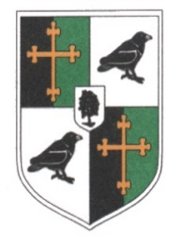
Ravens Wood School
Person Specification – Receptionist/Administrator

KEY SKILLS/COMPETENCIES | ESSENTIAL | DESIRABLE
Educated to GCSE or equivalent in English and Maths A*-C | *
Educated to A Level |  | *
Be professional, calm and supportive | *
Work effectively as part of a team and contribute to group thinking, planning, etc | *
Have a knowledge of the School’s Information System (Bromcom). |  | *
Have excellent IT office skills | *
Possess good organisational skills with the ability to multi task and work to deadlines | *
Have excellent attention to detail | *
Be flexible and calm under pressure | *
Be able to maintain accurate records | *
Have excellent communication skills verbally and in writing | *
Be confident in communicating positively with young adults/Parents/ Carers and external agencies | *
Follow instructions accurately | *
Uphold the positive image of the school in terms of dress and behaviour | *
Solve straight forward problems use own initiative and work independently | *
Ability to adapt quickly and effectively to changing circumstances/situations | *
Understand the need for confidentiality | *
Committed to personal and professional development | *
Be aware of and comply with policies and procedures relating to child protection, Safeguarding Policies and Procedures, health and safety, security, confidentiality and data protection | *
Experience of working with students of secondary age |  | *
Be aware of, support and ensure equal opportunities for all | *
Promote and safeguard the welfare of children and young persons you come into contact with. | *
Basic Knowledge of first aid |  | *

