Head of Psychology (Maternity Cover) -Job Description

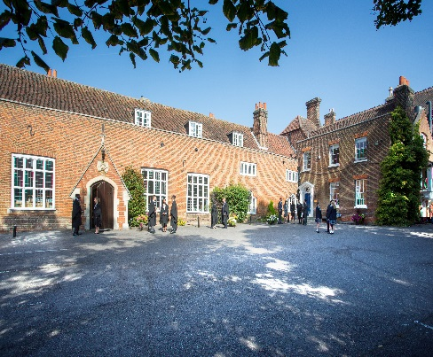

Introduction
Chigwell School is seeking a well-qualified, energetic and committed Head of Psychology to join our highly successful school. Psychology, although relatively recently introduced as an A level, has proved very popular and successful. This post is a maternity cover required from April 2018.

Background
Founded in 1629 by Samuel Harsnett, the son of a Colchester baker who went on to become Archbishop of York, Chigwell School stands on it original site with the original school building still in use. However, whilst Chigwell of today is conscious of its long-standing history, it is a forward-looking, ambitious, co-educational independent school of 930 pupils aged four to eighteen. It enjoys excellent facilities, a dedicated staff, bright and hardworking pupils, and a site of 100 acres.

Chigwell School is located in the picturesque village of Chigwell just over ten miles from central London and on the Central Line. The extensive, beautiful grounds are close to the edge of Epping Forest and it is rare for a school to have so much space and yet be so close to the centre of the Capital. Most pupils are day pupils but in the Sixth Form, there is a small community of international boarders, roughly thirty from sixteen countries, and these live in four small boarding houses.

a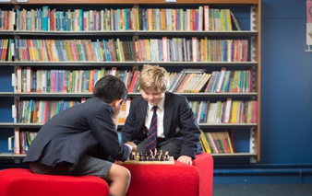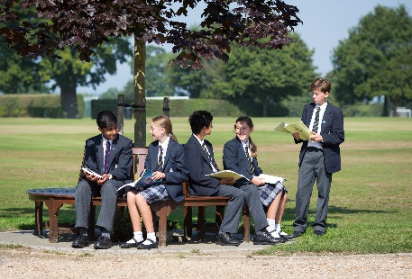
As well as being an academic school, Chigwell has the reputation for providing a rich and full education, with plenty of opportunities for all pupils who are enthusiastic, co-operative and able. Chigwell is a caring and friendly school, with a close sense of community, not least between colleagues. As the Good Schools Guide reports: Academically, pupils are put through their paces but it all seems to be done in such a civilised and pleasant manner that you are more likely to hear pupils talk about opportunities and prospects than pressure and stress. “Anyone who wants to do well here, will do well” said one student, and I can’t think of a nicer place to succeed.”

The School Development Programme
Over recent years, the School’s facilities have been extensively developed in order to enhance the educational experience that pupils receive. The development programme has included the following additions:
- 2008 Wilson Building teaching block
- 2008 Floodlit AstroTurf pitch
- 2009 Junior School library extension
- 2010 Complete redevelopment of catering facilities
- 2010 Sixth Form coffee shop
- 2010 Harsnett’s and Church House converted into boys’ boarding houses
- 2012 The Old Chigwellian Club and land was incorporated into the school estate
- 2013 Pre Prep School built and opened
- 2013 Two new science labs created
- 2014 Drama Centre balcony extended to provide additional music and drama rehearsal space
- 2016 The Risham Sarao Sixth Form Centre was completed

Currently the extension of the Dining Hall is underway. In the future we plan to:
- Renovate the Chapel
- Develop the Sports Centre
- Expand our music facilities
- Further expand our provision of bursaries

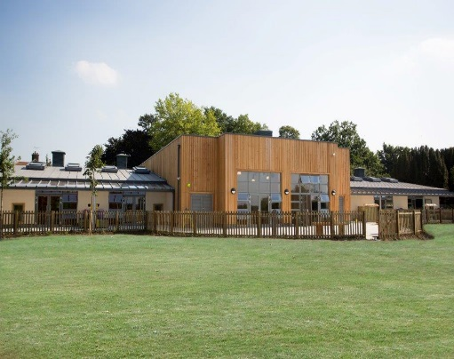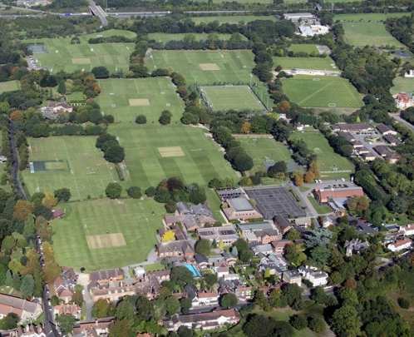

The School
Some pupils join in Reception and there are two classes in each of the three Pre Prep year groups. A small number of other children join the Junior School at 7+ (Year 3) and there are two or three classes in each of the KS2 year groups. At 11+ (Year 7), there is a further entry with four classes making up Years 7 to 11. Again, there is a small entry into the Sixth Form. Entry at each stage is selective and although there are three main sections to the School (Pre Prep, Junior School and Senior School) these sections work closely together and there is a common ethos running throughout.

There are over a hundred teachers and together with the support staff, there is a friendly, mutually-supportive atmosphere. All teaching staff contribute to the extra-curricular programme.

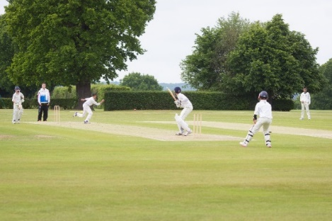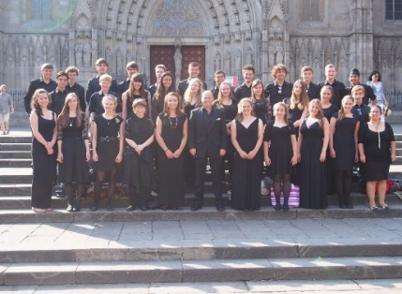

The Role
Psychology A level was introduced at Chigwell in 2013 and has proved to be a popular option. Currently, forty students take the subject at A level. At present, there are two teaching groups in Year 12 and two in Year 13. It is a popular subject choice with internal students and also with external students who join the school in Year 12, with over thirty students having chosen it from the current Year 11. The department has a large bank of resources including textbooks, journal articles and revision guides. The department has its own designated classroom in the new sixth form centre and it is equipped with an interactive white board and associated equipment.

The syllabus taught is Edexcel, which is a new specification introduced in 2015. All students sit the A level linear qualification after completing the two year course. It is a challenging and interesting specification to deliver with a significant degree of freedom with regard to some of the learning objectives and key study choices. The syllabus has a strong focus on research methods, scientific research techniques and statistics. At A level, there are three papers each designed to target particular skills. In 2016, 50% of students achieved an A* or A grade at A level and all achieved at least a B grade.

We are looking for an energetic teacher who can communicate a passion and enthusiasm for the subject, along with the ability to think strategically and creatively. Chigwell students are genuinely eager to learn and we are seeking a colleague who will encourage ideas and contributions from others whilst having the capacity to be flexible and innovative.

Heads of Department are key to ensuring the high quality of teaching and learning at Chigwell School. They have responsibility for the promotion of their subject, the organisation and teaching of the material, and for ensuring that learning is positive and effective. HoDs therefore have a leadership role which relates to both colleagues within the department and to pupils studying the subject.

The psychology department is based in the purpose-built Risham Sarao Sixth Form Centre which opened in September 2016. It includes a study and social base for students, as well as six classrooms for Sixth Form subjects and space for university and careers advice. The successful candidate will work to help all students achieve the very best they can in all aspects of their time at school.

Chigwell School is increasingly using ICT as a teaching, learning and administrative tool. All rooms are networked, they have integrated whiteboards and are fitted with a projector, and all teachers receive a laptop.

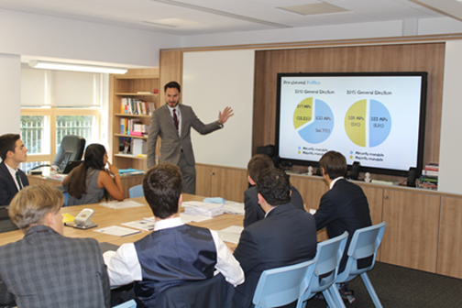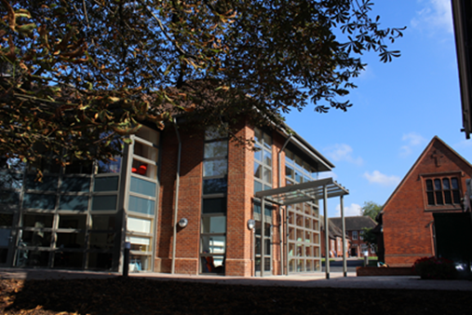

Salary: The salary on offer is competitive and based on National Pay Scales with a Chigwell enhancement.

Hours of work: This is a full time position during term time only.

Benefits:
The School provides a supportive working environment. There is a well-developed programme of professional development, pupils are enthusiastic, co-operative and able, and colleagues get on well together. There is a strong sense of community. Other benefits of working at Chigwell School include:

- A competitive salary  - A beautiful working environment- 100 acres site beautifully landscaped with a number of listed buildings  - A supportive community of highly motivated students and staff  - Commitment to professional development  - Access to the School Pension Scheme  - Personal Accident Cover | - Free lunch and refreshments during term time  - Medical Centre on site  - Free use of School’s sports facilities outside of the School day  - Childcare Vouchers  - Employee Assistance Support Programme  - On site free parking and cycle racks  - Use of School Library

Applications
Applicants should complete the teaching staff application form which can be accessed directly from our website: www.chigwell-school.org (Vacancies) and sent to the Headmaster’s P.A.: hmpa@chigwell-school.org. The Deputy Head (Staff & Systems), Mrs Anna Savage, will be happy to answer any questions; she can be contacted at the School by telephone 020 8501 5701 or by e-mail to asavage@chigwell-school.org

Closing date: Friday 5th January 2018. Early applications are welcome.

Chigwell is committed to safeguarding and promoting the welfare of children and young people and expects all staff and volunteers to share this commitment. Applicants must be willing to undergo child protection screening including checks with past employers, prohibition orders and enhanced DBS.

