Equal Opportunities Statement

United Church Schools Trust and United Learning Trust (“United Learning”) have Equal Opportunities Guidelines, which has been agreed by United Learning Trust’s recognised trade unions.

Below is United Learning’s Equal Opportunities Statement. If you would like to see the complete Guidance, it can be accessed on the United Hub or by contacting your school.

To ensure that United Learning develops and maintains a working environment in which each individual has complete equality of opportunities.

To ensure that individuals do not suffer discrimination directly or indirectly as a result of their employment with United Learning or deny their application for a position within United Learning.

Yours sincerely
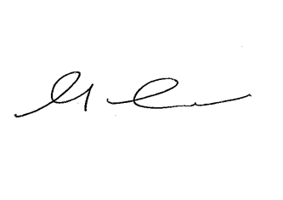

Mandy Coalter
Director of People

