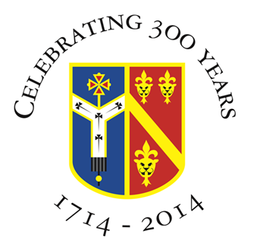

Archbishop Tenison’s CE High School
Selborne Road, Croydon CR0 5JQ
Tel: 020 8688 4014

HEAD OF COMPUTING

Full time

Location: Croydon, Surrey
Required for: 1st September 2021
Contract: Permanent
Salary: MPS including Outer London Allowance plus TLR 2b
(or 2c for a suitably qualified graduate / teacher of Computer Science)

Archbishop Tenison’s is looking to appoint an enthusiastic Computer Scientist with up to date understanding of GCSE and A Level OCR specifications. The successful applicant will be able to support, develop and lead the teaching of KS3 to KS5 Computer Science ensuring excellent progress of pupils and students in this discipline. They will lead a small but highly committed and innovative department in a well-resourced teaching area. This position would suit an existing Head of Department looking to expand their skills or a talented teacher of Computer Science who is keen to move into middle leadership.

Archbishop Tenison’s is a 307 year old Church of England, mixed 11-18 comprehensive school with an excellent track record at both GCSE and A Level. Most importantly, it is a community where the people who work believe they can make a difference to the young people they teach. Our school motto is “Academic excellence for each person in a Christian community”.

The school is situated near East Croydon Station which has excellent fast rail links to London and the South Coast. There is staff parking on-site at the school.

Archbishop Tenison’s is committed to safeguarding and promoting the welfare of children and young people and any appointment will be subject to an Enhanced DBS disclosure as well as any other pre-employment checks.

Closing date: Wednesday, 14th April 2021
Interviews: To be held week beginning 19th April 2021 (possibly remotely)
Application: Please complete the school’s application form.

For any further information, please contact Sue Rathbone, the Headteacher’s PA via patoheadteacher@archten.croydon.sch.uk).

Visits to the school prior to the application are also welcome.

