Swan Lane First School
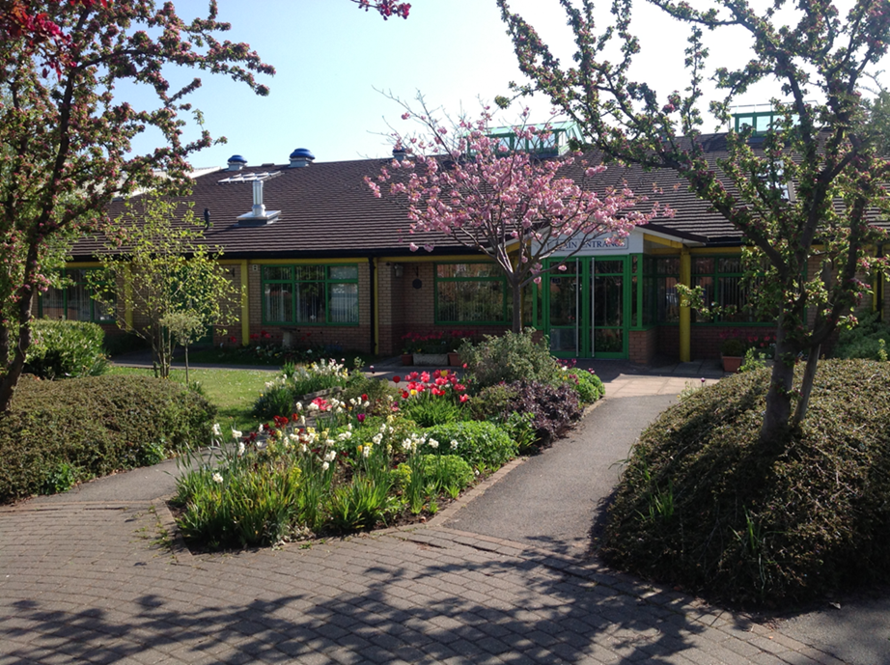
Headteacher Vacancy

Candidate Information Pack

Dear Candidate,

May we thank you for taking the time to read this letter and the accompanying information pack relating to the position of Headteacher at Swan Lane First School. The Governors are extremely proud of the school and determined to find the best candidate to continue the outstanding work of our Headteacher.

Swan Lane is a large first school, offering excellent provision for pupils with a wide range of abilities from very mixed backgrounds. There is a large and increasing proportion of pupils who speak English as an additional language. It is a very happy school with a safe learning environment in which the pupils and staff feel valued. These comments are confirmed by recent questionnaires carried out amongst staff, pupils and parents. The strength of Pupil Voice is one of the key features of our school. Swan Lane First School has always been graded as Good by Ofsted, often with outstanding notable features, the most recent inspection being in March 2016.

In order to continue our drive towards achieving an outstanding curriculum that meets the needs of every individual, we have prioritised our aims.

Our main priorities for 2019 - 2020 are:

Curriculum

To continue to embed a skilled based curriculum that is broad and balanced with appropriate coverage, content, structure and sequencing.

Oracy

To embed oracy in the curriculum so that children are confident, skilled speakers in a range of situations when presenting to different audiences.

Mental Wellbeing

To ensure children and staff understand what positive mental health looks like and have strategies so that they can achieve and maintain healthy mental wellbeing.
If the advertisement appeals to you, we would strongly recommend that you arrange to visit. You will not be disappointed!

If successful, you would be joining a dynamic, committed team of people who are trusted to innovate in ways that inspire the pupils. You will see from our person specification the characteristics we are seeking in the successful candidate.

The Governors thank you for your interest in this position and look forward to receiving your application on or before 9am on 18th November.

The Governors of Swan Lane First School

APPLICATION PROCEDURE

Application form

Please complete the application form included in the pack and submit this with a covering letter of no more than two pages explaining why you see yourself as the right person for this position

All parts of the application must be completed in full along with the covering letter and retuned either by post to this address:

Swan Lane First School
Rynal Street
Evesham
Worcestershire
WR11 4QA

Or by email to:
pa@swanlanefirstschool.worcs.sch.uk

Applications must be received by 9am 18th November

Shortlisting will take place on 21st November

Interviews will be held over 2 days, 27th and 28th November

C V’s will not be accepted

Please ensure that you read the full job description and person specification carefully when completing your application as these will be considered during shortlisting and recruitment.

Once shortlisting has occurred the successful candidates will be called for testing and to make a presentation to the Governors on 27th November 2019. There will be a further shortlisting and the remaining candidates will then be interviewed on Thursday 28th November 2019.

