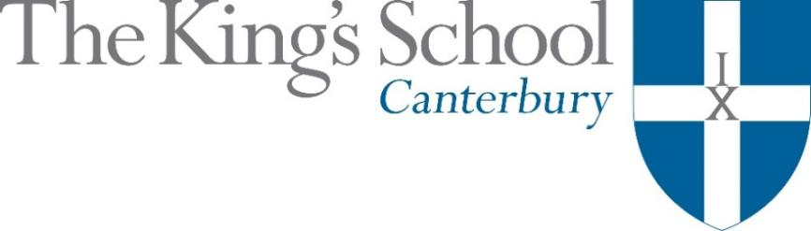

Appointment of a Teacher of Mathematics
September 2018

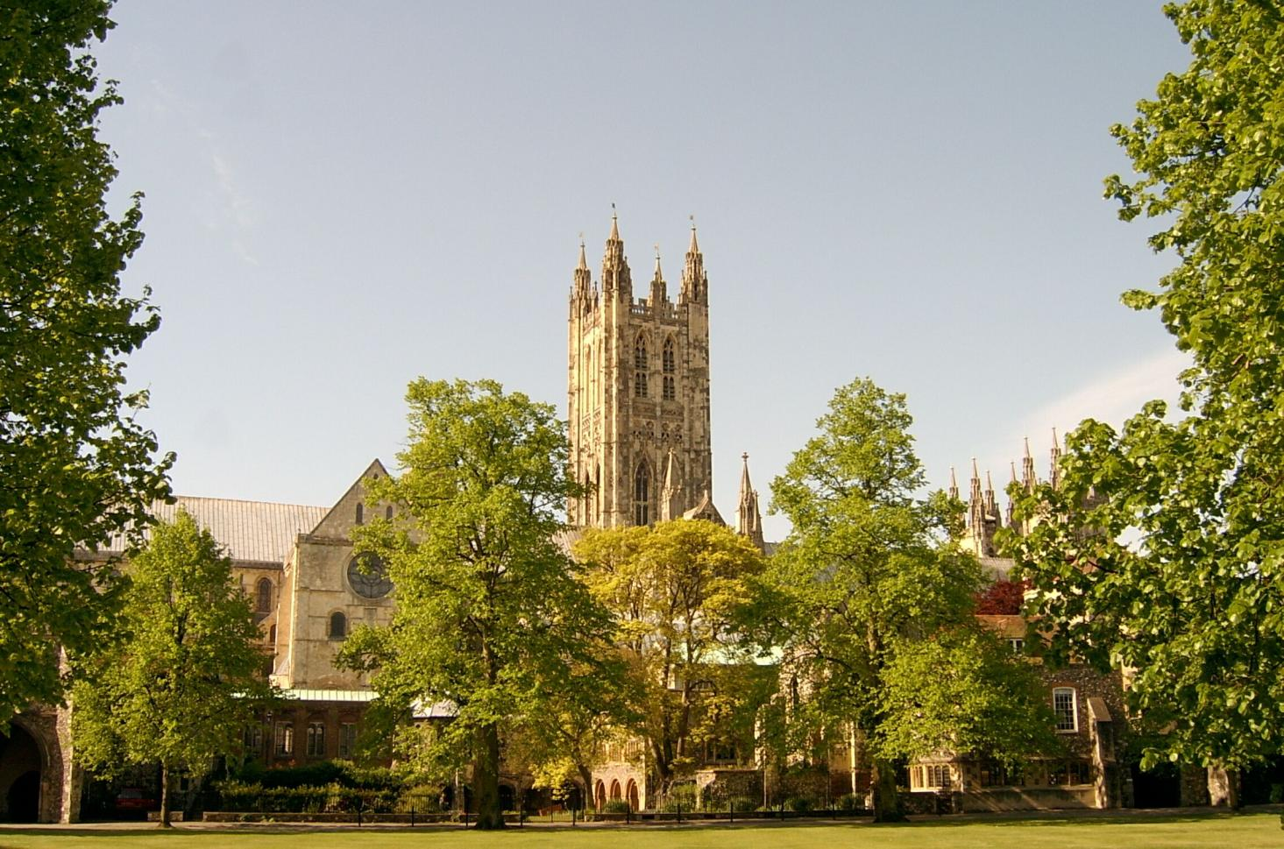

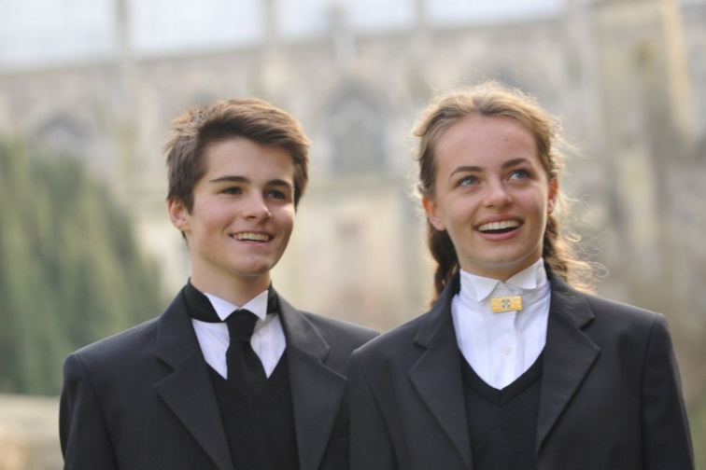
THE KING’S SCHOOL is a leading independent co-educational boarding school, situated in the heart of the historic cathedral city of Canterbury in Kent.

The precincts of Canterbury Cathedral are part of a world heritage site, a centre of pilgrimage and study, and host to over 1 million visitors each year from many different cultures. This international dimension deeply influences the life of the city and the school.

The origins of King’s date back to the arrival of St Augustine in 597 AD and the school’s Christian tradition remains at its heart although pupils and staff subscribe to many different faiths and beliefs and none. Embracing this diversity, there is a desire to foster fairness, tolerance, courage, perseverance, mutual respect and understanding. The Benedictine tradition of developing mind, body and spirit within a community given to hospitality still influences the life of the Cathedral and the school lives out its life in that context. Thus, academic excellence and scholarship take their place alongside the school’s commitment to physical and cultural endeavour. Sport is strong, with a number of boys’ and girls’ teams at national level. Music and drama are outstanding, both having the finest traditions and producing performances of the highest standards. King’s Week, the school’s own Festival of Creative and Performing Arts, attracts thousands of visitors each summer.

The curriculum at King’s is based upon strong academic roots. It emphasises and relies upon what is best in traditional school education: scholarly excellence supported by a caring pastoral and tutorial system, and a wide-ranging co-curricular programme. The curriculum is continually adapting and reacting to the changing demands of modern education: new subjects are added, new teaching techniques adopted, and there is an increasing awareness of the need to provide programmes of study that match individual needs and skills. The school does not gauge its success by exam results alone but by broader measures of educational attainment and personal development, helping pupils to achieve their potential and equipping them to play an active and responsible role in society as young adults.

Our family of schools comprises The King’s School, Canterbury (KSC), The Junior King’s School (JKS) and, from September 2018, the International College. At KSC there are currently 826 pupils at the school – 452 boys and 374 girls – of whom about 80% are boarders. There are six boys’ boarding houses, seven girls’ boarding houses and three mixed day houses. Junior King’s occupies a fine rural site on the banks of the River Stour, in Sturry, two miles from Canterbury. There are over 375 pupils at Junior King’s of whom around 20% are boarders.

The King’s School occupies various sites around the Cathedral and its precincts. Many teaching departments and the majority of houses are in the beautiful ancient buildings around Green Court on the north side of the Cathedral. To the east of the Cathedral the St Augustine’s site is home to five boarding houses, a medieval refectory, and the magnificent neo-Gothic school library (shown in the picture below). There are two major sites for sport: Birley’s, and the Recreation Centre, both within walking distance of the school, with rowing at Westbere Lakes in Sturry. The International College opens in September 2018 as the third school in the King’s family and a fourth school is planned in Shenzhen, China.

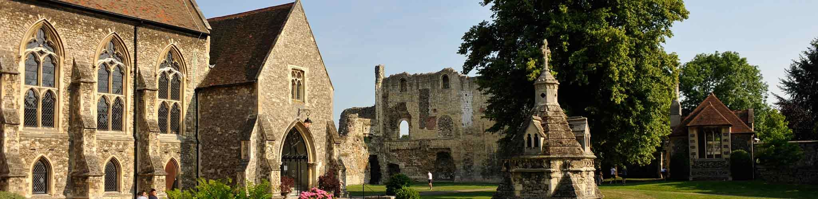

The school library, Undercroft, and ruins of St Augustine’s Abbey on the St Augustine’s campus at King’s

www.kings-school.co.uk

THE ROLE
We seek to appoint a highly qualified and motivated graduate teacher to teach mathematics throughout the School from September 2018. The mathematics department at King’s comprises fifteen full-time, and one part-time, members of staff (two shared with ICT), most of whom teach at every level – from Shells (Year 9) to A level further mathematics and university entrance (including Oxbridge). The department is a good mix of men and women of various ages. All have wider involvement outside the classroom, and many have extra responsibilities; there is currently one housemistress (and two deputies), for instance.
The lower and middle school years (Years 9-11) follow a course leading to Edexcel 4MA1 (9-1) IGCSE Mathematics A. Although there is setting (under constant review) throughout these years, usually the entire year group sits the higher tier (at the end of Year 11). The top two sets also sit the OCR FSMQ in additional mathematics, and the lowest set might sit the IGCSE in January as well as or instead of the summer sitting. In the sixth form students work towards the new Edexcel GCE linear A level in mathematics, and may progress onto AS or A level in further mathematics, currently taught in linear rather than parallel order. As well as classes provided for Oxbridge preparation, there is usually a small entry for STEP II and STEP III, and the best further mathematicians sometimes sit STEP I a year early. A small number not taking A level study the AQA Level 3 qualification in Core Maths. All these courses deliver mathematics to an increasing number of sixth form students (currently over half the year group), who are seeking a wide variety of outcomes to their studies.
Outside the standard mathematics curriculum the pupils participate in the full range of national team and individual mathematics contests, and some will also attend external masterclasses and lectures where possible. There is often a small group that enters the National Cipher Challenge and other external activities, but there is also scope for more club-type activities to be formed.
In addition to academic excellence, the school seeks to promote excellence in all its varied co-curricular pursuits. All teachers at King’s are expected to be fully involved in some capacity in this programme. They are also required to contribute fully to the pastoral care of the pupils through taking on a tutor group and duties in one of the boarding or day houses.
The post is suitable for a man or a woman who is a fine communicator and who combines academic excellence, energy, enthusiasm and experience with good humour, administrative skill, patience, flexibility and tolerance. We work hard but enjoy ourselves, and get on well as a team with an open-door policy. The successful applicant will be capable of truly interactive teaching, rather than mere transmission. Although not necessarily a mathematics graduate, he/she will be able to propagate the strong belief in a subject worthy of study for its own sake, and one that at its best has all the quality of creative play.

APPLICATIONS
Applications should be submitted online through the King’s School website (www.kings-school.co.uk – Staff Vacancies), and should include a personal statement for the Headmaster and a CV by 9am on Friday 9th February. If you have any difficulties accessing the internet please contact the School Office: reception@kings-school.co.uk; 01227 595501.
Those considering applying but requiring more information, can contact the Head of Maths, Stuart Ocock,
for an informal discussion: spo@kings-school.co.uk.

January 2018

