
BE THE BEST YOU CAN BE

Headteacher Pack
Malmesbury Primary School
Coborn Street, Bow, London E3 2AB
April 2023

0208 980 4299 http://malmesburyschool.uk/

Contents

Welcome from the Chair of Governors 3
Recruitment Process Details 4
About the School 5
Values and Ethos 5
Curriculum 6
Aims 6
EYFS 6
Key Stage 1 and Key Stage 2 7
SEND 8
Ofsted Results 9
Governors at Malmesbury Primary School 10
Headteacher Job Description 11
Person Specification 15

Welcome from the Chair of Governors
April 2023
Dear Candidate,
Thank you for your interest in Malmesbury Primary School. Malmesbury is a much loved, successful, two form entry school in Bow, Tower Hamlets. Our children come from a wide variety of backgrounds, reflecting the borough’s rich cultural and economic diversity.
We are proud to be a local authority school, with a roll of 481 children coming from a catchment area of less than a mile. We strive to give our children the best possible education and start in life and to inspire in every child a love of learning, which we do through an extremely broad curriculum, with lots of school outings.
We pride ourselves on our close-knit, friendly school community. Our staff are a tight, cohesive team who work together. Our parents are strongly committed to helping their sons and daughters succeed in school. Members of the wider community make valuable contributions to school life, helping our children learn about the world around them.
Working in partnership, we are extremely fortunate to have a network of support for teaching and learning, which has become more and more important as fiscal and LA structures have been realigned. Partnership working enables our teachers and support staff to grow and showcase their skills within a wider teaching environment, as well as providing an opportunity to learn from and reflect on each other’s practice.
The school has established an ethos where pupils are expected to achieve their best and parents are expected to support their children on this journey. This improvement ethos is supported by a committed Governing Body who are strategic and collaborate to further improve standards.
We believe this is an exciting opportunity for a new head to build on the existing success to achieve even higher standards and ever broader educational experiences for our children.
If you would like to apply, please do come and visit us. The current leaders will be happy to show you around and answer questions, so please contact Amina, School Business Manager on 0208 980 4299 in our school office to arrange a suitable time. We look forward to hearing from you.
Yours sincerely,

Tom Foster
Chair of Governors

Recruitment Process Details

To start: September 2023

Salary range: L20 to L27 (£79,113 to £92,330) (Negotiable, depending on experience)

NOR: 481

Closing date for applications: 12 noon on 21st April 2023

Interview date: 28th April 2023

A visit is highly recommended and can be booked by contacting Amina, School Business Manager on 020 8980 4299 or by email at Amina@malmesbury.towerhamlets.sch.uk

The Headteacher Job Description and Person Specification can be found at the back of this pack.
To apply for this role please complete the Tower Hamlets Application form.
In addition to the Application Form you are required to respond to the Person Specification requirements for this role with examples of the relevant abilities and experiences you have gained. You are not at this stage expected to respond to all points as many can only be established at interview. Your response to this should be no longer than 2 A4 sides in Arial 11 font.
You are also required to provide a Personal Statement explaining what you think you would bring to the role of Headteacher of this school. Your Personal Statement should be no longer than 1 A4 side in Arial 11 font.
If you have any questions about the role or the process of application, please call Andrew Best on 07917 080201.
We are committed to ensuring equality and diversity is central to the operation of our school through the staff we employ and the provision that we make.
We are committed to safeguarding and promoting the welfare of children and young people, and expect all staff to share this commitment. An enhanced DBS check is required for all successful applicants.

About the School
Malmesbury Primary School prides itself on being an inclusive community school and we are privileged to be able to celebrate a wealth of cultures within our school. We have the highest expectations for both ourselves and for the achievement of our children. We encourage our children to ‘Be the Best They Can Be’ at whatever they do.
We have a holistic ethos of education with the well-being of our children at the heart of school life. We are passionate about the children’s learning not only in English, Maths and Science but also Music, Sport and the Arts. An exciting curriculum motivates our children by making learning fun and come alive through extending experiences into the wider world.
We encourage our children to become independent learners and confident young people through developing skills and attitudes which prepare them for their future life.

Values and Ethos
Our school community includes children, parents, carers, staff and governors. Our shared vision is that when our children leave Malmesbury they will be:
- literate and numerate
- healthy and happy
- independent learners
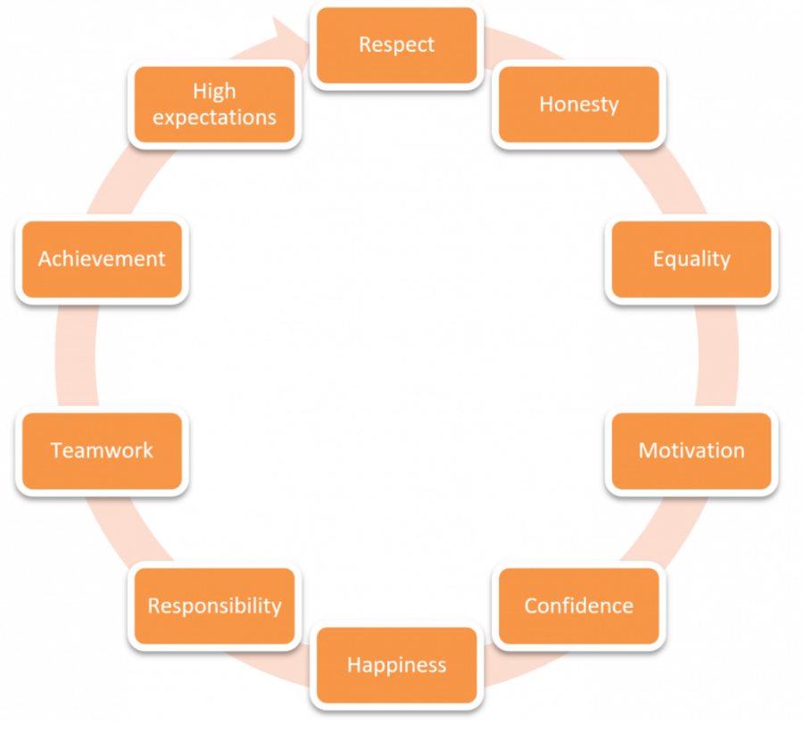
Our shared values are:

Curriculum
At Malmesbury Primary School, our curriculum is based on National Curriculum for Key Stages 1 & 2 and the Early Years framework in the EYFS. We are a Rights’ Respecting school, we have adopted a coherent values framework which shapes the ethos and curriculum of the school.
We believe that the curriculum should be broad and balanced which promotes the social, moral, spiritual and cultural development of pupils at the school. It encourages cooperation, independence and prepares pupils for the opportunities, responsibilities and experiences of later life.
We ensure that children have a range of learning experiences throughout school that challenge, stimulate them and promote thinking. The curriculum is progressive from Early years to year 6 and is based on first-hand experiences.

Aims
- to develop a lifelong love of learning
- to provide contextual and purposeful learning
- to give children a breadth of experiences outside school including residential, theatre and music visits
- to offer range of basic skills integrated into topic including English, maths, ICT skills, as well as skills such as cutting and sticking and drawing.
- preparing children socially for adult life
- preparing children to be global citizens who value other cultures
- value all subjects especially creative subjects
- focus on quality and depth of learning
- develop problem solving skills
- follow children interests and national/ international events wherever possible and/or important
- develop personal attributes especially persistence and learning to work with others
- teach children about the importance of, and how to, live a healthy lifestyle

EYFS
At Malmesbury we plan to engage, creative adult led activities based on the prime and specific areas.
Prime Areas
- Personal, Social and Emotional Development – making relationships, self-confidence and self-awareness, managing feelings and behaviour
- Physical Development –moving and handling and health and self-care
- Communication and Language– listening and attention, understanding, speaking

Specific Areas
- Mathematical Development –Numbers, Shape, space and measures
- Literacy – reading and writing
- Understanding the world – People and communities, the world and technology
- Expressive art and design –exploring and using media and materials, being imaginative
EYFS Children develop independence and concentration, working at activities based on a 'hands-on' approach with active learning through play as an important feature of the children's experience.
Our approach to learning is based on the Characteristics of Effective Learning.
- Playing and exploring – engagement
- Active learning – motivation
- Creating and thinking critically – thinking

Key Stage 1 and Key Stage 2
- Core Subjects: English, Mathematics and Science
- Foundation Subjects: History, Geography, Art and Design, Computing, Design and Technology, Music, Physical Education, PSHCE, RE and MFL (KS2)
In KS1 and KS2 our focus is on a broad and balanced curriculum with basic skills in English and Maths at the heart.

SEND
Malmesbury is committed to early identification of Special Educational Needs (SEN). Our school adopts a graduated response to meeting SEN and Disability (SEND) in line with the SEN Code of Practice. We work in partnership with parents to meet the needs of the children.
We have high expectations of all children regardless of where they begin their learning journey. Throughout the school children are monitored regularly to enable early identification of need. A range of evidence is collected through assessment and monitoring arrangements, as well as regular formal discussions between the Special Educational Needs and Disability Coordinator (SENDCO), class teachers and parents/carers

Ofsted Results
Short Inspection – 30 January 2018
Main Finding – This school continues to be good
Safeguarding is effective.
Since the previous inspection, the leadership team has developed its skills further through effective partnerships with other local schools. You said that this has developed the expertise of the leadership team and helped leaders build consistency in teaching and learning. Results in national assessments, at the end of 2017, suggest that standards have continued to rise at the end of key stages 1 and 2. At the time of the last inspection, inspectors found that there was more work to do to improve pupils’ speaking skills. The work I saw during the inspection suggests that the actions you have taken to address this has had a positive impact. Pupils are articulate and enthusiastic to discuss their learning.
You are rightly proud of the school’s work to promote the development of the curriculum so that pupils develop their understanding in music, art and physical education. This has helped to raise pupils’ aspirations and develop their language skills. As a result, the proportion of pupils achieving the highest standards in reading, writing and mathematics is now above the national average.
You recognise that there was a slight fall in the proportion of pupils meeting the required standard in the Year 1 phonics screening check in 2017. Leaders ensure that they allocate experienced staff to support pupils whose phonics skills are below age-related standards. Consequently, these pupils make strong progress.
You have focused on developing the teaching of mathematics over the last year to develop pupils’ arithmetic skills. Leaders have sought to develop pupils’ reasoning skills so that their achievement in mathematics can be as high as it is in English. You check pupils’ progress regularly. Senior leaders provide additional support to selected pupils.
Governors have a strong understanding of the school and set high expectations. They have a ‘no excuses’ attitude and understand the school’s progress to date. Parents and carers who responded to Ofsted’s online questionnaire, Parent View, agreed that pupils are well looked after and kept safe at the school.
Next steps for the school
Leaders and those responsible for governance should ensure that:
- The quality of teaching and learning improves further by:
– providing the lower-attaining pupils with books matched to their abilities, and opportunities to develop their fluency and expression in reading
– ensuring that pupils develop their reasoning and problem-solving skills in mathematics

Governors at Malmesbury Primary School

The Governing Body of Malmesbury Primary School is made up of parents and staff who have been elected, and of people from outside the school, who have been appointed by the Local Education Authority.
The Governing Body is responsible for the running of the school and works closely with the Senior Leadership Team.
Governors are responsible for agreeing the annual budget, for ratifying school policies and scrutinising performance to enable them to work with the school to raise standards.
There are six Governing Body meetings each year, along with regular meetings of smaller sub committees such as the Finance and Resources Committee.
In addition to scheduled meetings it is vital that Governors make themselves available to support the Senior Leadership Team with day to day issues, and other initiatives such as working towards the Healthy Schools Award and interviewing new staff. This level of involvement keeps the Governing Body in touch with what is happening with in the school, fosters good relationships, and benefits the whole school community.

Headteacher Job Description
Salary:
L20 to L27
Qualities:
The Headteacher of Malmesbury should be passionate about achieving the best possible outcomes for our children. They will value people and care about the whole family: parents, carers and children. They will recognise that the strength of a school is built upon the strength of the families who attend. Our Headteacher will have empathy, understand the importance of listening and enjoy learning. They will be prepared to observe and adapt and have a flexibility that allows them to work collaboratively and nurture development. The Headteacher will enjoy celebrating success, in all its forms, and have a strong belief in growing the whole child. An holistic approach to the education of our children is essential for a leader of Malmesbury.
Duties:
This job description is subject to the general conditions of service for a Headteacher as set out in the current School Teachers Pay and Conditions Document. This job description is based on the National Standards for Headteachers.
Main Purpose:
The Headteacher will work with the Strategic Leadership Team (SLT) to provide professional leadership, vision and strategic direction for the school in order to ensure the highest quality of education for all its pupils in all areas of learning, through the following key areas:
Leadership and Shaping the Future
- To uphold the school values of “being the best you can be”.
- To share vision and strategic direction which inspires and motivates pupils, staff, governors and all other members of the school community.
- To promote and maintain a school culture based on emotional intelligence and taking an holistic view of the child.
- To work with staff and the Governing Body to produce a school improvement plan which identifies priorities and targets based on robust school self –evaluation.
- To monitor, review and evaluate the work and organisation of the school to ensure effective implementation of policy and practice.
- To develop leadership capacity at all levels.
- To promote the development of teamwork and collective responsibility.
- To ensure the development, management and leadership of the School, placing pupils at the centre of all decisions.
- To lead and promote inclusive practice
- To regularly review own practice, set personal targets and take responsibility for own personal development.
- To manage own workload and that of others to encourage an appropriate work/life balance.
- To promote a learning community which provides and values continuous professional development for all staff.
- To create an environment where pupils are given the opportunity to expand their horizons beyond their previous experience.
Leading Teaching and Learning
- To be the Lead Learner in the school.
- To be passionate about setting high expectations for all pupils regardless of their ability or background.
- To promote a successful learning culture that will enable pupils to become effective, enthusiastic, independent learners committed to lifelong learning.
- To champion creative, responsive and effective approaches to teaching and learning.
- To promote high expectations of teaching and monitor and evaluate its effectiveness on learning outcomes.
- To develop and oversee the regular review of a broad, balanced, flexible, creative and differentiated curriculum designed to involve, engage, challenge and stimulate.
- To implement strategies which are seen as consistent, firm and fair and that secure high standards of good behaviour, punctuality and attendance.
- To identify and provide for the specific needs of all pupils in line with the SEN Code of Practice and the Disability Discrimination Act.
- To promote and celebrate the positive benefits of living within a culturally and ethnically diverse society.
- To maintain and develop effective systems of planning, assessment and record keeping, sharing effectively with parents/carers and pupils.
Managing the Organisation
- To manage the schools financial and human resources effectively, in conjunction with the school’s governors, to achieve the school’s priorities.
- To agree, set and monitor budgets, allocate funds and ensure systems are in place for effective administration and control of the budget.
- To recruit, retain and deploy excellent staff to achieve the vision and goals of the school whilst being mindful their workload.
- To delegate the responsibilities of the Senior Leadership Team to ensure the effective running of the school.
- To develop and maintain effective strategies and procedures for staff induction, professional development and appraisal.
- To ensure that learning is at the centre of strategic planning and resource management.
- To monitor and evaluate standards of teaching in the classroom and provide constructive feedback and relevant support.
- To challenge underperformance at all levels and ensure effective support and, where necessary implement appropriate procedures.
- To treat people fairly, equitably and with dignity and respect to create and maintain a positive school culture and foster and facilitate team work.
- To lead and motivate staff to ensure that they have access to suitable advice, education and training appropriate to their professional needs as identified through performance management and the priorities identified in the School Improvement Plan.
- To ensure that the local authority and the school’s equal opportunities and race equality policies are followed and actively pursued.
- To manage and organise the accommodation to ensure that the school buildings meet the needs of the curriculum provided and health and safety regulations.
- To use and integrate a range of technologies to effectively and efficiently manage the school.
- To designate a member of the senior leadership team with leadership responsibility for the Headteacher’s function when the Headteacher is absent.

Strengthening the Community
- To maintain and develop the school culture and curriculum which takes account of the richness and diversity of the school community.
- To maintain an effective partnership with parents and carers to support and improve pupils’ achievement and personal development.
- To communicate effectively at all levels with all stakeholders.
- To continue to seek opportunities to invite parents and carers, community figures, businesses or other organisations into the school to enhance and enrich the school and its value to the wider community.
- To promote the positive strategies already in place, for challenging prejudice and dealing with racial harassment and other discriminatory practices or behaviour.
- To work with the Governing Body providing information, objective advice and support to enable it to meet its responsibilities.
- To develop and present a coherent, understandable and accurate account of the school’s performance to a range of audiences including governors, parents and carers.
- To promote the positive and mutually supportive relationship linking home and school in a working partnership, ensuring parents/carers are fully informed about all matters relating to the education of their children.
- To share effective practice working in partnership with other schools and promoting innovative initiatives.
Safeguarding
- To have due regard for safeguarding and promoting the welfare of children and young people and to follow all associated child protection and safeguarding legislation and any policies as adopted by the school and local authority.
- To be accountable for child protection and ensuring that the welfare and safety of pupils is promoted and safeguarded.
- To prevent, identify and minimise risk of interpersonal abuse or violence, safeguarding children, initiating the management of cases involving actual or potential abuse or violence where needed.
- Be aware of and update staff as appropriate to comply with current legislation and policies affective practice e.g. Children’s Act, National Service Framework, Child Protection Procedures, Health and Safety and Date Protection.

Health and Safety
- To work in compliance with the school’s health and safety policies and under the Health and Safety at Work Act (1974) ensuring the safety of all parties with who contact is made, such as members of the public, in premises or sites controlled by the school.
- To ensure compliance of procedures are observed at all times under the provision of safe systems of work through a safe and healthy environment and including such information, training instruction and supervision as necessary to accomplish those goals.

Data Protection
When working with computerised systems to be completely aware of responsibilities at all times under the Data Protection Act 1998 for the security, accuracy and significance of personal data held on such systems.
Malmesbury Primary School is committed to safeguarding and promoting the welfare of children and young people and expects all staff to share this commitment. An enhanced DBS check is required for all successful applicants.

Person Specification
 | Criteria
Qualifications | Qualified Teacher status | E
Qualifications | Graduate level qualification | E
Qualifications | Completed NPQH (except substantive Headteachers in post before April 2004) | D
Qualifications | A record of recent and relevant in-service training | E
Experience | Proven successful leadership at senior level in a primary school as a Head Teacher or Deputy Head or equivalent. | E
Experience | Experience of working in an urban setting (inner-city). | D
Experience | Experience of working in a culturally diverse community. | D
Experience | Experience of working effectively with the school community and external partners. | E
Experience | Experience of developing a differentiated and creative curriculum to pupils with a diverse range of social, emotional, cultural, intellectual and physical needs. | E
Leadership/ shaping the future | Ability to innovate and find creative solutions, and to communicate a vision to inspire and motivate all stakeholders. | E
Leadership/ shaping the future | Be emotionally intelligent and have a commitment to the well-being and development of the whole child and the staff.
Leadership/ shaping the future | Proven track record of the ability to raise significantly the academic and personal achievement of all pupils. | E
Leadership/ shaping the future | Evidence of the ability to promote a positive, sensitive and caring ethos and pride in the school and its physical environment together with high standards of achievement and behaviour. | E
Leadership/ shaping the future | Excellent interpersonal and communication skills, both oral and written. | E
Leading Teaching and Learning | Knowledge and understanding of how to raise standards of learning across the school and a proven track record in doing so. | E
Leading Teaching and Learning | Excellent knowledge of the current major curriculum issues and recent educational developments and legislative changes, together with their significance for the leadership of a primary school. | E
Leading Teaching and Learning | Ability to use, analyse and monitor pupil assessment data to identify needs and trends to promote an appropriate level of challenge to all pupils. | E
Leading Teaching and Learning | Demonstrate a commitment to providing choice and flexibility in learning to meet the individual needs of every child | E
Leading Teaching and Learning | An ability to acknowledge excellence and challenge poor performance across the school. | E
Leading Teaching and Learning | A proven commitment to an inclusive education which addresses the needs of all learners in a diverse community. | E
Leading Teaching and Learning | A clear vision for consistent systems and procedures which bring about effective behaviour management. | E
Managing the Organisation | Knowledge of legal issues relating to managing a school including equal opportunities, race relations, disability, human rights and employment legislation. | E
Managing the Organisation | The ability to use performance management and line management to secure accountability and improve performance. | E
Managing the Organisation | Proven track record in working collaboratively and building, leading empowering and developing effective teams. | E
Managing the Organisation | Evidence of the ability both to delegate and work in collaboration, and to establish robust systems to monitor implementation and impact. | E
Managing the Organisation | The ability to prioritise tasks, make informed decisions and implement them in a flexible manner. | E
Managing the Organisation | An understanding of new technology and its role within the classroom and across the wider school environment. | E
Managing the Organisation | Experience and understanding of managing finance efficiently in accordance with benchmarking, financial management and best value principles. | D
Managing the Organisation | A commitment to continuing CPD for oneself and for all members of the school community. | E
Managing the Organisation | Evidence of a commitment to sustaining a safe, secure and healthy school environment, in accordance with Child Protection and safeguarding legislation. | E
Strengthening the Community | Proven ability to negotiate and consult effectively with pupils, staff, parents, governors, the LA and the wider community. | E
Strengthening the Community | Experience of developing and managing good communication systems, chairing meetings effectively and working in partnership with other agencies. | E
Strengthening the Community | A vision for governor, parent and community involvement in the life of the school and a commitment to creating and expanding community and global links. | E
Strengthening the Community | A willingness to engage the school community in self and external evaluation to better understand the strengths and weaknesses of the school. | E
Strengthening the Community | An unwavering commitment to acknowledge, celebrate and foster respect for the richness and diversity of the school's communities. | E
Strengthening the Community | Prepared to make a direct contribution to the broader life of the school and "go the extra mile" with a sense of humour. | E

E- Essential, D Desirable
Appointment to this post is subject to a satisfactory enhanced DBS check. This post is exempt from section 4(2) of the Rehabilitation of Offenders Act, 1974, as the duties give you access to persons who are under the age of 18. Applicants are not entitled to withhold information about convictions, which would be regarded as spent for other purposes.

