
Design & Technology Department

The Post
The post will involve teaching KS3, GCSE Food Preparation and Nutrition and the possibility of some A level.

Courses and Students

Key Stage 3

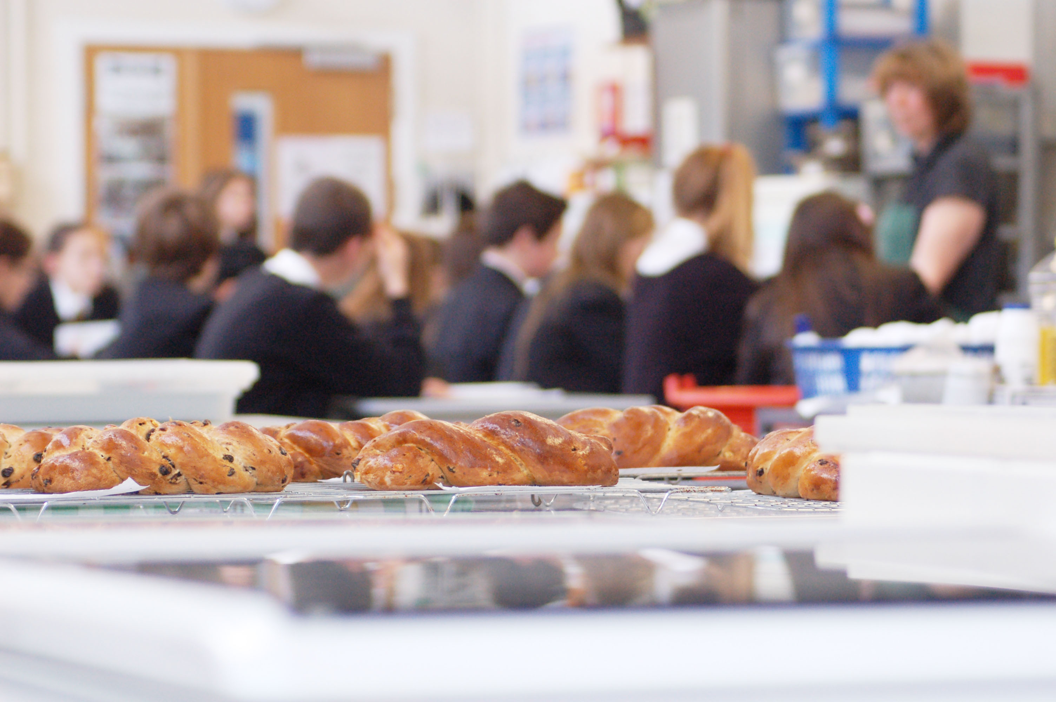
In Years 7, 8 and 9 pupils undertake a range of projects over an 11 week period. These include projects in modelling, electronics, wood, mechanisms, graphics, food and textiles.

Food modules are currently taught to students in Year 9.

In all design based projects, students are given the knowledge they need when designing and making and are then encouraged to use this information to research and design their own product in a creative and imaginative way.

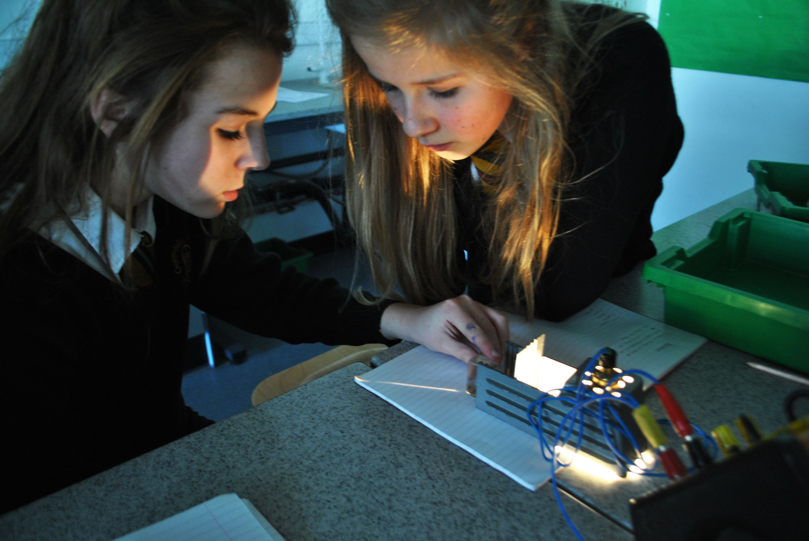
Key Stage 4

Design and Technology is a popular option choice and students can choose from one of the following:

GCSE Food Preparation & Nutrition
(WJEC Eduqas)
Food and Nutrition includes studying food nutrition, diet, health, factors affecting consumer choice and health and safety. Students are assessed on two pieces of practical work.

GCSE Design & Technology
Imaginative practical work is at the heart of Design and Technology. Students explore, design, create and evaluate prototypes to solve real world problems. They will gain a broad understanding of technical, designing and making principles and there are no restrictions on materials when making prototypes.
There are however opportunities to explore a particular material area in greater depth. Students study a common core of knowledge and then specialise in one particular area, either: Resistant Materials or Graphics.
The structure of this course lends itself to future studies at A level.

Textiles Technology (Edexcel)
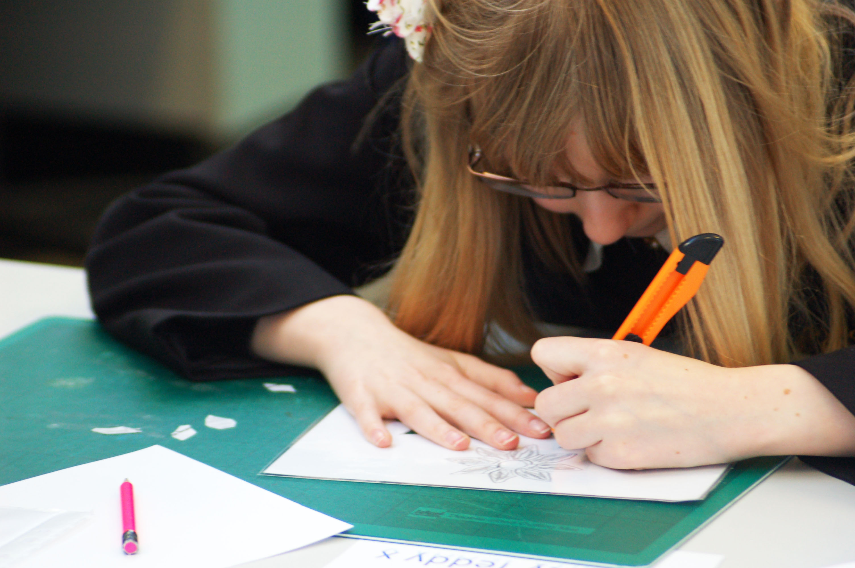
During Year 10 students undertake short skills based projects before starting their GCSE coursework. As part of the course all students also visit the Clothes Show. Year 11 coursework is varied, the course is popular with students and high quality work is produced.

A evel Design and Technology
In Years 12 and 13 we currently offer two A level courses, both (AQA), Product Design and Textiles.
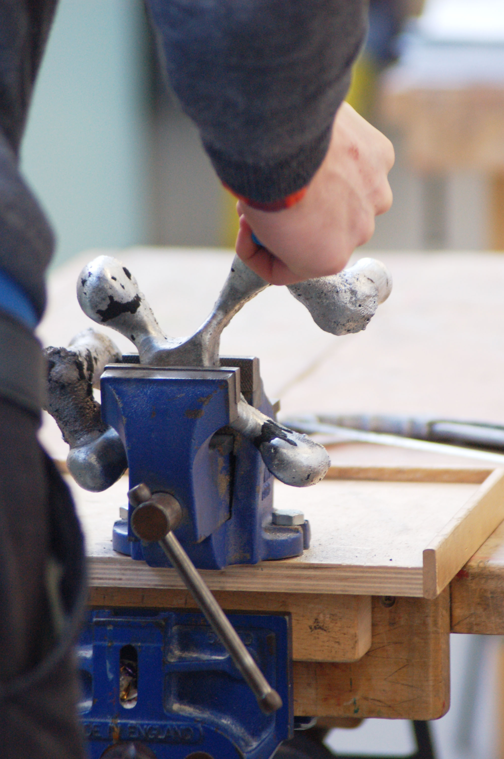

Staffing
The Design and Technology curriculum is delivered by six specialist teaching staff, supported by 1 full-time Resistant Materials technician and one part-time technician in Food. We collaborate as a whole on all aspects of the delivery of the curriculum. Staff development, in particular Health and Safety, and support, is a priority and training needs are met whenever possible.

Accommodation
The department has three Resistant Materials workshops, a Resistant Materials preparation workshop, one Food room, one Graphics room, two Textiles rooms and a CAD/CAM suite which includes a Laser Cutter, 3D Printer and 33 desktop computers.

Resources
Design and Technology receives an appropriate level of capitation to fund all projects.

