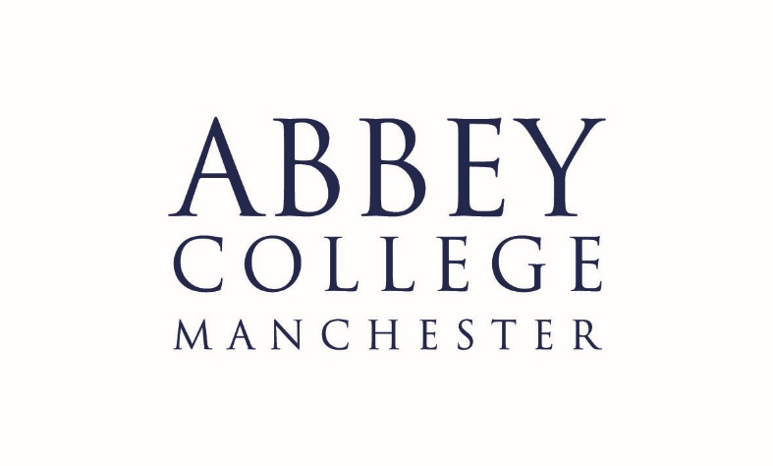

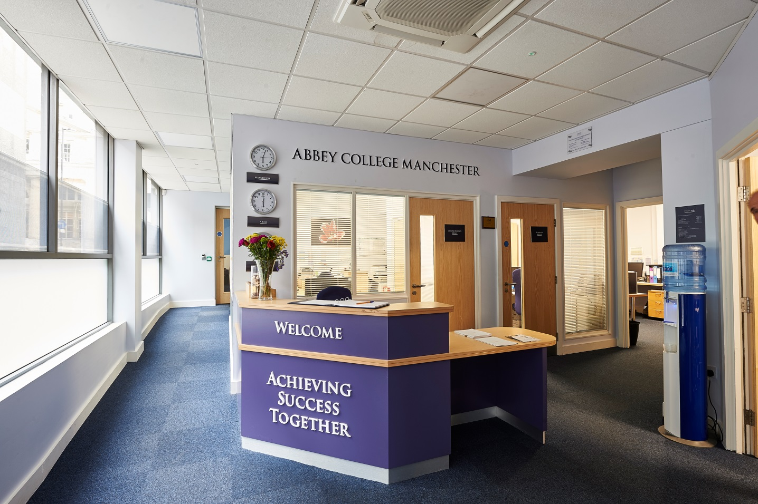

Information Pack:

Riverside House Cook

October 2019

About Abbey College Manchester

Abbey College Manchester was founded in 1990 and over the past twenty eight years has become one of the leading providers of independent sixth form education in Greater
Manchester. There are approximately 220 students in the college. Within this around 40% are from the Manchester area with the remainder coming from 25 different countries across Europe; Africa; Asia and the Americas.

We aim to:

• guide our students to achieve academic success and fulfil their aspirations
• respect and value each student providing a friendly, safe, supportive environment where students are happy and grow in confidence
• show a sensitive understanding of the challenges facing young people in the 21st Century by
empowering students to make informed decisions and have the determination to achieve their goals
• prepare our students for university, their future careers and to make a positive contribution to the community.

We are a dynamic, exciting college, situated in the heart of Manchester providing high quality, flexible A Level, International Foundation and GCSE programmes. We have recently introduced two unique programmes to complement our offering; these being the Combined Studies Programme and the Academic Studies with football Training Programme. Our modern building provides an environment conducive to study and in our small classes each student can develop their individual aptitudes aided by a strong system of tutorial guidance.

Teaching and learning is rigorous whilst being creative and responsive to individual need. Our enrichment activities include sport, voluntary work, charity events and many other opportunities led by the students and staff. We encourage students to raise their own expectations
and standards to the highest possible level. Staff, students and families get to know each other well and enjoy working together.

At Abbey College Manchester we offer a unique alternative to the traditional school whilst maintaining a strong academic ethos. Everyone contributes, everyone is appreciated; our committed teachers love their subjects and seek to inspire their students, in their turn, to love learning and value the acquisition of knowledge.

Riverside House

Currently 60 students live in our Senior Boarding House (Riverside House) which is a 15 minute walk from the main college building. Only students aged 16+ reside in this boarding house. The students live in flat clusters on two floors at Riverside house which are accessed only by ACM students and boarding staff. There is on-site secure parking for boarding staff at Riverside House. The kitchen facilities are in the student hub where dinner is cooked and served to the students. About 20 students have cooked food each evening.

The kitchen is a clean kitchen as at present there is no double sink facility. This will be changed in the new planned developments at Riverside House.

Description of the post

The role of the cook is to provide the evening meal for the boarding students in Riverside. The duty is five days per week from 4-7pm. The normal days of working will Monday to Friday with one weekend day per month as an alternative.

Responsibilities:

- Establish a vegetarian menu on a weekly basis and display this menu for students
- Ensure correct ingredients ordered/purchased in accordance with the menu from trusted outlets
- Highlight any potential allergens/intolerances within the food to students via information board
- Check food condition and best before dates daily and ensure any “bad” food is disposed of correctly
- Ensure stock rotation so oldest food used first and menu to incorporate this
- Check fridge temperature as per guidelines
- Check freezer temperature as per guidelines
- Ensure kitchen area clean prior to commencing food preparation (daily)
- Prepare all food for the menu
- Ensure no cross contamination of food types – separate boards for bread and vegetables
- Ensure work surfaces and equipment is cleaned throughout preparation and serving
- Ensure food core temperature is checked and maintained to guidelines throughout serving period
- Ensure kitchen area/oven cleaned after food service
- Liaise with cleaner/Riverside to ensure oven and kitchen thoroughly cleaned on regular basis
- Liaise with Director of Accommodation and notify immediately of any issues or concerns and to ensure best practice is adhered to by all Houseparents when using the kitchen area.

Note: This job description is indicative of the duties and responsibilities of the post but does not form part of any contract of employment. All jobs within the college evolve over time and their features vary from year to year.

Person specification

1. Personal skills and qualities

- High levels of personal and professional integrity
- Personal warmth, good rapport with students and colleagues
- Ability to cook nutritious food and provide an interesting and appropriate menu

2. Knowledge and experience

- Hygiene certificate level 2 or higher
- Experience of cooking in this type of environment i.e. a school canteen or equivalent

Philosophy and Ethos
- High expectations for student attainment, personal development and conduct

Reporting to:

The Director of Accommodation

About the Alpha Plus Group

The Alpha Plus Group is the parent company of Abbey College Manchester and nineteen other schools. It was founded in 1931 under the name Davies, Laing and Dick. The schools and colleges within the group have developed a longstanding reputation for delivering premium quality education.

In all its educational establishments, the Alpha Plus Group aims to provide a supportive and controlled environment in which children and young people are encouraged to pursue high academic and personal goals as happy and secure individuals. The Group expects that all its staff will be alert to the needs of its pupils and students - including their need for safety and protection - and will put the interests of children and young people first at all times.

Each school and college retains its own identity, with the Heads and Principals afforded significant management authority, but with the benefits of financial security, camaraderie and opportunities for sharing best practice by belonging to one of the country's leading educational groups.

The selection process

Job title: Riverside House Cook

Activity | Date
Deadline for receipt of applications | 20th November 2019
Shortlisting of candidates | 22nd November 2019
Interview dates | w/c 25th November
Start date | 1st January 2020

Applications will only be accepted from candidates completing the Abbey College Manchester Application Form and Equal Opportunities Monitoring Form. These forms, together with a short covering letter explaining why you believe you are suitable for the role, should be addressed to the Principal and sent to: Abbey College Manchester, 5-7 Cheapside, off King Street, Manchester M2 4WG.

Safeguarding Statement
Candidates should be aware that all posts in the college involve responsibility for safeguarding children. The Abbey College Manchester Safeguarding Statement is as follows: “We recognise our moral and statutory responsibility to safeguard and promote the welfare of all students. We endeavour to provide a safe and welcoming environment where children and young people are respected and valued. We are alert to the signs of abuse and neglect and follow our procedures to ensure that children and young people receive effective support, protection and justice”.

Rehabilitation of Offenders Act, 1974
This post is exempt from the Rehabilitation of Offenders Act 1974 and therefore all convictions, cautions and bind-overs, including those regarded as ‘spent’ must be declared. Please provide full details in a sealed envelope marked ‘Confidential’. The letter will be opened after shortlisting, prior to interview.

References
These will be taken up after interview. As part of this your referees will be asked about your suitability to work with children and whether they know of any disciplinary offences relating to children or young persons (whether the disciplinary sanction is current or time expired) and whether you have been the subject of any child protection allegations or concerns and if so the outcome of any enquiry or disciplinary procedure.

Interview
If you are invited to attend an interview this will be conducted in person and will include questioning on your suitability to work with children. All candidates must bring original documents confirming any educational and professional qualifications that are necessary or relevant for the post (e.g. the original or certified copy of certificates, diplomas, etc.). All candidates invited to interview must also bring their passport or photo ID and proof of the right to work in the UK (if applicable).

Terms and conditions

Remuneration
- The hourly rate is £12.50

Hours of work
- The post is 15 hours per week; evenings 4-7pm. Normally Monday to Friday with one weekend day per four weeks in exchange for a week day. Additional hours maybe required if cover is needed.

Holidays
- The college summer holidays (July/August) and Christmas holidays (three weeks)

Pension provision
Abbey College Manchester is part of the Alpha Plus Group and automatically enrol all new employees (unless requested not to by the employee) onto the company pension scheme. Notification of the pension plan (and all further details including opt out / opt in rights) will be provided.

Offer of appointment
Any offer of appointment is conditional on receipt of satisfactory references, an enhanced DBS clearance, the interrogation of qualifications and proof of the right to work in the UK.

We are committed to safeguarding and promoting the welfare of children and young people.

We expect all staff to share this commitment and to undergo appropriate checks, including enhanced DBS checks.

