In Essentials Unity
In Non-Essentials Liberty
In All Things Charity

Dear Colleague

Welcome to Fulneck School! I am delighted that you have chosen to investigate an application to come and work at this very special school and look forward to receiving your details in due course.

Over the years, I have worked in five schools, two maintained and three independent, but none has been anything like as welcoming and warm a community as Fulneck. This may be down to our traditions and history, it may be due to our amazing location, but more likely it is because of the people who study, work and live in Fulneck.

Fulneck is a place of high academic achievement. In both 2017 and 2018, for example, the Department for Education performance tables placed us in the top 5% of school in England at A Level. Class sizes here are small, with a much lower teacher:pupil ratio than that found in the vast majority of independent schools. Behaviour is excellent and aspirations are high. The quality of provision for dyslexia-type needs in our Learning Support Department has been recognised by CReSTeD.

The standard of pastoral care for day pupils and boarders is incredibly high. We also place emphasis on the all-round development of each individual’s character. Indeed, we are widely renowned as the school that nurtures pupils of all abilities to become the very best version of themselves. Much of this character education takes place outside the classroom.

We are, however, not complacent and are always looking to improve. So what are we looking for in a new member of staff? Staff rooms should be full of individuals; there is no such thing as an identikit teacher! However, teachers at Fulneck share the following characteristics:
• Passion for their subjects (above all else)
• Subject content expertise
• Pedagogical understanding
• The approach of a life-long learner
• A growth mindset approach for themselves and for our pupils
• The patience and compassion that defines a fine pastoral carer
• The desire to contribute to the extra-curricular programme
• Understanding of the world that we are preparing our children for
• Encouragement of pupils to contribute to the wider community

If you would like to find out more about our ethos, do have a look at my blog at http://www.fulneckschool.co.uk/blog. If you are excited by what you have discovered, I look forward to hearing from you.

Yours faithfully

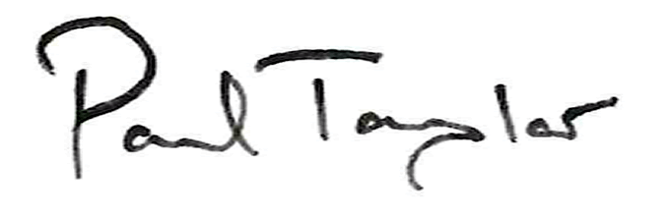

Paul Taylor
Principal

