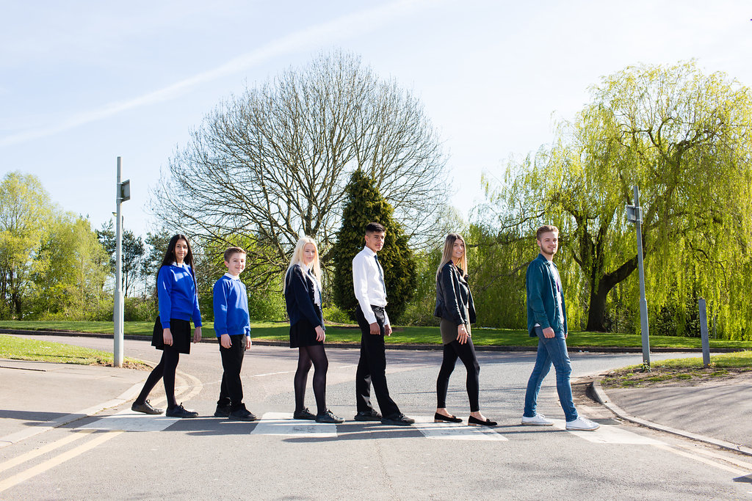

Cover Supervisor

Permanent – 30 hours per week, term time
Monday – Friday, 8.30am – 3.30pm
Plus 30 holiday hours for training, meetings etc

Grade 7 - £12,775 per annum
Content

Vision, Values and Ethos |  | Page 3
Testimonials |  | Page 4
General Information |  | Page 5
The Application Process |  | Page 6
Vacancy Advert |  | Page 7
Letter from the Headteachers |  | Page 8
Job Description |  | Page 9-10
Person Specification |  | Page 11-12

Vision, Values and Ethos
The shared vision and values of the Trust underpins all that we do, including the governance arrangements for the Trust.

Our Vision
Valuing Everyone, Achieving Excellence

Our Motto
Work Hard, Be Kind

Our goals
The goals of our trust:
- Outstanding levels of progress and achievement for all
- Outstanding levels of wellbeing for all
- Outstanding preparation for adult and working life
- Outstanding family and community engagement
- Outstanding levels of professional learning for all
Informed by “Schools of Tomorrow”

Testimonials
Extract taken from email correspondence, following a tour of the school by a prospective parent
(April 2016):
‘I would just like to say thank you for the time spent with me today on my tour of the campus, and state how impressed I was with the school. There seems to be a very calm, relaxed and organised approach to how the school operates, and I believe that obviously shows in the way your students behave’.

Written comments from parents following Year 9 Progress Evening (2017):
‘My child always talks positively about school to other children the same age, which I think is a good indicator that he is enjoying school’

‘Welcoming, approachable, friendly and knowledgeable staff’.

Written comments from parents following Year 11 Progress Evening (2017):
‘The teachers have pride in their teaching and in the pupils’ progress. They really care and are prepared to go the extra mile to support the students’.
‘My son seems to have progressed so well in most subjects. I feel this is due to good relationships he has been able to form with teachers and the standard of the lessons’.
Written comment from parent at the end of KS5 (2016):
‘This is my final parents evening after my youngest daughter is coming to the end of her years at GCE. Thank you for very happy years for my three daughters and for their excellent education!’
Thank you from parent of ex-student taking up a place at Cambridge University (2013):
‘To all the staff at Brookvale Groby Learning Campusl.
My son has just started at Cambridge University studying Engineering. It was his ambition to go there and this summer, he achieved the grades he needed. We want to acknowledge the great teaching and support he received during his time with you. He progressed well academically, but also grew so much in maturity and confidence. With thanks to you all for your hard work and dedication.’

Extract of letter from staff member:
‘I have thoroughly enjoyed my time on campus. It has been a real pleasure working with staff who are always friendly, extremely supportive and willing to share ideas and knowledge. I have really appreciated having a senior leadership team which is so warm towards its staff and open to their comments and new ideas.

The children I have taught have made me smile, laugh and cry! I will miss my relationship with them and that buzz you get from seeing them progress. It does, however, give me great satisfaction to think that I have put into place schemes of work for pupils and created learning opportunities for them which should continue even after I have left.

I am sad to leave a post which I still love. Once more, thank you for all of your support and kindness.’

Extract of letter from staff member:
‘I have been very fortunate to have worked with amazing people. I have learnt so much as both a Teacher and as a Head of Department.

I will truly miss everyone here, and it really has been an amazing experience. Thank you for allowing me to be part of such a wonderful group of people.

I wish every success to the campus.’

GENERAL INFORMATION

The Brookvale Groby Learning Campus is a highly successful 11-19 educational organisation created from the integration of two schools on the same site. Brookvale High School is an ‘outstanding’ 11-14 school and Groby Community College is a 14-19 upper school graded ‘good with outstanding features’ in its last Ofsted. Together, the campus meets the educational needs of 1,600 students with nearly 400 at Post 16, and we became a Multi Academy trust together at the beginning of April this year.

We have an established team of Cover Supervisors, who are highly regarded within the school by staff and students alike.
Karen Middleton is our Senior Cover Supervisor, who also has responsibility for organising cover requirements for the whole campus.
If you thrive on a busy, ever-changing routine, then this is the job for you! You will find yourself being supported every step of the way by our highly motivated team, who are always open to feedback and structured suggestions on how to make the role work even better.
If you feel you are ready for a new challenge within a fast moving, highly successful campus, then we look forward to hearing from you.

The Application Process

Complete application forms should be returned to efreeman@brookvalegroby.com

Or by post to

F.A.O. Elaine Freeman
Brookvale Groby Learning Campus
Ratby Road
Groby
Leicester
LE6 0FP

A letter will be sent to shortlisted candidates with details of the interview process.

Queries

If you have any queries on any aspect of the application or need additional information please contact Elaine Freeman, PA to the Headteacher on 0116 2879921.

Thank you.

The Role

COVER SUPERVISOR

Permanent

To support the learning of students by providing cover for absent teachers.

Grade 7 - £12,775 per annum
30 hours per week, Monday – Friday, term time
8.30am – 3.30pm
Plus 30 holiday hours for training, meetings etc.

For informal information, please contact Elaine Freeman, who will also arrange an appointment for you, should you wish to visit us.
Please email – efreeman@brookvalegroby.com
or telephone 0116 2879921
Full details and an application form available from:
www.brookvalegroby.com
or contact Elaine Freeman as above.

Closing date: 9am, Tuesday 24th October 2017
Interviews will be held within 2 weeks of closing date.

Brookvale Groby Learning Campus is committed to safeguarding and promoting the welfare of children and young people and expects all staff and volunteers to share this commitment. Applicants must be willing to undergo appropriate child protection screening, including checks with past employers and the Disclosure and Barring Service.

October 2017

Dear Applicant

Cover Supervisor

Thank you for your interest in the Cover Supervisor vacancy within the Brookvale Groby Learning Campus.

We hope the documents provided help you to gain a feel for the school and if you would like to visit us as well, we would be delighted to show you round. Please contact Elaine Freeman on 0116 2879921 or efreeman@brookvalegroby.com to make an appointment.

All the documents to support this application process are available on our campus website – www.brookvalegroby.com.

To apply please complete the following:

- Application Form
- A letter of application, no more than two sides of A4, word processed using font size no smaller than 10

Your letter needs to be addressed to ourselves, and if you would like to e-mail your application then please send this to Elaine Freeman on the email address above.

The closing time and date for this post is 9.00am, Tuesday 24th October 2017. The interviews will be held within 2 weeks from that date. If you have not heard from us by then, please assume that your application has not been successful on this occasion. If this is the case, we would like to thank you for your interest and the time spent in applying.

This post will be subject to an enhanced level Criminal Records Bureau check. All Brookvale Groby employees are expected to promote and safeguard the welfare of students at the school. Our Safeguarding Policy is made known to all and is designed to guide staff, students and parents/carers with regard to Safeguarding issues.

In line with best practice guidance re safeguarding we do not require an additional CV and any included with application forms sent to the school will not be taken forward to the short listing panel.

Yours sincerely
Katie Rush Robert Coles
Headteacher, Brookvale High School Headteacher, Groby Community College
Co-Director of BGLC Co-Director of BGLC

Job Profile

GRADE: 7

HOURS: 30 hours per week, Monday – Friday,
8.30am – 3.30pm,
plus 30 holiday hours

JOB PURPOSE: To support the learning of students by providing cover for absent teachers.

Key Responsibilities:

- In the absence of a teacher, provide supervision for classes across the curriculum.
- Liaise with Faculty Leaders/Subject Leaders/Teachers as appropriate with regard to the work set for a class.
- Deliver the work set by the class teacher to the students, always with a focus on supporting the students to make the maximum progress within the lesson.
- Respond to any questions from students about process and procedures.
- Motivate students to complete their tasks.
- Meet the learning needs of all the students within each class by using the information provided by class teachers to good effect.
- Get to know the learning needs of target students across the school, with a particular focus on SEND and disadvantaged students, and ensure SEND and disadvantaged students are prioritised in your cover lessons.
- Deal with any immediate problems or emergencies according to campus policies and procedures.
- Manage the class in accordance with the campus Behaviour Policy.
- Provide support as necessary to students.
- Ensure the health, safety and welfare of those students supervised.
- Collect any completed work after the lesson and return it to the appropriate teacher.
- Accompany teaching staff and pupils on educational visits as and when necessary.
- Register tutor groups as required.
- Participate in the campus duty rota as and when required.

Support the campus by:

- Being aware of, and upholding campus policies and procedures, and when appropriate contribute to the development of them.
- Being aware of confidentiality issues and maintaining confidentiality at all times.
- Participating in appropriate campus-based meetings and training activities.
- In accordance with campus guidance and policies provide comfort and immediate care in case of minor accident and upsets – reporting serious problems to appropriate person for action.
- Undertaking relevant administrative duties.
- Undertake any other curriculum duties that may reasonably be regarded as within the nature of the duties and responsibilities/grade of the post as defined.
- Participation in the campus performance management procedures.

This post is subject to enhanced disclosure from the Criminal Records Bureau.
All Brookvale Groby Learning Campus employees are expected to promote and safeguard the welfare of students at this school.
The Governing Body and the County Council are seeking to promote the employment of people with disabilities and will make any adjustments considered reasonable to the above duties under the terms of the Equality Act 2010 to accommodate a suitable candidate with a disability.
This Job Description sets out the responsibilities of the post at the time it was drawn up. Such responsibilities may vary from time to time without changing the general character and requirements of the post or the level of responsibility entailed. Variations are a common occurrence and do not necessarily constitute additional responsibilities or warrant a higher grade.

Personnel Specification

 | Essential |  | Desirable
Qualifications: | GCSE Grade C or higher (or equivalent) in Maths/numeracy and English/literacy  Evidence of recent personal and/or professional development training | A  A/R | Higher or Further Education qualification.  Interest in progressing within the education profession. | A  A
Experience: | Experience of working with children in a school environment | A | Experience of working with KS3/4 students | A
Knowledge and skills: | Good communication skills, written and spoken  Willingness to develop ICT skills  Good organisational skills  Knowledge of a range of strategies to promote good behaviour  Good time management skills and an ability to work under pressure, as well as the ability to be flexible and react positively to a busy, ever changing daily routine | T/A/R  A/R  A/R  T/I/R  A/R | Knowledge of SEN issues | A
Motivation: | Enthusiasm for learning, and for working with young people in a school environment, and participating in the wider life of the campus | A/I
Health and presentation | A good punctuality, health and attendance record  Willingness to dress and present oneself as a professional, in line with the ethos of the campus. | R  I/R
Application: | A well written and well presented application written specifically for this post | A

Evidence to be gleaned from:

A Letter of application and application form
I Interview process
R References
T Teaching sample lesson

In addition to candidates’ ability to perform the duties of the post, all Brookvale Groby Learning Campus employees are expected to promote and safeguard the welfare of students at the school, therefore the interview will also explore issues relating to safeguarding and promoting the welfare of children including:

- Motivation to work with children and young people
- Ability to form and maintain appropriate relationships and personal boundaries with children and young people
- Emotional resilience in working with challenging behaviours
- Attitudes to use of authority and maintaining discipline

Please be aware that any relevant safeguarding issues that arise on receipt of references may be discussed at interview.

