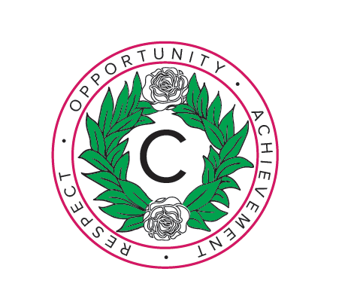 | Challney High School for Girls  Addington Way  Luton Beds  LU4 9FJ  Tel: 01582 571427  Fax: 01582 578122/578133  Website Address: www.challneygirls.luton.sch.uk  Email: admin@challneygirls.luton.sch.uk  Headteacher: Mrs J K Mylles BA (Hons), MEd, NPQH
May 2019

Dear Applicant

Re: Post of History – Subject Leader

Thank you for your enquiry about this post.

Challney High School for girls is an ambitious school. The school’s results in 2017 and 2018 were very good and we aim to build on these. The Progress 8 score in 2017 was +0.42 and in 2018 was +0.38. Our staff are highly valued, well supported and benefit from extremely positive staff/student relationships and a calm and purposeful working environment.

Our school motto of ‘Respect, Opportunity and Achievement’ underpins all the work we do. Fostering a love of learning, celebrating individual and collective achievements and developing consideration for others and friendships are central to our ethos and school community.

If you join our team you will access outstanding professional development opportunities within Challney High School for Girls and across the Chiltern Learning Trust schools. In 2018 staff took part in personalised CPD on a range of themes in small collaborative groups (Challney Collaborative Communities) to support whole school priorities and all staff had the opportunity to visit another school on our ‘Inset Day Away’ in November.

I hope that you feel your professional and personal qualities coincide with the opportunities that we can offer you. The closing date for Applications is noon on Tuesday 21st May 2019 with interviews taking place on Thursday 23rd May 2019.

Visits to the school are warmly welcomed: please contact Mrs Smith (HR) on ssmith@challneygirls.luton.sch.uk or 01582 571427 if you wish to meet with me, students and the department.

Yours sincerely
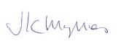
Mrs J Mylles
Headteacher

