

**Copthall School**

**Science Technician**

**Candidate Information Pack**



***A Positive Learning Environment that inspires a passion for learning so that every student progresses and thrives***



***A Positive Learning Environment that inspires a passion for learning so that every student progresses and thrives***

Dear Candidate

Thank you for your interest in the position of Science Technician at this exciting time for our organisation. I would like to welcome you personally, and I hope that you will find here all the information you need to inspire you to join our team.

Our school is unstoppable in its pursuit of Excellent Education for All, which has been highlighted by Ofsted 2018. We have been recognised for the rapid transformation and excellent progress of students and have been awarded **Good** status. The full report can be accessed using the following link: <http://www.copthallschool.org.uk/226/ofsted>

Our Governing Body is strong and highly ambitious for the school. Their recent award by the NGA for Outstanding Governance is further evidence of their ambition. They have a wealth of expertise in a range of areas and are very committed to ensuring we deliver first class educational opportunities to the communities we serve and make a difference to the lives of the girls who learn with us.

Over the last three years, Copthall has gone from strength to strength as we raise standards, enrich the lives of our students, focus on staff wellbeing and workload and continue to be a good and improving school. Our priority remains the same in that we offer our students a highly personalised academic experience – one that ensures that all our students receive an excellent education. We have an extensive enrichment programme involving mentoring, cultural activities/visits/trips, STEM workshops, a full careers programme and a range of partnership opportunities involving universities, businesses, charities and alumnae.

In addition, our collaboration with Mill Hill Independent School offers a range of joint opportunities for all students from leadership, tutoring, philanthropy extended projects and a variety of bespoke and unrivalled programmes that benefit our young people.

In preparing our students for the future we will endeavour to provide them with the skill set they will need including complex problem solving; critical thinking; creativity; emotional intelligence; judgement; and decision making; negotiation and cognitive flexibility. We want to ensure they play important influential and aspirational roles, ready to make a positive contribution to society.

For the third year running, we celebrated another very successful year in our examination results. Our preliminary P8 score is +0.83 which places us in the top 3% in the country for progress. 90% of English grades were 9-4 with increases in outcomes for both Maths and Science. One of our students was the highest achieving history student in the whole country and gained a suite of grade 8s & 9s. Our A-level results were equally impressive with our A*-C grades increasing from 61% in 2018 to 74%. In addition to this, students who sat vocational subjects did equally well with the average grade a Merit+.

InSeptember 2018 we launched our STEM Scholarship Programme across all year groups, including the Sixth Form. Students were involved in a wide range of workshops and enrichment activities tailor-made to students’ talent and potential.

We want you to look forward to each day at our school. We expect hard work, skill and dedication to our core values, and in return we will provide you with outstanding experiences and training opportunities. We have a strong focus on staff well-being and have a range of incentives including staff yoga and staff well-being days.

If you feel you can make a positive contribution to our school, please apply online via our website, [www.copthall.barnet.sch.uk](http://www.copthall.barnet.sch.uk). If you would like to discuss a role or have any queries, please call 0208 959 1937 or email [recruitment@copthall.barnet.sch.uk](mailto:recruitment@copthall.barnet.sch.uk). Visits to the school are also encouraged and welcomed.

I look forward to receiving your application.

Yours sincerely



Evelyn Forde

**Headteacher**

Evelyn Forde

**Headteacher**



***A Positive Learning Environment that inspires a passion for learning so that every student progresses and thrives***

**ABOUT COPTHALL**

As a girls’ non-selective comprehensive academy, Copthall offers the rare opportunity of single-sex education for students of all abilities. We are a values driven school which was noted by Inspectors in May 2018 when they commented “The school’s values of respect, equality for all, support and safety, aspiration and responsibility underpin this improving school’

Many girls stay on to join our vibrant Sixth Form, from where the vast majority progress to higher education, with a number achieving places at Russell Group universities. In addition, the school also offers a strong and varied vocational curriculum. “Students benefit from strong teaching and outcomes, which are rigorously checked by effective leadership in the sixth form” *Ofsted 2018.*

**OUR LOCATION**

Copthall School is located in one of London’s more prosperous and leafy boroughs and the area offers a wealth of good quality social, sporting and shopping facilities. That does not mean however, that we do not have to face social issues similar to many inner-city schools and there is a substantial amount of deprivation in our catchment area.

**VISION AND VALUES**

Our Vision and Value statements are borne from our commitment to girls’ education, we want to ensure that they can take their rightful place in society. We work together to communicate the vision so that any obstacles to success are removed.

**Mission Statement:** Excellent education for all - *A Positive Learning Environment that inspires a passion for learning so that every student progresses and thrives*

**Values:**

* **Respect:** Pride and respect in the cultural diversity of our school and the global environment in which we live
* **Equality for all:** An environment of kindness and tolerance that demonstrates equality for all
* **Support and Safety:** A school that cares and is inclusive, supportive and safe for all
* **Aspiration:** Expectation and celebration of high standards of aspiration and achievement in learning and life
* **Responsibility:** Being responsible and ready for learning

**Vision:**

* To empower every member of the school community to reach their full potential
* To equip our young women with the skills to enjoy, succeed and have choices in their adult lives
* To be an outstanding first choice school for young women
* To provide an inspirational, exciting and broad education
* To create a positive learning environment that inspires a passion for learning so that every student progresses and thrives (this is the teaching and learning vision)

**FOCUS**

We have a relentless focus on improving teaching and learning; this includes collaborative planning and coaching, both of which have been hugely developmental for staff. The way we improve teaching is through a series of steps which allow teachers to improve on one aspect of their teaching at a time before moving onto another area. We also use leadership coaching, according to need. Both models facilitate teachers to spend significant time on chosen aspects of their practice, in line with research into effective professional development and the motivating effect of autonomy.

The DNA of our school is *good* and we will continue to strive for excellence. The Governors and I hope you would want to be part of our journey.

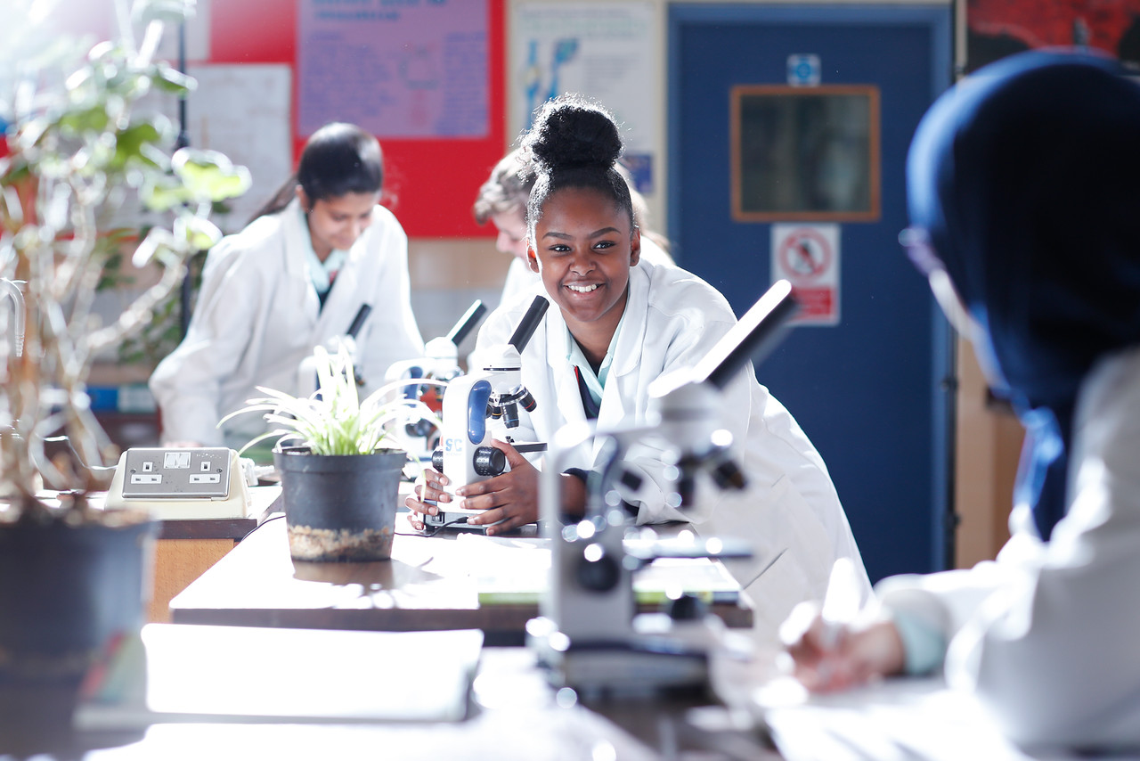



**Job Description: Science Technician**

**Reporting to: Curriculum Leader**

**Hours of Work: 35 hours per week**

**Weeks per year: Term time only, 40 weeks per year**

**Pay scale: SCP 5**

1. **Main purpose:**

* To provide specialist support in a specific curriculum or resource area, including the preparation and maintenance of resources and support to staff and pupils
* To supports pupils’ access to learning activities
* Work under the guidance of teaching staff or senior colleagues

1. **Key accountabilities**

* To assist the Senior Technician in the day to day running of technical matters
* To assist the Senior Technician in Health and Safety matters. To keep up to date with COSHH regulations and current safety legislation and implement where necessary
* To set up and test new practical’s with staff and explain existing practical’s to new members of staff
* To assist the Senior Technician in stock taking and replacing equipment and ordering new materials as appropriate
* To assist the Senior Technician in reporting faults and repairs to the appropriate person
* To assist the Senior Technician in arranging for photocopying of worksheets required for the schemes of work
* To assist the Senior Technician in setting up audio visual aids (video/DVD/OHP/electronic whiteboard)
* Any other appropriate duty as requested by the Curriculum Leader
* To assist teachers and students in the classroom with practical demonstrations
* To check the latest advice from CLEAAPS regarding practical work and ensure that teachers are made fully aware of best practice.
* Record any health and safety points onto technician’s notes and into Schemes of Learning.

**Support for the Pupils**

* Support pupils in accessing learning activities under the guidance of the teacher
* Communicate with pupils, teachers and other staff on commonly occurring issues within specialism and how to resolve them

**Support for the Curriculum**

* Maintain specialist equipment and systems, checking for quality and safety and carrying out specialist repairs or modifications within own capabilities and arranging for other repairs or modifications to be carried out by others

**Support for the Teacher**

* Create and maintain a purposeful, orderly and productive working environment
* Design, where required, maintain, prepare and use specialist equipment, resources, materials and/or systems as required by staff, lesson plans and the curriculum
* Support structured and practical activities for groups or on a one-to-one basis, including the use of technology
* Ensure the safe treatment and disposal of used materials, including hazardous substances and respond to actual or potential hazards

**Support for the School**

* Work within and comply with policies and procedures relating to child protection, health, safety and security and confidentiality, reporting all concerns to an appropriate person
* Support contingency arrangements to respond to any unforeseen or unplanned circumstances that may arise to maintain safety and security and minimise disruption, for example security of data, hazardous materials
* Be aware of and adhere to risk assessments

1. **Specific Duties**

* To have overall responsibility for the technical support for the KS3, KS4 and KS5 Biology scheme of learning

**4. Flexibility**

The jobholder may be required to carry out other reasonable duties commensurate with the grade, as requested by line manager.

This job description is not exhaustive and may change as the post or the needs of the Council develop. Such changes will be subject to consultation between the post holder and their manager and, if necessary, further job evaluation.

1. **Skills**

**Planning, organising and controlling skills**

* Work under the guidance of teaching staff or senior colleagues
* Carry out a range of duties that are specific in nature, for example planning, preparing and setting up specific resources, materials and/or equipment for lesson

**Communication and influencing skills**

* Provide routine information to pupils and staff within defined guidelines
* Use language and concepts appropriate to the child’s age, stage of development, and culture
* Build and maintain effective working relationships with colleagues to ensure the appropriate level of service is provided

**Initiative and Innovation skills**

* Work under the direction of teaching staff or senior colleagues to support learning by providing a range of technical assistance through the preparation and maintenance of teaching areas and specialist equipment, resources and/or materials for a specific curriculum or resource area

Work within and comply with policies and procedures relating to safeguarding, child protection, health, safety and security, equal opportunities, confidentiality and data protection.

***A Positive Learning Environment that inspires a passion for learning so that every student progresses and thrives***