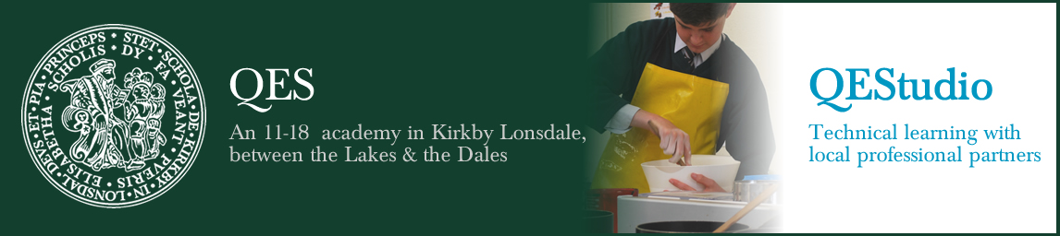

Department Details

Food and Catering
Food and Catering is a small, dynamic and forward-thinking department at QES and QEStudio. All of our staff are well motivated with sound relevant professional and classroom experience. This means that you will be working alongside a department of outstanding classroom practitioners who inspire pupils to achieve the high levels of success they enjoy.
At Key Stage 3, pupils are taught in classes of mixed ability in a rotation with Textiles. The pupils progress through well-planned work schemes that develop and expand their knowledge of, not only Food and Nutrition but wider issues such as environment and health. The curriculum encourages independent learning and enquiry, whilst developing the skills that will help pupils progress onto Level 2 courses. Years 10 and 11 currently follow Eduqas GCSE Food Preparation and Nutrition or the WJEC Hospitality and Catering course. Both courses offer pupils plenty of opportunity to be creative and achieve well in final exams.
Our facilities are new and inspirational, giving pupils plenty of bright rooms in which to work both in practical and theory classes. We are able to offer pupils the chance to work and learn with local professional partners in our industry kitchen at QEStudio. We have a department focus on careers in the industry, forging strong links with employers and further education providers in the community, which gives our pupils a thorough knowledge of careers available to them in the future alongside developing their employability skills.
Finally, it is important to emphasise the close cooperation that takes place at all times between members of the department. Our success is a result of teamwork, with ideas and information shared on a day-to-day basis. The combination of differing experience and a variety of strengths provides a creative and outward looking department. The support and good humour that is in evidence is just another part of what makes teaching Food at QES and QEStudio so enjoyable.

