Appointment of teacher of English
(with the possibility of some Drama)

at

Rydal Penrhos School

for

January 2018

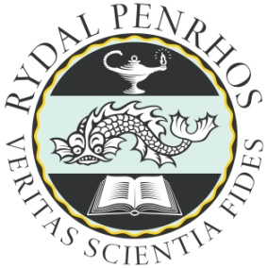

Information for applicants
The School
Rydal Penrhos School began its history in the 19th century. Rydal School was founded in 1885 by Thomas Osborn as a boys’ boarding school in the Methodist tradition. Penrhos College had been founded five years earlier, in 1880, by Thomas Payne as a girls’ boarding school, also in the Methodist tradition. In 1999, the two schools merged into a single foundation called Rydal Penrhos.
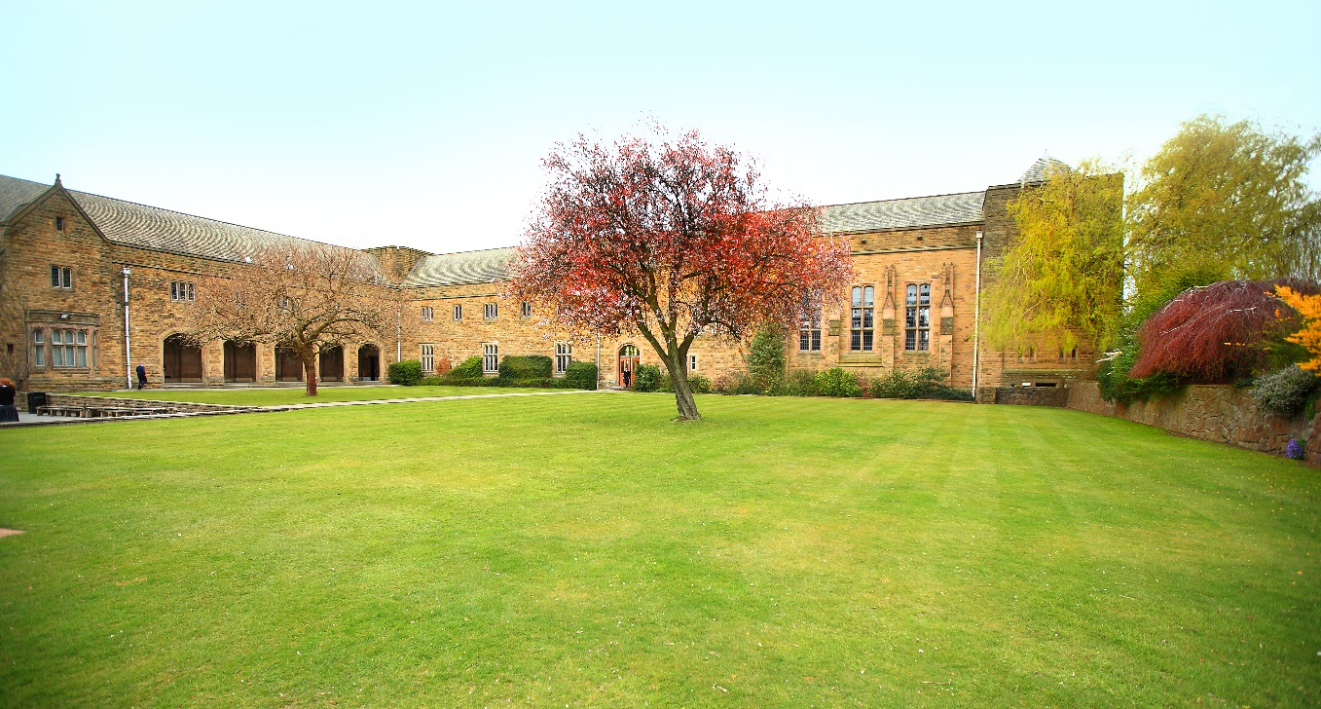
Rydal Penrhos Preparatory School is on a neighbouring site and offers co-education from age 3 to 11 years. Links between the Preparatory School and the Senior School are strong. Both schools have a Christian ethos with Chapel and prayers held daily.
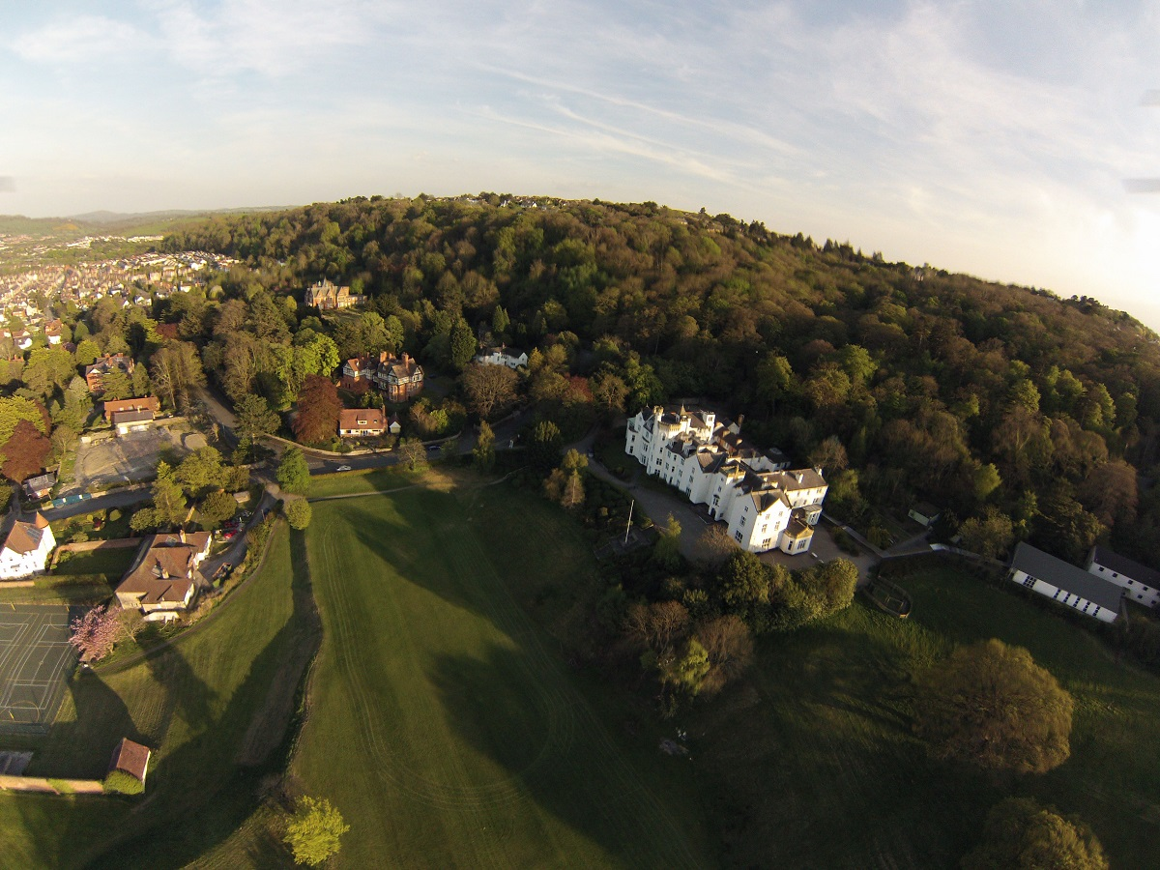
The Senior School, which takes pupils from the age of 11 to 18 years, is also co-educational. Entry is normally into Year 7, by means of an entrance test, though there is also an intake into Year 9, particularly from prep schools. Educational initiatives and development are always at the forefront of the school’s development planning; within the curriculum, the School offers a wide range of subjects at Key Stage 3, GCSE, and A-Level. The International Baccalaureate has been offered since 2004.
The Senior School is divided into a Lower School (Years 7 & 8), Middle School (Years 9, 10 & 11) and then Sixth Form. Tutor groups are organised vertically within the Middle School and Sixth form, and pupils remain in their pastoral house throughout their time in the school. Most teaching staff act as form tutors, with responsibility for groups made up of both day and boarding pupils. The boarding houses are allied to each pastoral house and are run by Housemasters/mistresses, all of whom teach in the school. Teaching staff make an important contribution to the boarding community through evening duties as house tutors and running and overseeing boarders’ activities at the weekends. Heads of Lower and Middle Schools and Sixth form, together with tutors, oversee discipline, academic progress and overall pupil development.

As is to be expected of a successful boarding school, there is a rich co-curricular programme of games, music, drama, art, and activities. The school’s location between the sea and the mountains means that sailing and outdoor education (including climbing and mountain expeditions) are important elements in that programme, which involves a wide range of teaching staff. Cultural, technical, community and creative options are also well represented.
The Senior School currently numbers around 360 with 180 in the Preparatory and Pre-Preparatory School. There are around 150 boarders accommodated across the five boarding houses.
The school is a member of HMC (Headmasters’ and Headmistresses’ Conference), SHMIS (Society of Heads of Independent Schools) and BSA (the Boarding Schools Association) and the Prep school is a member of IAPS (Independent Association of Prep Schools). The school is also an Associate member of the Methodist Independent Schools group.
For further information, please visit our website: www.rydal-penrhos.com.

The Successful Candidate

Essential Characteristics:
- A good honours degree or equivalent
- Proven teaching ability in English up to Sixth form level
- Proven teaching ability in English and Drama to KS3 level
- The ability to command respect from staff and pupils, to impose discipline when required and to stand firm to his or her moral convictions
- Commitment to the life of a busy community and a resilience to its demands
- Commitment to the well-being of the school as a whole
- Experience or understanding of boarding schools

Salary and Review

Rydal Penrhos operates its own salary scale. The salary for the successful candidate will be fixed according to expertise and experience. The school also pays the Rydal Penrhos allowance to staff to reflect their contribution to extra-curricular and boarding responsibilities.

The Appointment Process

A fully completed application form, which includes contact details for two referees, is an essential part of the process. An additional covering letter or curriculum vitae may be addressed to the Headmaster. The closing date for applications is 20 October 2017. Interviews will be held in the week beginning 6 November 2013.

The interview process will include:
- A tour of the school.
- An observed 40 minute lesson, details of which will be provided with interview information.
- An interview with the Director of Studies, Head of English and Drama
- An interview with the Headmaster and Deputy Head.

The successful candidate will be contacted by telephone in the first instance and an appointment will subsequently be confirmed in writing. Unsuccessful candidates will be notified in writing and may telephone to request a debrief.

Sally Harding
Director of Studies
October 2017

