THE GRANGE SCHOOL

Specialising in Business & Enterprise

SCIENCE STRATEGY MANAGER

THE GRANGE SCHOOL

The Grange School is a well established, friendly school, specialising in Enterprise.
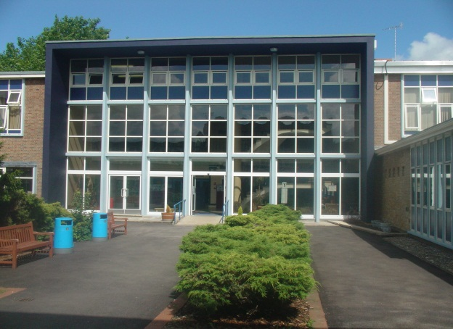
Enterprise is a driving factor throughout learning as evidenced by our Grange Enterprise and Learning Skills (GELS) which are embedded across the curriculum.

We aim to equip all students with the adaptability and flexibility to meet the demands of a rapidly changing world and to promote a sense of responsibility towards others, the school and the wider community. The support and guidance of students is based on a Year system and aims to develop co-operation, involvement and respect in all students.

A broad and balanced curriculum is provided for Years 7 to 9. In Years 10 and 11 all students will study English, Mathematics, Science, PE, RS and PSHCE (Personal, Social & Health and Citizenship Education). Students can then choose from a range of additional GCSE, BTEC and vocational courses. We offer a range of traditional and vocational courses at Key Stage 5. The curriculum in all Key Stages is further enhanced through wide ranging extra curricular experiences.

We aim to attract energetic and conscientious staff who have a commitment to the education of our students. The professional development of all staff is an important focus for the school. We strive to create a learning environment, which serves the needs of all the members of our diverse and vibrant community.

THE GRANGE SCHOOL

STRATEGY MANAGER FOR SCIENCE

To be accountable for, and provide professional leadership and management within the Science Department. To support the Subject Leader for Science to secure high quality teaching and learning, effective use of resources and monitoring and tracking information to improve achievement for all students.

Responsible to: Curriculum Coordinator for Science

Line Management Responsibilities:

- Teachers of Science

Accountability for leading, managing and developing a curriculum area:

Working with other relevant teachers in Science:

- Co-ordinate strategies to achieve relevant improvement priorities that have been agreed with the Subject Leader.
- Evaluate and report upon the effectiveness of practice in identified developing strategies.
- Lead professional development in agreed developmental strategies through example and support.
- Use financial and resource management innovatively and effectively when allocated budgets are agreed with the Subject Leader.

Impact on educational progress beyond assigned students:

- Monitor and evaluate assessment data within agreed strategy development to identify trends in student performance and issues for development.
- Work with the Subject Leader to define intervention strategies to address issues for development that have been identified.
- Evaluate and report on the effectiveness of intervention strategies identified above.
- Support teachers in planning for the implementation of agreed strategies.
- Support the Subject Leader in ensuring that agreed targets within the subject are met.
- Encourage students’ motivation and enthusiasm for Science, developing positive responses to challenges set and high expectations.

Leading, development and enhancing the teaching of others:

Working with other relevant teachers in Science:

- Monitor and evaluate the planning of other teachers, towards the implementation of strategies within Science, providing constructive and developmental feedback.
- Disseminate appropriate examples of effective planning practice within Science.
- Support the Subject Leader in ensuring that Science teachers are clear about the teaching objectives, understand the sequence of teaching and learning in Science, and communicate this to students.
- Act as a performance management team leader for identified teachers.
- Observe colleagues within the department teaching, through performance management arrangements, and provide evaluative feedback upon the effectiveness of their teaching strategies to bring about further improvement.
- Identify and promote innovative and effective practice, for agreed strategies, to meet the needs of all students.

Strategies for development will be discussed and agreed with the Subject Leader for Science as part of your annual job. Such strategies will be linked to the local development or national development of Science.

THE GRANGE SCHOOL

SCIENCE AT THE GRANGE SCHOOL

STAFF AND STRUCTURE

We are looking for a colleague who has:

• the ability to raise the expectations and aspirations of students from all backgrounds;
• a record of outstanding practice in learning and teaching;
• a strong leader with a commitment to teamwork and excellent interpersonal skills;
• the ability to continue to raise standards in Science;
• the vision to promote Science in exciting and innovative ways:

DEPARTMENT FACILITIES

The Science department is located within close proximity of one another. All classrooms have interactive whiteboards and projectors. The department is fully staffed with dedicated Science specialists who have a wealth and breadth of experience. The Science labs have recently been refurbished to enable all staff to carry out practical activities.

EXTRA CURRICULAR

The school recognises and values the work of the Science team both within the curriculum and through its extra curricular contributions. For example; a thriving Brainiacs Science Club for KS3, STEMNET Club and after school revision classes.

Candidates are invited to visit the school prior to interview.
Please contact Jenny Bell, PA to Headteacher, to make an appointment
The Grange School, Wendover Way, Aylesbury, Bucks, HP21 7NH
Tel: 01296 390900
Fax: 01296 390991
E-mail: office@grange.bucks.sch.uk
www.grange.bucks.sch.uk

