

Assistant Headteacher
Teaching and Learning
Canon Slade School

Assistant Headteacher
Teaching and Learning

Leadership Group L12 - L16 (£65,286 - £72,162)
1.0 FTE
Permanent Contract
Required Easter 2025
Closing date: Wednesday 12th February 2025 @ 9.00am
Selection Day and Interview: Wednesday 26th February 2025


The Trust’s vision is based on our strongly held Christian values: “To allow all children to experience ‘Life in all its fullness’, no matter what their starting point.” We offer a high quality, inclusive and distinctive education within a caring and nurturing environment based on our Christian values, recognising the uniqueness of each child.

We are an outward facing Trust and constantly look to learn and collaborate with others. We also have an excellent provision via our Train Teach Lead Partnership (TTLP), which offers excellent CPD and school to school support. Our links with Manchester Diocese, GMLP and the Bolton Learning Partnership continues to be strong.

We became a Trust to secure the special nature of our individual schools as we do not think that one size fits all. Our schools still retain considerable autonomy over their curriculum to ensure it is the best possible offer for the context of the school.

Welcome to The Bishop Fraser Trust
From Mrs Tuesday Humby, Chief Executive Officer
Dear Applicant,

In January 2024, I took on the role of chief executive at The Bishop Fraser Trust, and I’m delighted that you are thinking about joining us. The Bishop Fraser Trust is Multi Academy Trust which was set up on the 1st December 2017. Our family of schools are as follows;

- St James’s Church of England High School (11-16)
- Canon Slade School (11-18)
- Bolton St Catherine’s Academy (3-16)
- Bury Church of England High School (11-16)
- St Catherine’s Church of England Primary, Horwich (3-11)

Our employees are very important to us as we rise or fall by the professionalism and dedication of our staff. As such, I place great importance on continuous professional development for all staff members and have always strived to create a culture where our educators know that if they go the extra mile for our children, we will do the same for them.

Educational attainment is important to me, I want to make sure we are opening all doors for our children. However, as important to me is children’s personal development. I firmly believe that character education is a cornerstone in the development of well-rounded, responsible, and empathetic individuals who will go on to make meaningful contributions to our world. In this way we prepare our pupils to lead 'life in all its fullness'.
When recruiting, we always look for people who share these beliefs. If this strikes a chord with you, then we would love to hear from you.

Tuesday Humby
Chief Executive Officer

Why work for The Bishop Fraser Trust?

Professional development
Making thousands of professional decisions every day requires the best evidence, knowledge, and professional wisdom to secure the best outcomes for our children. At TBFT, we recognise the importance of investing in our staff and placing continuous professional development (CPD) at the heart of our efforts to engage, develop, and retain the best talent. We offer a range of development opportunities and strong career pathways for all roles within the Trust. Whether through internally run programmes or partnerships with external providers, we provide accredited and bespoke training programs, including a range of NPQs to support teachers and leaders at all levels. Moreover, we collaborate closely with other educational leaders to deliver high-quality CPD in pedagogy, behaviour management and curriculum development. Through steering groups, forums, improvement networks, peer reviews and conferences, you’ll have the support and challenge of your peers from across the trust, fostering opportunities to network and collaborate.

Equality, diversity, and inclusion
Our strategy underscores the importance of weaving equality, diversity and inclusion throughout all our work. While we acknowledge that there is more to be done in this area, we are committed to the process of inclusion, and the continuing focus on removing barriers to participation and access, alongside the focus on recruitment and support of a diverse workforce. We want to become a more diverse organisation at senior levels, and so welcome applications from black and ethnic minority candidates who are currently under represented. We always hire on merit and welcome discussions around flexible working. We believe in the power of our people and their potential to make a positive impact on the lives of our pupils. Join us in shaping a brighter future for education, where everyone is valued and empowered to succeed

Wellbeing and support
We understand the importance of taking care of our employees’ wellbeing. We know that the thing that has the biggest impact on people’s wellbeing is their leadership, and with that in mind we are focussed on developing our leadership capability across the trust. In addition, we also offer a range of services that are designed to support your health and wellbeing. From an employee assistance programme for you and your family, a counselling service and legal helplines, fitness and wellbeing support, to gym and retail discounts and more, we strive to ensure your happiness and health in your role. Additionally, our academies have the freedom to offer workload support tailored to their local preferences, which may vary slightly from one location to another. We also value the need for refreshment and re-energisation, offering generous holiday provisions, parental leave, and flexible working arrangements. Working for TBFT also includes membership of either the Local Government Pension Scheme (LGPS) or Teachers’ Pension Scheme (TPS) depending on the role applied for. Our package of support continues to evolve as we refine how we recognise and reward our employees’ contributions in various ways. We recognise the importance of TBFT being a flexible workplace and are determined to be creative and to develop our approach further.

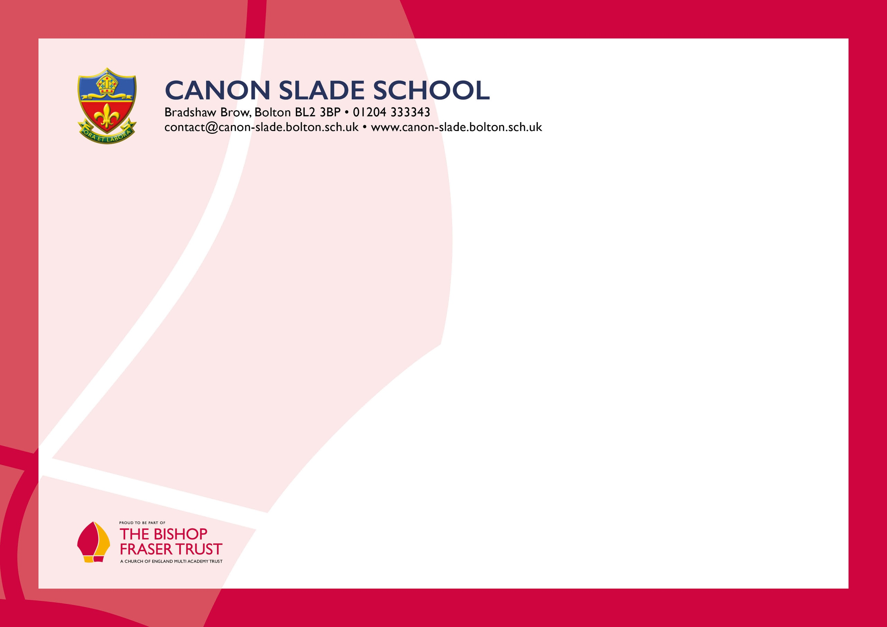
Dear Applicant,

Thank you for your interest in our current vacancy.
Canon Slade School has a long and distinguished history, originally founded in 1855 by the then Vicar of Bolton, Canon James Slade. Over that time, the school has served families throughout Bolton and much farther afield in providing an excellent education set firmly within a strong Christian ethos. We are blessed with a beautiful 57-acre site in the foothills of the West Pennine Moors. There is so much to admire in what has been created here over the years, in a traditional but forward-looking school, with a large number of students and staff, but where each individual is known, nurtured and cared for.
Our mission as a Church of England Academy is to provide an excellent education within a Christian environment to fulfil individual potential and to prepare pupils for life and service in a rapidly changing world. Our motto “Ora et labora” (Pray and Work) is our guiding principle. It is this commitment to work and the Christian life that drives the success of the school. Our ethos and values of compassion and love for one another allows each individual to grow in a safe, caring community, which has high expectations for all.
We believe that every one of our students should have unlimited ambition to go on and become outstanding members of society. Strong relationships with parents and carers, ensures a shared understanding and belief in the school’s values and aims, working in partnership to maximise and promote the value of education. Our school is a friendly, vibrant and exciting place in which every member of our school community is recognised and valued for the individual they are and where each is given every opportunity to fulfil their potential.
The school has a well-deserved reputation not only for its academic work but also for drama, music, sport and many other activities. Our students progress onto world-class institutions, apprenticeships and employment each year.
You will find further information about our school and the Bishop Fraser Trust on the school website and we hope that you find the information of interest to you. If there is anything else, you would like to know please contact me.
Whatever the outcome, we would like to thank you for the interest you have shown.

Yours sincerely,

Karen Sudworth
Headteacher

Welcome to CANON SLADE SCHOOL
from Karen Sudworth, Headteacher
Canon Slade School has a long and distinguished history, originally founded in 1855 by the then Vicar of Bolton, Canon James Slade. Over those one and a half centuries, the school has served families throughout Bolton and much farther afield in providing an exceptional education set firmly within a strong Christian ethos.
Though the school has changed much since its inception, our motto “Ora et labora” (Pray and Work) is still the guiding principle. It is this commitment to work and the Christian life that ensures the success of the school and its ability to flourish in a constantly changing and challenging world.
A visit to the magnificent school chapel bears witness to the centrality of Christian faith. Every member of the school community is involved in an act of Christian worship each day and everyone is expected to do their best in every aspect of their work. High standards of behaviour are demanded and mutual respect is part of the embedded culture.
Christian values of compassion and love for one another allow each individual to grow in a safe, caring community which has high expectations for all.
Canon Slade School is a friendly, vibrant and exciting place in which every member of the school community is recognised and valued for the individual they are, made in the image of God, and where each is given every opportunity to fulfil their potential.
ABOUT CANON SLADE SCHOOL

LIVING AND WORKING IN BOLTON AND BURY

Affordable cost of living: compared to some of the bigger cities in the UK, the cost of living in Bolton and Bury is relatively affordable.

Convenient transportation: Bolton and Bury have transportation links, with easy access to the M60, M61 and M62 motorways and regular train services into Manchester City Centre. Bury has an excellent tram link to Manchester central and two major train stations.

Beautiful green spaces: Bolton and Bury have a range of beautiful parks and green spaces, such as Heaton Park, Jumbles Country Park and Rivington and Moses Gate Country Park. These offer an opportunity to escape from the hustle and bustle of daily life, and enjoy nature walks, picnics, or outdoor activities. The local moorland is exceptional.

Cultural attractions: Both towns have a rich industrial heritage and have a number of museums, galleries and historical landmarks that showcase this. These include the Bolton Steam Museum, Bury Transport Museum, and the East Lancashire Railway, which is a popular tourist attraction. Bolton has an excellent theatre, The Octagon. Manchester offers a huge array of culture and arts programmes.

There is a plethora of eating places, country pubs and activities. Bolton runs the UK Iron Man competitions in July and there is the Food Festival in August.

Academic institutions: Bolton and Bury are home to a number of Universities, Colleges and other academic institutions, such as the University of Bolton, and Bolton and Bury Colleges. There are great links with our Universities in the area such as Manchester University and MMU.

Please also include within the body of your application form a statement of no more than two sides of A4 to explain why you want to work at our school, why you are the best candidate for this post and what you would contribute to our Trust and school, with examples from your recent work if possible. We are keen to learn about your impact and your educational philosophy.

In accordance with the General Data Protection Regulations, the details provided in the application form will be used for selection and interview procedures, and for employment records if your application is successful. Our recruitment privacy notice with further details is available both on our school website.

If you do not hear from the school within two weeks of the closing date, then please assume that your application has been unsuccessful on this occasion.

The school has an Equal Opportunities Policy. If you are disabled, please give details of how we can ensure that you are offered a fair selection and interview process or if you would prefer, please contact recruitment@thebishopfrasertrust.co.uk to discuss any requirements.

Successful candidates will be asked to provide, prior to taking up the appointment, documentary evidence (including National Insurance number) showing their entitlement to work in the UK. We will also carry out reference checks, an enhanced DBS and declaration of health check.

How To Apply

We hope that you have enjoyed reading about The Bishop Fraser Trust and our school and that you will feel able to apply for this post.

To apply, please complete the application form via the Face-Ed link
https://thebishopfrasertrust.face-ed.co.uk/Vacancies/Detail?campaignRef=SCH-TBFT-0037&urlKey=94169606-8ef7-40c8-9086-7cd73cf69be4

Please do not send CV’s or open references as part of your application as these will not be considered.

It is important that you provide a complete employment history from when you left full time education. If the application form is not fully completed or has unexplained gaps in your employment history, your application will not be considered. Copies of your qualifications will be required at the interview stage; please do not send these with your application.

We will not be able to consider late applications.

