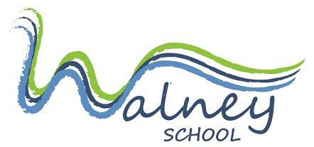
JOB PROFILE
Post title: Cleaner
Job purpose:
- To be responsible for the daily cleaning of specified areas of the school.
- To ensure general areas of the school (including the toilets) are clean and tidy.

Accountabilities / duties:
- Daily cleaning of areas of the school to a high standard
- Report any faults/problems that hinder effective cleaning tasks being undertaken
- At all times follow health and safety requirements and ensure that machinery, materials and equipment are used effectively and safely
- Communicating in a friendly, professional manner with teachers, class staff and students
- To undergo on and off site job training sessions as required by the school
- To be aware of the Fire / Emergency procedures
- Any other duties as directed by the Cleaning Supervisor, Site Managers, Headteacher or Office Manager

Line manager:
This role reports to the Cleaning Supervisor.

Person specification: Cleaner
 | Essential | Desirable
Qualifications/Competencies | Willing to undertake training. | Health and Safety training.
Experience | Experience of relating well to people at all levels.  Previous experience of cleaning work. | Experience of working in a school or similar environment.  Experience of working in an environment with children including those with special needs.
Knowledge | Basic cleaning procedures. | Manual handling training.  Basic Health and Safety knowledge.
Skills/Ability | Able to work with cleaning machinery and equipment.  Ability to work quickly and efficiently.
Personal Skills | Ability to work as part of a team.  Ability to use initiative.  Ability to keep calm and patient with students.  Positive, can do attitude.

