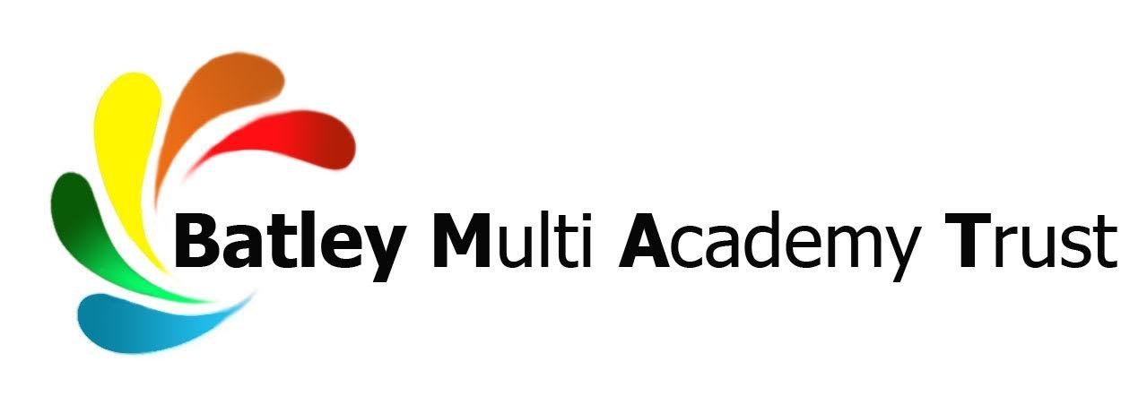
TEACHER OF SCIENCE
NQT/MPS/UPS
Full time
Permanent
To commence January 2019 or earlier if available

Upper Batley High School is a dynamic, innovative and forward thinking learning community. We are proud that our focus is on educating ‘Tomorrow’s Successful Men’ and we are specialists in the education of boys. Respect lies at the heart of everything we do. We are looking for a forward thinking individual to join our team on our journey to outstanding.

Our GCSE results increased again in 2019, demonstrating great progress for boys and a record number of learners achieving the highest possible grade 9. Ofsted visited us in 2019 and said our school “provides all pupils with a high quality education”. Upper Batley High School were identified as a Beacon School in the Northern Challenge report due to the excellent progress our disadvantaged learners make. We also hold the PSHCE Charter Mark, the Careers Quality Standard and we are a lead school within the Kirklees Careers Hub. We are one of only a few schools in the UK to achieve 100% in all Gatsby benchmarks. Ofsted identified out careers programme as a “real strength of the school”.

Our 11-16 school is multi-cultural and located close to the town centre, within easy access of the motorway network. Our work is focused on developing the unique potential of every individual whilst working towards becoming an outstanding educational organisation. We are a vibrant, rich and exciting learning community with unique and inspiring opportunities inside and outside the classroom.

We are part of the Batley Multi Academy Trust, whose sole purpose is to provide an outstanding education through our family of schools. Batley Multi Academy Trust currently comprises Batley Girls’ High School, Upper Batley High School, Healey Junior, Infant and Nursery School and Field Lane Junior, Infant and Nursery School.

We are seeking to appoint an innovative Teacher of Science to join our successful and hardworking team. The successful applicant will be learner centered and a collaborative practitioner. The post offers excellent opportunities for a committed teacher with good knowledge of the Science curriculum at KS3 and KS4.

If you are a highly effective classroom teacher with excellent communication skills and are keen to make a difference to the progress and aspirations of our learners, then we would welcome your application.

In return we can offer:
- A firm commitment to your professional development with a structured programme of CPD
- A supportive team of exceptional staff and school leaders to ensure success in the role
- Excellent facilities with highly motivated learners, keen to learn and engage in lessons
- Leadership development opportunities and a bespoke development programme

This is an excellent opportunity to join a supportive forward thinking school who in return for your commitment and hard work will support you to achieve your own career goals and aspirations.

Please apply by completing a Batley Multi Academy Trust application form, available at www.ubhs.co.uk or by contacting our Human Resources department on 01924 350081/recruitment@batleymultiacademytrust.co.uk, for consideration by our selection panel. Please also include a letter of application, no more than two sides of A4 (minimum font size 11), outlining why you would like to apply for this role and what skills, qualities and attributes you will bring.

Closing date for applications is 25 September 2019
Interviews will be held week commencing 30 September 2019

Batley Multi Academy Trust is committed to safeguarding and promoting the welfare of children and young people and expects all staff and volunteers to share this commitment. The post is subject to an Enhanced Disclosure and Barring Service check for Regulated Activity.

Batley Multi Academy Trust is an equal opportunities employer and welcomes applications from all sections of the community.

