WALTHAMSTOW SCHOOL FOR GIRLS
“Neglect not the gift that is in me”

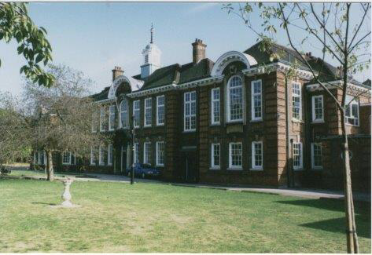

Information for applicants for the post of
Learning Support Assistant
(Fixed term)
Required for September 2019 until the end of the summer term July 2020

September 2019

Dear Applicant
Thank you for requesting an application pack for the post of Fixed term Learning Support Assistant.
Walthamstow School for Girls is a high achieving, oversubscribed, diverse school which is regularly in the top 5% nationally for progress and the top 10% nationally for attainment and is at the centre of the vibrant local community of Waltham Forest (the first London borough of culture). We have an ambition to become ‘world class’ and a commitment to work with other professionals both locally, nationally and internationally, through our Erasmus links. We won the national High Aspiration Award for the progress made by disadvantaged students and have won SSAT Achievement and Progress awards annually since 2014. We have been awarded the SSAT Exceptional Education standard twice; in 2017, for Leadership through Moral Purpose, and, in 2018, for Systems: use of assessment, data, policies and monitoring to support teaching and learning. We were awarded Teaching School and National Support School Status in September 2017. In June 2018, following a Section 8 inspection, we were awarded an ‘outstanding’ judgement.
Our students are ambitious and hard-working; they embrace the range of opportunities offered to them both during and beyond the school day. This is highlighted not only by our exceptional examination results but also by the maturity of the girls, their sense of responsibility, community and fun. They are a delight to work with.
We offer excellent facilities to both staff and students. Our acclaimed architect designed site is an oasis of green and a pleasure to work in. It is well served by transport connections, being just ten minutes’ walk away from Walthamstow Central tube and overground station and five minutes’ walk from the popular Walthamstow ‘village’, and creative and restaurant quarter. We pride ourselves on working hard to retain our role as an important part of the local community. Examples of this commitment can be seen in our weekly Greensheets. Our staff are inclusive and friendly, with regular social and wellbeing events as well as charity fundraising.
We are committed to Safer Recruitment practices and procedures and shortlisted applicants will be questioned about their commitment to the safeguarding of young people. The successful candidate will be subject to an enhanced DBS clearance.
Thank you for taking an interest in this position. I do hope that having read more about the school you will decide to apply for the post. I look forward to receiving your application. Please note that it will not be possible to give feedback to unsuccessful applicants, other than those called for interview. Thank you for your understanding and good luck with your career in education.
Ms Meryl Davies
Headteacher, NPQH, NLE

The History of Walthamstow School for Girls
In January 1890, a circular stated that a “school for girls” was to be opened. Walthamstow was described as a pleasant suburb on the borders of Epping Forest. Hoe Street was almost a country road, with a few houses on either side and meadows in which were sheep, cattle, hawthorn and wild roses.
Miss Hewett was the first Headmistress, at the age of 27 until she retired in 1924. There were 49 girls, whose ages ranged from 7-16 years. At this time there were only five teachers, two of whom were graduates. The School’s original Staff Book gives details of the first one hundred teachers. Of them 30 remained at the school for ten years or more, 22 giving over twenty years’ service. Until 1944 all the teachers were women and not married.
The original building was in West Avenue Road and when the numbers grew the school moved to Church Hill House, where a church now stands. At this time there were also boys up to the age of 13 years at the school. It was in September 1913 that 243 girls came into the present building with the Greek Theatre being added in the 1920s. However in July 2008 the whole school moved off site for a period of four school terms to facilitate the building and refurbishment programme that has resulted in the unique blend of traditional and state of the art facilities found at the school today.
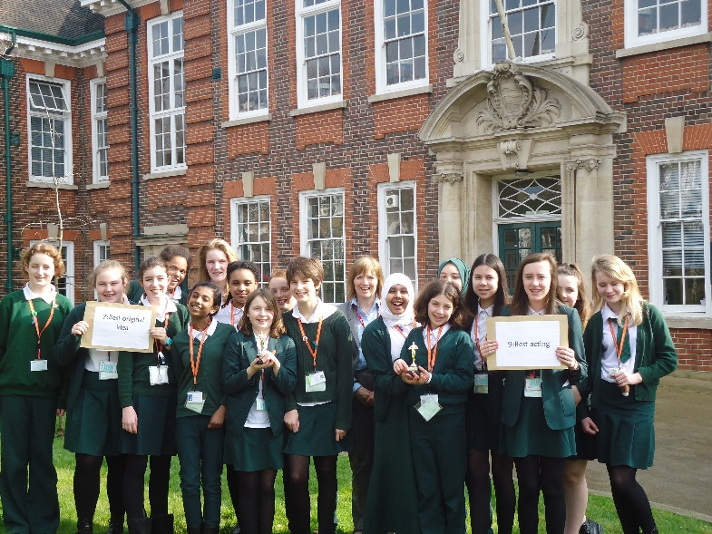
Walthamstow School for Girls is a place of high achievement. Effective teaching and learning are at the heart of our school. The school motto “Neglect not the gift that is in thee” underpins all the school’s work. Every girl is expected, encouraged and supported to achieve her very best academically and our pastoral system supports our students’ academic and social experiences.
Our role is to educate tomorrow’s women through a range of activities and opportunities to be confident, secure and happy individuals as they prepare for further education, careers and future lives.

Fixed term Learning Support Assistant

1 Full-time Fixed-term Learning Support Assistant
(5 full days - 26 hours 40 minutes per week-term-time only)
Required for September 2019 until the end of the summer term July 2020
Scale 3

We are looking to appoint a Learning Support Assistant with experience of working with students to join the Language and Learning Development Faculty (LLD). This is a fixed term posts until the end of the summer term in July 2020.
It is essential that candidates are available to work five days a week from 9.00am to 3.30pm.
The successful applicant will work with subject teachers and the Faculty to support students with special educational needs, both with statements and without.
Closing date: Monday 16th September 2019 (noon)
Interview date: To be confirmed
An application form and recruitment pack are available to download from the school website: www.wsfg.waltham.sch.uk. Completed application forms should be returned to Mrs Mandy Madhani, HR Manager, by email to m.madhani@wsfg.waltham.sch.uk. Please note CVs will not be accepted.
Walthamstow School for Girls is committed to safeguarding and protecting the welfare of children and young people. The successful candidate will be subject to an Enhanced DBS check.

WALTHAMSTOW SCHOOL FOR GIRLS
JOB DESCRIPTION

1.1 Post Title: Learning Support Assistant
1.2 Post Purpose: To support students with Special Educational Needs,
particularly those students with learning difficulties.

1.3 Reporting to: Head of Faculty
1.4 Responsible for: Safeguarding and promoting the welfare of all students.
1.5 Liaising with: Teachers and other support staff.
1.6 Working time: 26 hours 40 minutes per week during term time with 2
periods a week for planning and preparation.

1.7 Salary/Grade Scale 3
1.8 Disclosure Level: Enhanced

2. Supporting

2.1 To work with children referred by the Special Educational Needs Co-ordinator

2.2 To carry out programmes set for the students with special educational needs.

2.3 To liaise with teachers regarding programmes for individual students.

2.4 To carry out behavioural programmes for students.

2.5 To work with students with special educational needs in the classroom.

2.6 To work with a small number of students in small groups outside of the
class room on specific programmes.

2.7 To support students with coursework completion.

2.8 To attend regular meetings with the SENCO.

2.9 To attend Faculty meetings within contracted hours.

2.10 To attend in-service training as required.

2.11 To submit reports on targeted students as required.

2.12 To attend Annual Reviews of statemented students and report back on progress and pre review assessment results.

2.13 To accompany specific students on school outings with teaching staff.

2.14 To carry out other duties as specified by the SENCO.

2.15 To act as a mentoring

  - To act as a reader/ scribe for exams and tests.

  - To carry out assessment using a range of assessment tools.

3. OPERATIONAL/STRATEGIC PLANNING
3.1 To assist in the development of appropriate differentiated resources for a range of subjects.
3.2 To contribute to the Faculty’s development plan and its implementation.
3.3 To plan and prepare support for targeted students
3.4 To contribute to the whole school’s planning activities.

4. CURRICULUM PROVISION & DEVELOPMENT
4.1 To assist the Head of Faculty in meeting the needs of all students.

5 STAFFING
5.1 To take part in the school’s staff development programme by participating in arrangements for further training and professional development.
5.2 To continue personal development in the relevant areas including subject knowledge relating to SEN.
5.3 To engage actively in the Performance Management Review process.
5.4 To work as a member of a designated team and to contribute positively to effective working relations within the school.
6. QUALITY ASSURANCE
6.1 To help implement school quality procedures and to adhere to those.

6.2 To contribute to the review of support provided from time to time.

7. MANAGEMENT INFORMATION
7.1 To contribute to the maintenance of appropriate records as required.
7.2 To track student progress and use information to inform support.

8. COMMUNICATIONS & LIAISON
8.1 To communicate effectively with the parents of students as appropriate.
8.2 To follow agreed policies for communications in the school.

9. MANAGEMENT OF RESOURCES
9.1 To assist the Head of Faculty in identifying resource needs.
9.2 To co-operate with other staff to ensure a sharing and effective usage of resources to the benefit of the School, Faculty and the students.
10 SCHOOL ETHOS

10.1 To play a full part in the life of the school community, to support is distinctive aims and ethos and to encourage staff and students to follow this example.
10.2 To promote actively the school’s policies.
  - To comply with the school’s Health and Safety policy and undertake risk assessments as appropriate.
10.4 To understand and comply with the council’s equal opportunities policy.

Whilst every effort has been made to explain the main duties and responsibilities of the post, each individual task undertaken may not be identified.
The school will endeavour to make any necessary reasonable adjustments to the job and the working environment to enable access to employment opportunities for disabled job applicants or continued employment for any employee who develops a disabling condition.
This job description is current at the date below but will be reviewed on an annual basis and, following consultation with you, may be changed to reflect or anticipate changes in the job requirements which are commensurate with the job title and grade.

September 2018

Walthamstow School for Girls
Learning Support Assistant
Person Specification
1. Experience
- Experience working with young people Essential
- Administrative experience Desirable

2. Special abilities / aptitudes

- Interest in working with students with special needs Essential
- Able to work independently and flexibly Essential
- Maintaining confidentially where appropriate Essential
- Clear, verbal communication especially with young people Essential
- Clear and accurate written communication Essential
- A knowledge and understanding of basic literacy sufficient Essential
to support students in school

3. Person Specification Requirements
- Ability to work with students with emotional and behavioural Essential
difficulties
- Sensitive to the needs of students with special educational Desirable
needs
- Ability to work with different professionals, including teachers, Essential
Education Psychologists and others
- Ability to seek advice and help when needed Essential
- Ability to work as part of a team Essential
- Sensitivity to the needs of pupils from the ethnic Essential
minority community.
- Willingness to learn new ideas Essential

4. Other job specification requirements
- Commitment to the Authority’s Equal Opportunities Policy Essential
and acceptance of their responsibility for its practical application

5. Education and Training
- Bilingual Desirable
- GCSE or equivalent qualification in Desirable
Mathematics and English
6. Disqualifying Factors
- Indication of sexist, racist or anti-disability attitudes or any other inconsistent
with the Authority’s Equal Opportunities Policy

September 2018

Staff Benefits

Outlined below are some of the additional benefits available to staff working at Walthamstow School for Girls.
Cycle 2 work scheme
This benefit offers staff the opportunity to make tax and national insurance savings whilst keeping fit at the same time.
Commitment to CPD
We actively encourage CPD to all staff. We regularly provide whole school CPD as part of the school calendar as well as supporting individual CPD requests.
Eye Tests
All staff using computer equipment should have eye and eyesight tests at regular intervals. Eyesight testing should also happen where staff experience visual difficulties, which may reasonably be considered to be caused by computer work.

Staff Wellbeing
As part of our CPD for staff we include sessions related to staff wellbeing. These include The Walthamstow School for Girls Running Club, Badminton, Box fit exercise sessions, yoga and the London Club (historical walks around London).

Employee Assistance Helpline
A confidential counselling, help and information service is provided for all employees of LBWF and is available free of charge 24 hours a day, every day of the year. Counselling is offered on the telephone or in a face-to-face setting. This service can help with a range of problems from practical everyday matters to sensitive and emotional issues. Please visit: employeeassistance.org.uk or call 0800 328 1437 for further information.

