**Todmorden High School**

Come join us! We champion our whole school values which are **RESPECT, CARE AND HONESTY**

*We are a recently inspected GOOD school engaged in a period of significant growth. We are located in the beautiful Todmorden valley. We’re a thriving comprehensive school for 11 to 16-year-olds, with approximately 800 pupils and just over one hundred staff.* ***Workload and Wellbeing*** *is at the forefront of all we do. We are looking for several new colleagues who may be fulltime, part time, or come to us with flexible requests. We encourage working in every formation possible, we know one size does not fit all. We endlessly support working families and champion worklife balance, we’re so much more than ‘just another school’…*



**Lead Practitioner of Science**

**Our LP role is permanent and applications from Aspiring LPs are welcomed**

|  |
| --- |
| *The introduction of Lead Practitioners is a new development for our school.*  *Our vision is for our Lead Practitioner team to provide pedagogic leadership within School and play a key role in raising teaching and learning standards through the leadership of thematic improvement priority, through the quality of their own teaching and by supporting the professional development of all colleagues.*  *Lead Practitioners are expected to meet the standards for either Advanced Skills or Master Teachers. This is a fluid advertisement, and applications are welcome from those interested in aspiring Lead Practitioner, or established Lead Practitioner opportunities.* |
|  |

Look at our recruitment page on our website, find out more about joining our team, click WORK FOR US on the link below, *openings close 25 February 2019 at 9.00am*

[www.todhigh.co.uk](http://www.todhigh.co.uk)

**OfSTED, October 2018**

*‘The Headteacher and other Leaders, including Governors, are determined to provide the best possible education for pupils’.*

*‘Leaders seek out best practice from other schools and Advisers, and are keen to provide the best care possible’.*

Our Vision

Our school will provide a safe and happy environment   
where everyone aspires to make remarkable rates of progress,   
both personally and academically.We will inspire all to develop our core values of respect,   
care and honesty. We will support each other and celebrate   
our talents. Our students will be supported to grow into remarkable   
individuals, ready to thrive in the modern world.We hope to give Todmorden an Aspirational, Inspirational   
and Remarkable school.

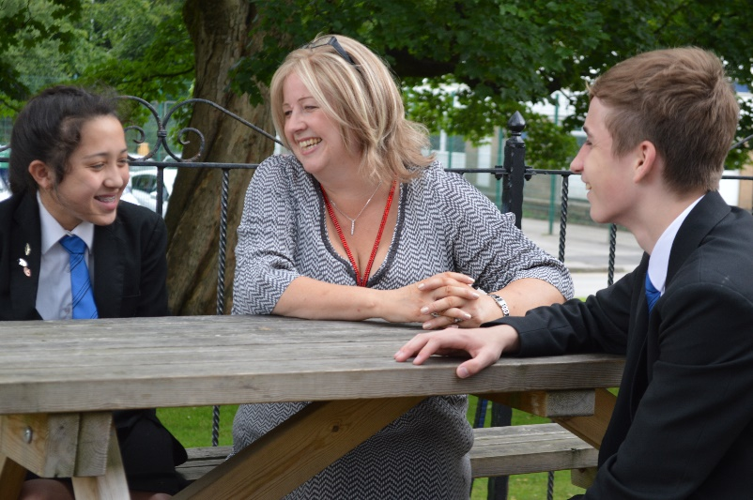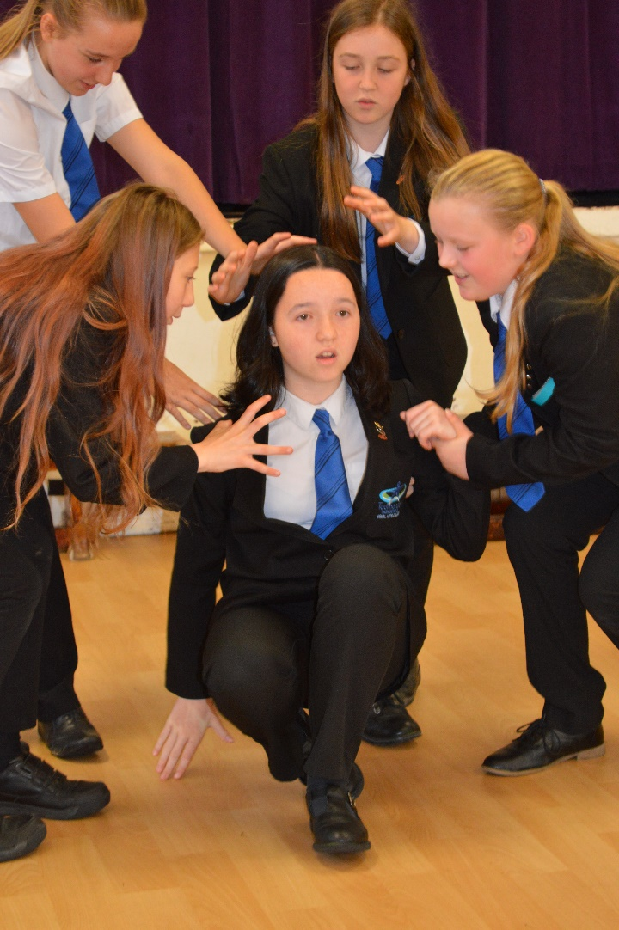

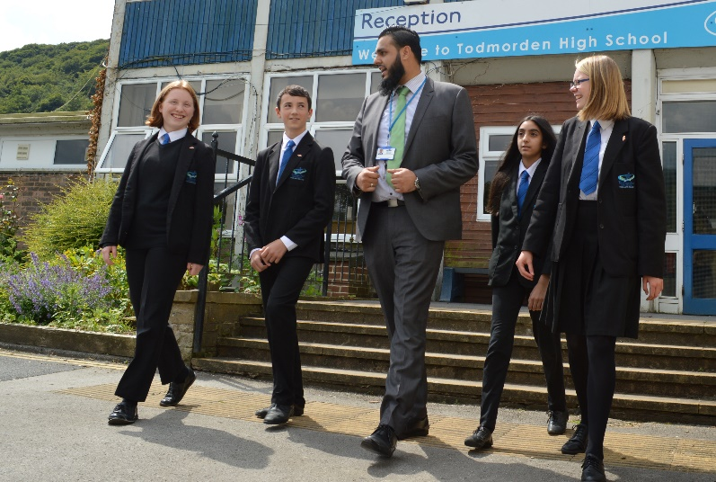

***February 2019***

Dear Applicant

Many thanks for your interest in working at Todmorden High School. This is a position for applicants who have qualified teacher status.

We remain passionate, and ensure our students have access to the very best educational experiences possible. In order to achieve this, it is vital that we attract and retain the right calibre of professional to work alongside our dedicated team. We are seeking colleagues who share the vision that our students are at the very heart of everything we do. A colleague who is able to enjoy positive, professional relationships with young people, and more importantly, a colleague who can demonstrate high levels of emotional intelligence and resilience when dealing with complex and sensitive situations. A colleague who models our core values of respect, care and honesty.

At Todmorden High School, our students are well behaved, respectful and polite. Students and staff work tirelessly to uphold our core values and behaviours. These provide the foundation for high aspirations and foster a love of learning from both staff and students. Our values underpin everything we do, on a daily basis, to ensure that we all know the role that we have to play in both our school, and our community as a whole.

We aim not only to foster a thriving climate for learning, but to provide the very best career opportunities for everyone; an environment where aspirations can be met and opportunities for personal development and growth remain a constant priority.

We are committed to creating a culture where all staff, at all levels, can feel proud of who we are, of our achievements and feel a sense of pride when they reflect on their individual contribution to our School development. All this in an environment where generosity and kindness can thrive.

In keeping with our values, we strive to create a workplace that celebrates difference. Somewhere we all feel responsible, valued, empowered and trusted to do the right thing for each other, our students and our community.

With very best wishes



**Gill Shirt**

**Headteacher**

**Science Lead Practitioner (or strong and aspiring)**

**(LPs will be appointed to LP Scale L1-L4)**

**Recruitment and Retention point available for outstanding applicants**

**Closing date 25 February 2019 at 9.00am**

**Aspiring Lead Practitioner/Lead Practitioner**

|  |
| --- |
| The introduction of Lead Practitioners is a new development for our school. Our vision is for our Lead Practitioner team to provide pedagogic leadership within School and play a key role in raising teaching and learning standards through the leadership of thematic improvement priority, through the quality of their own teaching and by supporting the professional development of all colleagues. The Lead Practitioners are expected to meet the standards for either Advanced Skills or Master Teachers.  ***Lead Practitioners fulfil their role by:*** |
| * Working with other teachers on classroom management and teaching methods / providing model lessons; |
| * leading professional development activities across whole school |
| * run workshops and sharing practice on whole school strategic issues such as behaviour for learning differentiation, assessment is for learning, functional skills, thematic or contextualised learning |
| * modelling how to tailor work more sharply to meet the needs of individuals and groups of students |
| * building on existing best practice in the School to improve the quality of feedback through marking |
| * matching teaching approaches to learner learning styles |
| * acting as a consultant to teams of colleagues developing strategies for learners experiencing difficulties. |
| * demonstrating model lessons in our training classroom |
| **Disseminating best practice based on educational research** |
| * identifying educational research to enhance existing practice; |
| * acting as a link with other external organisations e.g. Schools Network, National College in implementing strategies for dealing with challenging behaviour and promoting inclusion; |
| * co-ordinating the assessment and analysis of results and developing action planning. |
| * Recommending strategies for effective intervention to raise standards of attainment for individuals and groups of learners |
| **Producing high quality teaching materials** |
| * leading the development of new technologies such as whiteboard technology, the use of ICT, e-learning, development of student digital intelligence to meet the needs of the web 2 generation etc; |
| * developing resource packs to support existing teaching. |
| **Advising on professional development** |
| * designing and delivering professional development activities including undertaking lesson observations and feedback; |
| * leading a professional learning group as identified; |
| * participating in the planning and delivery of focussed CPD training days; |
| * participating in the performance management of other teachers; |
| * assisting in the performance review of teachers experiencing difficulty. |
| * Coaching colleagues to ensure School policies are implemented. |
| In addition our lead practitioners effectiveness in teaching and learning will enable them to be very effective in supporting whole School priorities for example: |
| * providing workshops for learners on key borderlines; |
| * providing targeted support for particular groups of learners, e.g. Gifted and Talented; disaffected learners, EMA etc. |
| * Required to carry out duties as set out in the current School Teachers’ Pay and Conditions doc. |
| The post holder will: |
| Planning |
| * plan teaching to achieve progression for learners learning; |
| * provide clear structures for lessons which maintain pace, motivation and challenge for learners; |
| * make effective use of assessment information on learners’ attainment and progress in teaching and planning future lessons; |
| * plan opportunities to contribute to learners personal, spiritual, moral, social and cultural development. |
| * Model the implementation of School standards and protocols for planning. |
| Teaching and Class Management |
| * ensure effective teaching of whole classes so that learning objectives are met and that best use is made of the available teaching time; |
| * ensure that homework is set regularly and marked; |
| * establish a safe environment which supports learning and in which learners feel secure and confident; |
| * use teaching methods which sustain the momentum of learners’ work and keep all learners engaged; |
| * set high expectations of learners’ behaviour, establishing and maintaining a good standard of discipline; |
| * evaluate their own teaching critically and use this to improve their effectiveness. |
| * embed the personalising learning culture of the School in their classroom, in order to demonstrate how to move from shallow learning to deep learning * set up a high quality learning environment in their own classroom, and model this for other colleagues in order to establish a high quality learning environment across the School |
| * ensure that the **School guidance on safeguarding** is implemented across their Area of Learning |
|  |
| Monitor, evaluate, assess, recording and reporting and accountability |
| * assess how well learning objectives have been achieved and use this assessment; |
| * mark and monitor learners’ assigned classwork and extended learning, providing constructive oral and written feedback, and setting targets for learners’ progress; |
| * use assessment is for learning strategies to model the use of effective feedback including peer and self-assessment to ensure that learners know how to make progress |
| * assess and record learners’ progress systematically; |
| * use comparative data to set clear targets for learners’ achievement. |
| Other Professional Requirements |
| Make a significant contribution to an Area of Learning and Key Stage so that it is organised to meet the aims and objectives of the School and the subject and in particular to: |
| Strategic direction and development |
| * help to develop and implement policies which reflect the School’s ethos and commitment to high achievement, effective teaching and learning and good learner behaviour; |
| * establish short, medium and long term plans for the development and resourcing of which are clear about action to be taken, timescales and criteria for success; |
| * work to put the plans into practice; |
| * monitor the progress made in achieving development plans and targets and use this to inform future planning and development and participate in the annual review of the department’s work and progress; |
| * participate in departmental meetings and contribute to planning and policy making. |
| Efficient and effective deployment of resources |
| * use available resources with maximum efficiency to meet the objectives of the School and subject plans and to achieve value for money; |
| * use accommodation to create an effective and stimulating environment for teaching and learning; |
| * establish effective working relationships with professional colleagues; |
| * set a good example to the learners they teach, through their presentation and their personal and professional conduct; |
| * be committed to ensuring that every learner is given the opportunity to achieve to their full potential and meet the expectations set for them; |
| * support the development of high quality schemes for learning, both within their own area of expertise and with colleagues in other areas. |
| * keep up to date with research and developments in pedagogy in the subjects that they teach; |
| * understand their professional duties in relation to the School policies and practices. |
| * commit to the School code of ethical practice in order that safeguarding policies can be fully implemented. |
|  |

This is not an exhaustive list of duties and is indicative of the type of work required by this post holder. The post holder will be expected to work closely with the SLT and deliver the operation provision required to work with groups of young people in learning environments. The Headteacher may also require the post holder to fulfil other duties, as required.

Our High School is a warm and friendly environment where staff are supported to grow and develop. Our Executive team plays a crucial role in removing any barriers to teaching and learning allowing our teachers to focus on teaching and good outcomes for our students. Every member of our team plays a vital role in promoting and supporting good teaching and learning.

We welcome applications from our wider community. We are looking for someone who can hit the ground running and join our team as soon as possible. We are a supportive and friendly environment. You will play a significant part in our journey to becoming a truly ‘outstanding’ school. Please send all completed applications to [d.todd@todhigh.co.uk](mailto:d.todd@todhigh.co.uk).

Todmorden High School is an aware employer is committed to safeguarding and protecting the welfare of children and vulnerable adults as its number one priority. This commitment to robust recruitment, selection and induction procedures extends to organisations and services linked to the School on its behalf. This post is subject to an enhanced DBS check. We value variety and individual differences, and aim to create a culture, environment and practices at all levels which encompass acceptance, respect and inclusion.

**Job Description**

**Form Tutor**

***Purpose of the job***

To ensure the effective learning of all students within the tutor group through effective support and challenge.

To structure the learning of students during tutor periods.

To monitor the academic and social progress of each student within the tutor group and effectively intervene where necessary.

To ensure that students are ready to learn on a daily basis and that barriers to learning are removed.

***Responsibilities***

Responsible to: Learning Manager

Responsible for: The social and academic progress of each student within the tutor group.

***Main duties***

To manage daily routines within school relating to uniform, equipment, time-keeping and readiness to learn.

To ensure that students hit target grades as reflected in interim and annual reports by:

* using data to assess students’ academic progress
* challenging students and make e-mail or telephone contact with parents where forecast grades are significantly below target grades
* intervening directly with students where forecast grades are significantly below target grade in more than three subjects

To oversee the behaviour of each member of the tutor group.

To monitor and promote the good lesson attendance of each member of the tutor group.

To monitor the social, emotional and physical well-being (including social integration) of each member of the tutor group.

To listen to and develop student voice within the tutor group.

To be a good role model to students.

**LEAD PRACTITIONER**

**PERSON SPECIFICATION**

|  |  |
| --- | --- |
| **POST TITLE**  **SALARY**  **PRINCIPAL**  **RESPONSIBILITY** | **LEAD PRACTIONER**  **Leadership pay spine 1 - 4**  Lead Practitioners provide pedagogic leadership within the School and play a key role in raising teaching and learning standards through the leadership of an School thematic improvement priority, the quality of their own teaching and by supporting the professional development of their colleagues. |
|  | Lead Practitioners should meet the standards of AST or Master Teacher |

**EXPERIENCE**

|  |
| --- |
| **Essential**   * Experience of leading teaching and learning * Experience of contributing to whole school policy review * Experience as an outstanding classroom teacher * Experience of collaborative and effective working with teams of staff * Evidence of continuing professional development.   **Desirable**   * Experience of delivering training * Experience of a strategic role in school improvement. * Evidence of teaching science in an All Through/Primary setting * Experience in professional networking and collaboration * Experience in delivering CPD in a locality, LA, regional or national forum |

**QUALIFICATIONS**

|  |
| --- |
| **Essential** |
| * A recognised teaching qualification * Good Honours Degree or equivalent |
| **Desirable** |
| * Other relevant qualifications e.g Advanced Skills Teacher status |

**TRAINING**

|  |
| --- |
| **Essential** |
| **Essential** |
| * Recent training in the curriculum, assessment and the leadership of subject specialism * Recent training in ICT. * Evidence of continuing professional development in subject specialism |
| **Desirable**  Evidence of wider training in learning and teaching |

**SPECIAL KNOWLEDGE**

|  |
| --- |
| **Essential** |
| * the impact of learning styles on effective teaching within subject specialism * relationship of the subject to the curriculum as a whole * up to date knowledge of statutory curriculum requirements at Key Stage 3 and KS4 * the characteristics of high quality teaching and the strategies for improving and sustaining high standards of teaching, learning and achievement for all pupils. * public examinations and procedures. * personal development needs of 11 -16 age group. * personal expertise in the use of ICT and its application. |
| **Desirable** |
| * effective deployment and use of staff and resources to ensure their best use. * the potential use of ICT to aid teaching and learning and leadership. |

**SKILLS**

|  |
| --- |
| **Essential** |
| Leadership skills needed to direct and co-ordinate the work of other staff  **Candidates should be able to:**   * set standards and provide support for pupils and staff * deal sensitively with people and resolve conflicts * work as part of a team as well as take the leading role * delegate and trust others to complete tasks * seek advice and support when necessary * analyse performance data and take a strategic view * deliver consistently high quality lessons, evaluate the impact of these and plan accordingly * respond calmly and supportively to pupils displaying anxious or challenging behaviours as well as planning effectively to support their individual needs   **Decision Making skills**   * analyse, understand and interpret relevant information and data and present it in useful forms to staff, parents, students, governors * judge when to make decisions and when to defer to senior managers * think creatively and imaginatively to solve problems and identify opportunities   **Self-management** and **organisational skills**   * prioritise and manage their own time effectively ; * work under pressure and to deadlines ; * be self- motivating * take responsibility for their own professional development   **Communication skills**   * communicate effectively and develop good working relationships with pupils, other staff, parents, external agencies, governors and others * be able to act, influence and negotiate in a professional manner in difficult or emotive situations * negotiate and consult effectively * chair meetings effectively * communicate effectively orally and in writing to a range of audiences   **ICT skills**   * Demonstrate a clear understanding and competence in the use ICT both for curriculum and for work organisation |

**PHYSICAL AND PERSONAL CIRCUMSTANCES**

|  |
| --- |
| **Essential** |
| Sufficient health, stamina and energy to cope with a very demanding post.  Sufficiently flexible circumstances to enable some out of school hours working including attendance at evening and weekend meetings.  Smart appearance |

**PERSONAL QUALITIES**

|  |
| --- |
| **Essential** |
| **Candidates should possess and display** :   * the ability to establish good personal professional relationships at all levels * adaptability * openness, good humour, energy, enthusiasm and a sense of proportion. * resilience * self confidence * intellectual ability * commitment * integrity - consistency between what you say and what you do * **a willingness to commit to the School code of ethical practice in order that safeguarding policies can be fully implemented.** |